
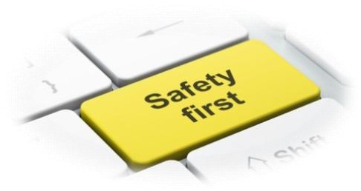
All Saints Upton CE Primary School
Child-Friendly Online-Safety Policy

Online-Safety is very important at our school. It is not just adults that need to know how to stay safe online. We talk about being safe online lots in lessons and in special Online Safety days. We can use our child-friendly policy to remember the top tips for in school and at home too!
The internet is great because:
- We can learn lots of things.
- We can have lots of fun.
- It can help us with our school work.
- We can stay in touch with close friends and family.
Some dangers are:
- Cyber bullying- Sending nasty texts messages and emails, swearing on games we can talk on and calling each other names.
- Stranger danger- Some people we could talk to online we might not even know, so they are strangers. Bad language- Sometimes when we are online, we can see or hear swear words that can upset us and others.
- Things we can see online- Some things online are not ok for children to look at.
- Viruses- Some emails or things we download can have viruses in them that can break our computers or steal information.
What is Online-Safety?
- It means staying safe online by never sharing personal information with people you don’t know well in real life. This includes friends of friends, as well as complete strangers.
- It helps to keep us children safe so that we can enjoy, explore and have fun online.
Why do All Saints children need this Online-Safety policy?
- To help to keep us safe inside and outside of school.
- To let us know about things that are not appropriate for children.
- So we know what to do if something strange happens and we become worried.
If people are mean online or something worries me... what should I do?
- Tell an adult I trust straight away.
- Try to stay calm.
- Report anything that worries me.
- Try to ignore the person.
- Block and delete the person or game.
- Keep all messages to show to the adults as evidence.

If people are mean online or something worries me... What should I not do?
- Do not keep my worries to myself.
- Do not be un-kind or nasty back.
- Try not to get angry - online bullies will try to hurt lots of people’s feelings and it is not ok and it is not my fault.
- Do not allow the person to keep being un-kind- tell an adult that I know.
- Do not delete messages.
Who can we tell if we have worries about our Online-Safety or Cyber-Bullying?
- Family
- Teachers
- Friends
- School council
- Digital leaders in school
- Police

What does my school do if somebody is not safe online?
- The Headteacher and all teachers take online safety very seriously.
- They listen to the children involved and give them support.
- They investigate and look at the evidence.
- They make sure that children face up to the consequences of their actions.
- They contact parents or carers.

What is there at All Saints to keep us safe?
- Anti-virus software to keep nasty viruses away.
- Internet filters so that it is harder for things we should not see to show up.
- I-Pads and Laptops are kept secure and computers have passwords on.
- Our Wi-Fi and Networks are very private and secure.
- All of the staff at school have training to make sure they know how to keep us safe online.
- School keeps children and parents up to date with information about websites, games and apps.
- School keeps searching safe on Google and other search engines.
- Online-Safety is a big part of learning in every single classroom for all children.

All Saints’ Internet Rules:
- Ask permission before using the internet.
- Use websites that our teachers have told us to look at.
- Only email people if our teachers have asked us to in a lesson. Send emails that are polite and friendly.
- Never give out our address, phone number or personal details.
- Never arrange to meet anybody that we do not know and without an adult that we know. Never open emails or messages from people that we do not know.
- We tell a teacher if there is anything that we are unhappy with or worried about online.

How should we act on the internet?
- S – Keep your personal information SAFE and SECURE.
- M – Do not agree to MEET anyone from the internet; they may not be who we think they are.
- A – Do not ACCEPT messages or emails from anybody we do not know.
- R – REMEMBER, do not always trust the information you see online; it may not be true or correct.
- T – If something upsets or worries us online, TELL a trusted adult in school or at home.

