ALL SAINTS UPTON C.E PRIMARY SCHOOL
PSHE POLICY

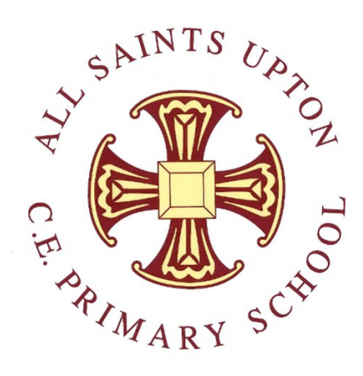

SPRING 2025

Signed…………… Date ……………..
Signed……….…. Date……………..
Signed………….. Date……………..

Introduction
- This policy is intended to describe the aims, principles and strategies for the teaching and learning of PSHE at All Saints Upton C.E Primary School
- It was created in Autumn 2019 using knowledge of previous policies, guidance from the PSHE association and through consultation with staff, and was presented to the Governing Body.
- The policy will be reviewed in line with the School’s Development Plan.

Our personal, social and health education (PSHE) programme promotes children's personal, social and economic development, as well as their health and wellbeing. It helps to give children the knowledge, skills and understanding they need to lead confident, healthy, independent lives and to become informed, active, responsible citizens. At All Saints Upton, children’s wellbeing, happiness and safety are our first priority, and PSHE is the key vehicle through which we share this with children. We regard PSHE as an important, integral component of the whole curriculum; it is central to our approach and at the core of our ethos.
Our PSHE curriculum is broad and balanced, ensuring that it:
♦ Promotes the spiritual, moral, cultural, mental and physical development of our children and of society;
♦ Prepares our children for the opportunities, responsibilities and experiences they already face and for adult life;
♦ Provides information about keeping healthy and safe, emotionally and physically;
♦ Encourages our children to understand how all actions have consequences and how they can make informed choices to help themselves, others and the environment.
Aims
For children to:
Health & Wellbeing
• Know and understand what constitutes a healthy lifestyle.
• Know how to maintain physical, mental and emotional health and wellbeing.
• Be aware of safety issues, including how to respond in an emergency.
• Know how to manage change, including puberty, transition and loss.
Relationships
• Develop and maintain a variety of healthy relationships within a range of social and cultural contexts.
• Know how to recognise and manage emotions within a range of relationships.
• Know how to recognise risky or negative relationships, including all forms of bullying and abuse, and ask for help.
• Know how to respect equality and diversity in relationships.
Living in the Wider World
• Know the importance of responsible behaviours and actions
. • Be responsible and independent members of the school community.
• Be positive and active members of a democratic society.
• Know about the importance of respecting and protecting the environment.
• Develop self-confidence and self-esteem and make informed choices regarding personal and social issues.
• Develop good relationships with other members of the school and the wider community.
• Know about where money comes from, keeping it safe and the importance of managing it effectively.
• Have a basic understanding of enterprise.
Organisation / Provision
PSHE is delivered within a whole school approach which includes:
♦ Weekly teaching sessions following a bespoke scheme of work
♦ Teaching PSHE through and in other subjects /curriculum areas
♦ Circle Time
♦ Specialised assemblies
♦ PSHE activities and school events e.g. Wellbeing Week
♦ Pastoral care and guidance
♦ Visiting speakers
As a school we use the PSHE Association planning toolkit and while making this specific for our school and our children. This is an explicit, structured, whole-curriculum framework for teaching social, emotional and behavioural skills to children, to aid our delivery of PHSE. The planning has been adapted by staff so that there is progression throughout the school. This progression document can be seen upon request.

Relationships within School
Relationships at All Saints Upton are based on an atmosphere of trust and respect for everyone, taking our Christian values from our vision. Children are encouraged to develop good relationships with their peers and all staff and to take responsibility for their own behaviour. All staff provide very good role models for children and work hard to promote a safe, happy environment. The children have an active School Council where children from each class are elected to represent the class’s views.
Assessment and Recording
Children are informally assessed by staff throughout their work. Recording of work will be in a form appropriate to the planned focus. Evidence of PSHE will be in a variety of forms e.g. photographs as well as written work, and recorded in the class PSHE book.
Role of the Subject Leader
Aspects of this will include:
Keeping up to date with developments in PSHE education, leading CPD and providing support to staff as needed.
Writing a yearly action plan, and being proactive in carrying it out.
Having an overview of PSHE resources.
Reporting to School Governors as appropriate.
Leading staff meetings and parent workshops.
Monitoring and evaluation, along with other members of SLT.
Assessing progress using pupil voice.

Parents
Parents are important influences on pupils’ attitude and attainment. We actively encourage and involve them in school life by:
Encouraging parents to think about talking to their children about PSHE.
Providing feedback to the school when requested.
Inclusion and Equal Opportunities
This policy has been considered to give due regard to the three principles of the Equalities Act
- Eliminate discrimination, harassment, victimisation and any other conduct that is prohibited by or under this act;
- Advance equality of opportunity between persons who share a relevant protected characteristic and persons who do not share it;
- Foster good relations between persons who share a relevant protected characteristic, and persons who do not share it.

We are committed to:
Eliminating discrimination and harassment
Promoting equality of opportunity
Promoting good relations and positive attitudes towards all people

All pupils have equal access to the curriculum regardless of their race, sex, religious belief or ability.
This policy is linked to the school’s RSE policy, our School Ethos and vision and our Christian and British values.
Policy written by: Jeanette McCann ( Head)
Adopted by Governors:
To be reviewed: September 2026

