Personal, Social & Emotional Development
- Learn about keeping safe in the sun
- Continue to manage own basic hygiene and personal needs.
- PSHE unit- Growing and changing.

Communication, Language and Literacy
- Write instructions for planting seeds
- Listen carefully to stories and respond with relevant questions, comments or actions.
- Label stages of different life cycles
- Write shopping lists, cards and invitations
- Daily Read Write Inc groups
- Read a range of non-fiction books
- Predict events in stories.
- WellComm sessions focusing on specific speech and language elements
- Daily handwriting sessions
- Build and retell stories using Mighty Writer
-Take part in P4C lessons, voting yes or no and debating ‘would you rather…?’ questions.

Mathematical Development
Follow the Mastering Number scheme to practise these skills…
- Subitising arrangements within 10 which show 1 more or doubles.
- Counting to 20 and beyond, starting from different numbers.
- Exploring the composition of 10
- Ordering sets of objects.
Use White Rose Maths to…
- Match and replicate shapes
- Find shapes within other shapes
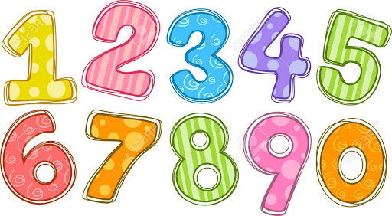



Summer 1

Growth and Change…
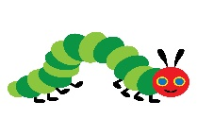



R.E
Our Special World
What is special about our world?
Learn about the story of the creation in Genesis and Allah’s creation.



Expressive Arts and Design
- Take part in weekly music lessons following the KAPOW scheme.
- Develop storylines in their pretend play.
- Observational drawings
- Creating symmetrical patterns to make butterfly wings
- Use role play to re-enact some of the life cycle stages.
- Make life cycle crafts
Follow KAPOW scheme for this half term’s DT unit- Food: Soup.

Physical Development
Follow the Get Set 4 PE scheme of work for this half term’s topic
GAMES to develop the following skills…
- Running
- Balancing
- Changing direction
- Throwing
- Catching
- Jumping





Home Links
Go on a walk and see if you can find some signs of spring. Take photos or draw and label the things that you find.
Understanding the World
- Grow beans and sunflowers
- Observe the stages of a caterpillar becoming a butterfly
- Learn about the life cycle of a frog and a flower
- Match baby animals to adult animals and name them
- Take photos of the stages of a butterfly’s life cycle
- Create butterfly pictures using ICT
- Name different types of spring flowers
- Name the different parts of flowers

Key Texts
The Crunching Munching Caterpillar, Oliver’s Vegetables, The Teeny Weeny Tadpole, Jack and the Beanstalk, The Tiny Seed

