Reception Knowledge Organiser: Spring 2
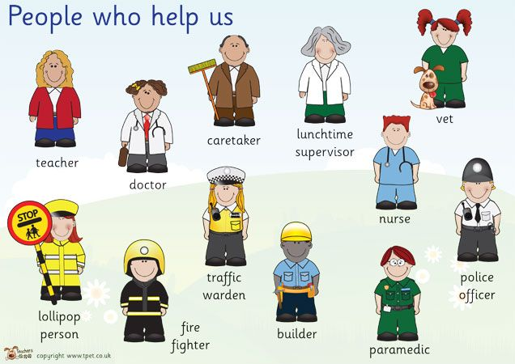
Superheroes
Key vocab
Job Helper Balanced diet Fruits and vegetables Costume
Superhero Villain Superpower Rescue Qualities
Disguise Bravery Healthy Resilience Gadgets

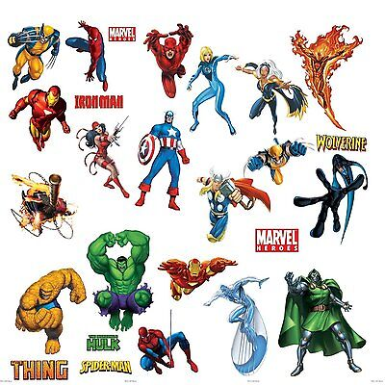
Key facts
- Superheroes usually wear costumes as a disguise.
- Superheroes have different types of superpowers such as invisibility or great strength.
- Superheroes are often brave and show resilience.
- Superheroes save people from baddies!
- There are lots of real-life superheroes, such as doctors, postal workers, nurses, fire fighters etc and they all have very different (but important!) jobs.
- We can all have superhero qualities, even if we can’t fly!
- We must brush our teeth twice a day to keep them healthy.
- Superheroes eat a balanced diet with lots of fruit and vegetables to keep them strong, fit and healthy.
- We must keep ourselves safe by thinking carefully about what goes in/ on our bodies, using the internet sensibly and knowing who helps to keep us safe.

