
Reception Knowledge Organiser
Spring 1- Once Upon a Time
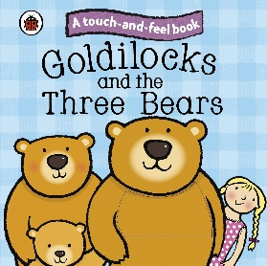
Definitions
Traditional Tale | A tale that has been retold over many years.
Character | A person or animal in a story.
Hero/ heroine | The main character in a story who is usually good and well liked.
Villain | The opposite character to a hero who is usually mean, nasty or evil.
Setting | Where the story is taking place.
Fiction | Stories that describe imaginary people and events.
Old/ New/ Past

Key Facts
- Materials can change consistency/ appearance/ texture when they are baked or when water is added.
- Homes have changed over time.
- Every story has a beginning, a middle and an end.
- Traditional tales have been retold by lots of different people so there will be different versions of the same story.
- Traditional tales have been around for a long time so some objects/ characters that we see in the pictures or read about in the text may differ from our current lives.
- Traditional tales have been around for a long time and characters have changed (Little Red Riding Hood)
