
Reception Knowledge Organiser
Autumn 2- Sparkles and Celebrations
Key vocab
Celebration Fireworks Gathering
Traditions Party Festival Nativity
Special Guy Fawkes Diwali
Cards Gifts Invitations
Rangoli Patterns Mehndi Patterns
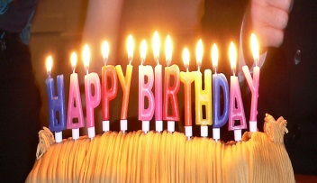
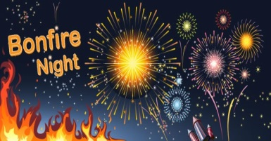

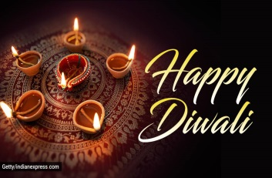
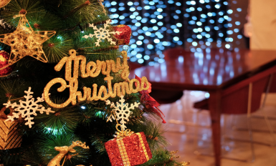

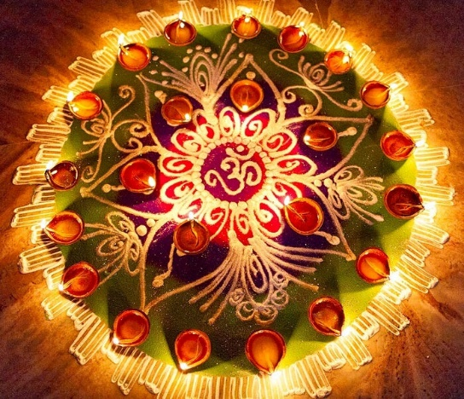
Key facts
- We have celebrations for special events.
- Different religions have different special events.
- Diwali is the Hindu festival of lights.
- Christmas is a Christian celebration of the birth of Jesus.
- We celebrate Bonfire Night to remember the story of Guy Fawkes.

