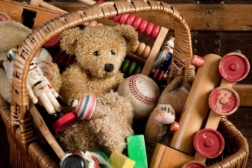Reception Knowledge Organiser

Autumn 1- Being Me

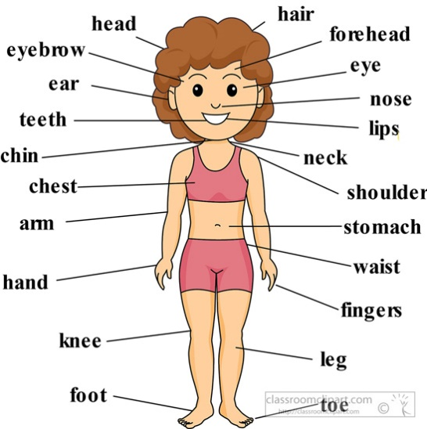

**Key vocab**

same different humans like/ dislike

families body body parts organs

old/ new baby toddler child teenager

adult elderly change a long time ago…

**Key facts**

* None of us are exactly the same- we have similarities and differences in terms of how we look and the things we like/ dislike.
* I have my own family and it may be different from my friend’s family.
* My body has lots of very important parts, both on the inside and the outside.
* The toys that my parents/ grandparents used to play with are different to the ones that I play with now.
* We all start off as babies, then we become toddlers, children, teenagers, adults then elderly.