viki | Autumn 1 | Autumn 2 | Spring 1 | Spring 2 | Summer 1 | Summer 2
Consolidation | - Conjunctions  - Paragraphing  - Basic punctuation  - Using tenses  - Commas to separate items in list  - Aptness of vocabulary  - Linking ideas across paragraphs |  | - Cohesive devices  - Correct subject-verb agreement  - Parenthesis  - Dialogue within narratives  - Devices to build cohesion  - Modal Verbs for possibility |  | - Relative pronouns/clauses  - Correct use of punctuation including commas for clarity  - Narrative and non-narrative devices  - Speech within narrative  - Ensure accurate sentence demarcation
Class Novel | 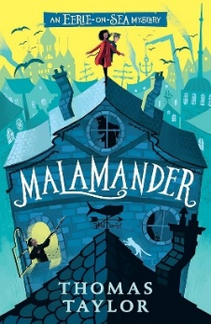 | 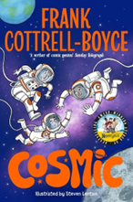 | 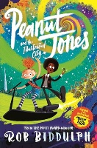  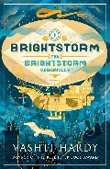 | 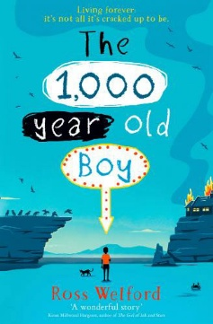 | 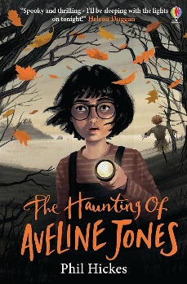 | 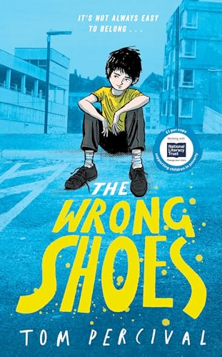
Texts | 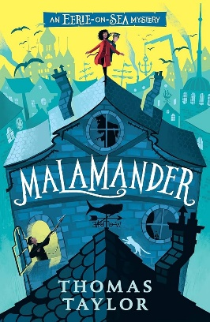 | 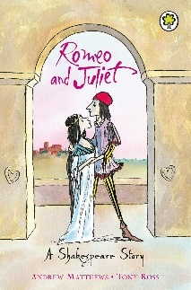  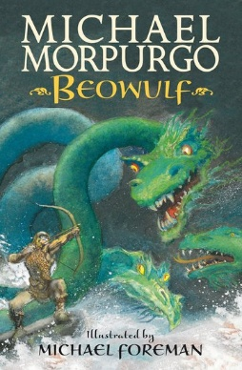 | 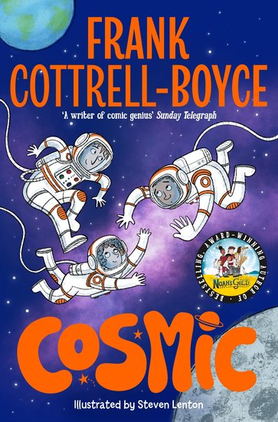  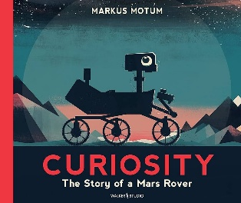 | 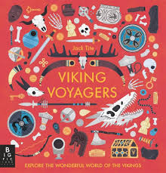 | 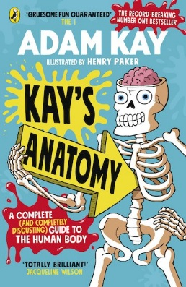 | 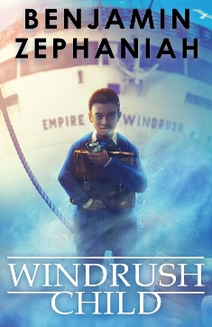  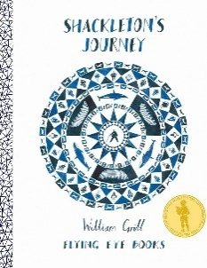
Writing Outcomes | 1. BASIC SKILLS WEEK – AIM: Revise and build component knowledge required to access current year group’s grammar objectives.  TASK: Review of previous year groups’ grammar knowledge using class Novel as stimulus.  2. Factual/Persuasive Report on Manchester (3 Weeks)  Text: The Big Book Of the UK by Imogen Russell Williams/ other non-fiction books.  Outcome: to write a Factual and persuasive report on Manchester relating to geographical content covered (e.g. double page spread, diagram of layers surrounded by text etc).  R – to inform kind our readers all about Manchester and its diversity.  A – other children in the school who read the ‘non fiction’ page- to be put in the library/displayed.  F – opening statement describing purpose, conclusion providing summary, organisational features including visual layout, captions, pictures, subheadings, fact box. mainly third person, some cohesive devices within and between paragraphs e.g. topic sentences, subordination using higher level conjunctions.  T – formal, informative, factual  GDS- add diagrams and display information in a range of formats  3. Narrative Setting Description within Journal Entry (3 Weeks)  Text: Malamander by Thomas Taylor  Outcome: Create a setting description of Eerie-on-Sea from the viewpoint of either Herbie or Violet (or both). Consider the feelings of the character to depict the setting through their eyes.  R- to understand the viewpoint of the characters in the book.  A – Send to the Author  F- devices to build cohesion within paragraphs, first person form consistent, pronouns to aid cohesion, select appropriate grammar and vocabulary, understanding how such choices can change and enhance meaning, use of dashes or commas to indicate parenthesis, use of commas to clarify meaning or avoid ambiguity  T- empathetic, understanding ,in the style of the characters. | 1. Romeo and Juliet Narrative re-Tell (3 Weeks)  Text: Children’s adaptation by Tony Matthews  Outcome: Modernisation of the fight scene with Tybalt and Mercutio.  to write a retell of the story, with the main characters' interactions in the present day.  R – to adapt style and form to audience.  A – our peers/ families (performing).  F – build tension and atmosphere, make precise word choices for effect, vary sentence length and structure for effect (include short sentences), integrate dialogue, beginning to use it to advance the action and convey different characters, beginning to understand how register will change between speaking and writing.  T – suspenseful.  GDS – use slang and maintain voice.  2. Poetry – Sonnet (1 Week)  Poetry Outcome: write a rap retelling the story of Romeo + Juliet  Input to include a study of Shakespeare’s poetry and sonnets.  R - to entertain and show understanding of story  A - perform for year 6  F – similes, metaphors, alliteration, repetition, powerful verbs and adjectives, figurative language to include onomatopoeia and personification.  T - fun, modern, engaging  GDS- write in the style of the time integrating old fashioned terminology.  3. Beowulf Narrative re-telling (3 Weeks)  Texts: Michael Morpurgo and Michael Foreman/ Monster Slayer: A Beowulf Tale by Brian Patten and Chris Riddell  Outcome: to retell the story of how Beowulf slayed Grendel and create their own Beowulf story.  R – to entertain our audience and introduce them to traditional English myths and legends.  A – children who visit the school library.  F - appropriate tense dependent on narration/speech, range of conjunctions, prepositions and adverbials, correctly punctuated dialogue to move the action on, beginning to show some cohesion between paragraphs, use of pronouns for clarity, building tension,  T – mirror the text, heroic, good conquers evil.  GDS – use the setting and plot points to build tension over time. | 1. Narrative with dialogue (3 Weeks)  Text: Cosmic- Frank Cotterell-Boyce  Outcome: write a scene from the book before reading to use own suggestions for what might happen.  R - to entertain our audience and build a sense of suspense, encouraging them to read similar texts.  A – Year 5 partners  F - describe atmosphere, make precise word choices for effect, use some figurative language, vary sentence length and structure for effect (include short sentences), integrate dialogue, beginning to use it to advance the action.  T – suspenseful, frightening.  GDS – write from a different perspective.  2. Labelled diagram alongside an explanation text (3 Weeks)  Text: Curiosity—A Mars Rover story  Outcome: Generate an explanation text as a group to label the features of the Mars Rover: Curiosity  R – To showcase the technical abilities of the Mars Rover design.  A – Year 4 who will learn about space next year/ parents showcase/ Class book  F- Introduction, main paragraphs, summary. Third person, present tense, technical vocabulary, subordination, fronted adverbials to vary sentence starters and introduce topic sentences, variety of sentence structures, pronouns and synonyms for cohesion, relative clauses.  T – Formal, technical, scientific  GDS – Write own version using the content aimed at adults  Poetry – Blackout Poetry (1 week)  Text: Once Upon a Star: The Story of Our Sun by James Carter and Mar Hernandez  Outcome: to use a range of texts about space to create our own blackout poems.  R – to entertain our audience and experiment with language.  A – Jodrell Bank staff.  F – effective word choice, description, technical vocabulary, noun phrases and expanded noun phrases, use of prepositions.  T – children’s choice.  GDS – use a number of different texts to construct their blackout poem, explaining their reasoning for their word choices. | 1. Letter (3 Weeks)  Text: The 1000-year old Boy by Ross Welford  Outcome: Write an informal letter as Alfie after the fire destroys his home. Include a farewell to his Mam, acknowledging her death and including memories from his childhood as a Viking and his new life in the 21st Century .  Incidental write: Life as a Viking  R- to reflect on Viking life in comparison to that of today.  F- Use devices to build cohesion, range of punctuation, commas to clarify meaning, apostrophes for possession. First person, use of personal reflection through subordination and parenthesis. Relative clauses.  T- personal, informal, heartfelt  GDS – Write letter from Mam to Alve that he has found in the ashes telling him that she forgives him and sharing the fond memories she has of their lives together.  2. Factual Report (3 Weeks)  Text: Viking Non-Fiction Texts such as The Penguin Historical Atlas of the Vikings or Viking Voyagers  Outcome: apply skills independently from Autumn 1 unit in a more informal style of a magazine article.  R – to inform kind our readers all about The Vikings – focusing on one aspect to create a class magazine.  A – other children in the school who read the ‘non fiction’ page- to be put in the library/displayed.  F – opening statement describing purpose, conclusion providing summary, organisational features including visual layout, captions, pictures, subheadings, fact box. Mainly third person, Linking ideas across paragraphs using adverbials of time [for example, later], place [for example, nearby] and number [for example, secondly] or tense choices [for example, he had seen her before]  , parenthesis using brackets, modal verbs for possibility  T – chatty magazine style, engaging and interesting.  GDS- add diagrams and display information in a range of formats | 1. Story - Suspense (3 weeks)  Text: The Haunting of Aveline Jones by Phil Hickes  Outcome: to create their own version of ‘The Lady in the Waves’ ghost story from Aveline’s book.  R – to entertain our audience with our own ghost story.  A – children in Year 6.  F – appropriate tense dependent on narration/speech, range of conjunctions, prepositions and adverbials, correctly punctuated dialogue with some character conveyed, use of pronouns for clarity, building tension, focus on suspense and atmosphere through short sentences, pathetic fallacy etc.  T – tense and suspenseful.  GDS – experiment with using a range of sentence types and forms to add to the atmosphere.  2. Explanation – human life cycle (3 Weeks)  Text: Kay’s anatomy by Adam Kay  Link text: DK everything from start to finish  Outcome: to write an explanation text which explains the development of a human.  R - to explain the human life cycle  A – teachers in lower year groups to use to help them about the human life cycle.  F – clear, logical steps in chronological order, technical vocabulary, use devices to build cohesion within and between paragraphs, use commas for parenthesis, consider the visual design of the overall text to support clarity and engagement for the audience, e.g. diagrams, flowcharts.  T – informative and clear.  GDS – include real quotations from scientists/apiarists in speech bubbles with accurate punctuation.  3. Poetry- Personification Poetry – written and oral outcome (1 week)  Text: A Miracle to Behold by Patricia Fleming  https://www.familyfriendpoems.com/poem/a-miracle-to-behold  Outcome: to write and perform their own short personification poem focused on the weather, with a choice of a sunny day, a stormy night or wintery morning.  R - to write a personification poem and create a class anthology.  A – school library visitors  F – personification, writing in verses, precise choice of language including abstract nouns, absence of rhyming, varied sentence types/phrasing for effect.  T – dependent on choice and personal opinions.  GDS – children to choose whether to evoke a positive or negative feeling about the weather in their poem and make careful language choices to suit that choice. | 1. Journal Entry about coming to England as a Windrush migrant (2 Weeks)  Text: Windrush Child by Benjamin Zephaniah  Outcome: Create own series of journal entries that showcase what life was like before coming, once arrived, and once settled in England.  R - Compare life in England to Trinidad and how hard it was for migrants.  A – Parents and fellow community with links to Windrush heritage (invite in)  F – First person, informal style, use of relative clauses, references to dialect and culture, subordination, range of sentence openers and cohesive devices to vary sentence types for the reader. Use of parenthesis using brackets and ellipsis. Modal verbs for possibility.  T – Personal, honest, explains.  2. Shackleton’s Journey  Letter of application (2 Weeks)  Debate – dogs (1 Week)  Journal/ news report (2 Weeks)  Text: Shackleton’s Journey by William Grill / The lost book of adventure by the Unknown Adventurer  Outcome 1 Letter: write a detailed job advert and the letters of application  R- to apply for a role in the crew on the ship  A- Peers- hold job interviews  F – first person, introduction stating aims, paragraphs – each one including a key point and discussion around it, evidence, and statistics to back up points, emotive language, adverbials to extend arguments/points, modal verbs, degrees of possibility. Formal letter layout and language features.  T- clear, detailed, in the style of the time.  GDS - formal application details providing CV-style page of previous experience  Outcome 2: Journal entries of crew v Shackleton himself  R- To show the leadership of Shackleton and empathise with the crew  A – Historical Society/Magazine  F – First person, secure use of taught punctuation, cohesive devices, relative clauses, subordination, language of the era, parenthesis, modal verbs to indicate possibility, Feelings and thoughts related content.  T – Informal with historical perspective, emotive, insightful.  GDS- show contrast in formality and character of Shackleton as leader in position of responsibility.  Outcome 3: Oral debate on if the dogs should have been killed.  Using a structured approach with sentence stems to support, share ideas for the two sides of the argument and share out the roles to pupils. Create a text with own perspective and possible counter arguments.  R - To debate a contentious topic  A- Other class/pupils in Y5 within debate  F- Persuasive language, conjunctions to structure arguments, sentence structures to introduce points, technical language related to the historical context, polite disagreement and contest, formal language including subordination, short sentences for effect, clear explicit reasoning and explanation.  T- Informative, forceful, polite, evidenced.  GDS- Take on role of the chairperson.  3-Day Transition TASK:  Outcome: Write a letter of application to be in Year 6 telling the new teacher all about the your assets as a pupil.  R- To introduce yourself to your new teacher  A- New teacher  F- (As above)first person, introduction stating aims, paragraphs – each one including a key point and discussion around it, evidence, and statistics to back up points, emotive language, adverbials to extend arguments/points, modal verbs, degrees of possibility.  T – polite, engaging, funny, honest

