 | Autumn 1 | Autumn 2 | Spring 1 | Spring 2 | Summer 1 | Summer 2
Consolidation | - Basic punctuation - applied  - Conjunctions – variety and used in context  - Correct tenses  - Paragraphing – cohesion within and across  - Aptness of word choices/vocabulary  - Handwriting – legibility  - Paragraphing  - Cohesive technique |  | - Relative clauses  - Parenthesis  - Dialogue within narrative  - Colons, semi-colons and dashes  - Active vs passive  - Hyphens to avoid ambiguity  - Bullet points to list |  | - Ellipsis  - Synonyms and antonyms  - Linking ideas across paragraphs using a wider range of cohesive devices
Class Novel | 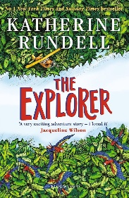 | 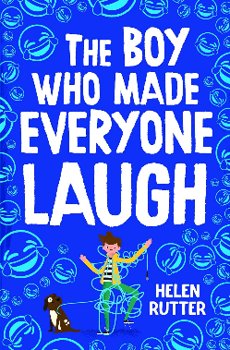  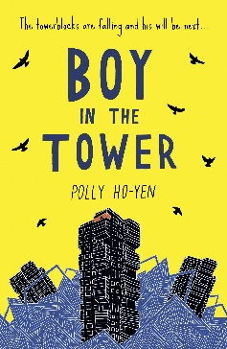 | 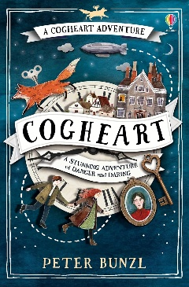  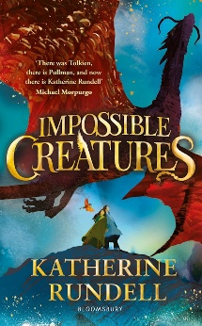 | 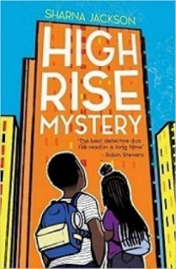 | 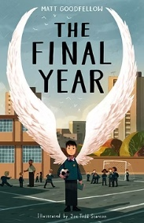 | 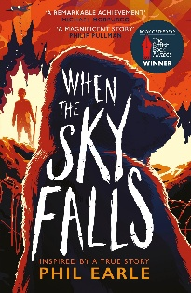  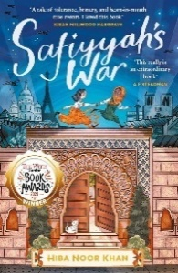
Texts | 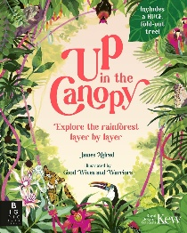    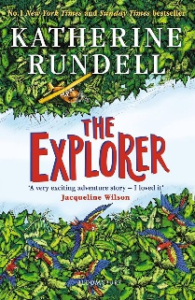  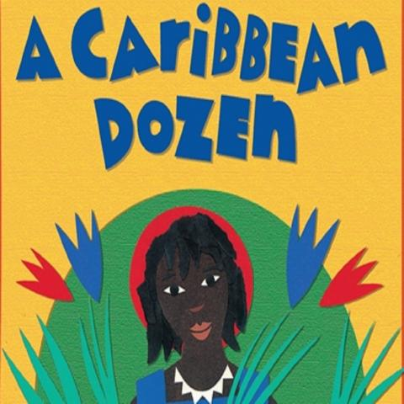 | 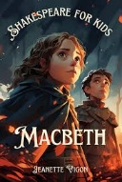  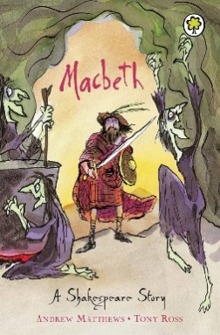  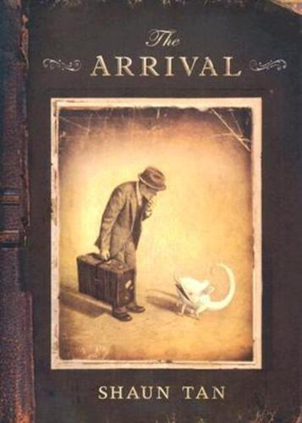 | 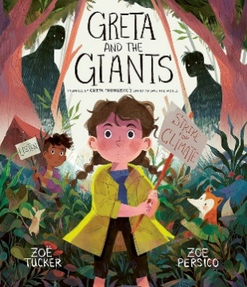  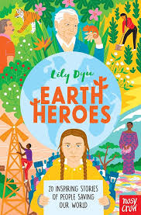  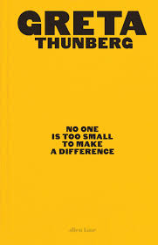 | 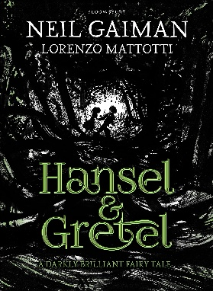  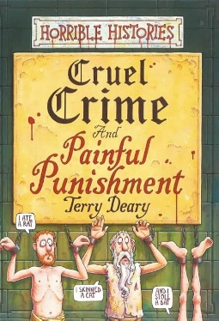  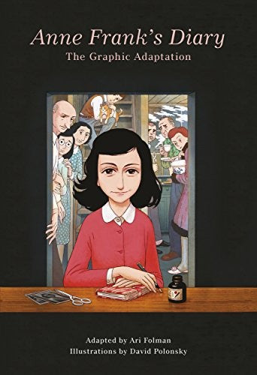 | 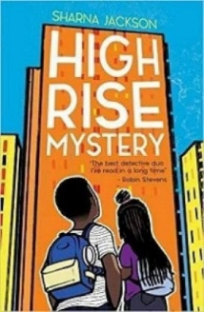  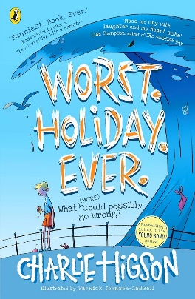 | 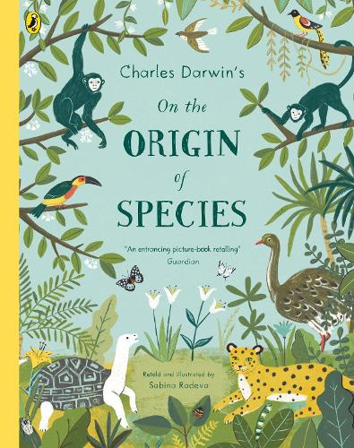  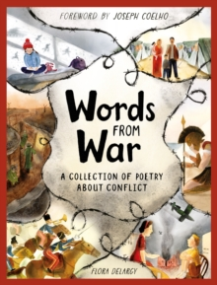  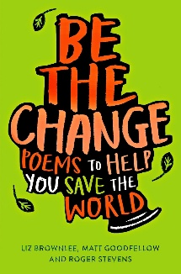  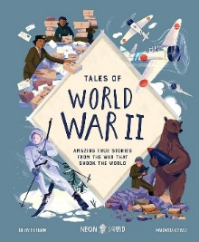
Writing Outcomes | 1. BASIC SKILLS WEEK – AIM: Revise and build component knowledge required to access current year group’s grammar objectives.  TASK: Review of previous year groups’ grammar knowledge using class Novel as stimulus.  2. Report (3 weeks)  Text: Up in the Canopy: Explore the Rainforest, Layer by Layer by James Aldred and Good Wives and Warriors  Outcome: to write a magazine report on the children’s choice of rainforest, considering how the information is presented on the page (e.g. double page spread, diagram of layers surrounded by text etc).  R – to inform our readers about a rainforest we find interesting and show our learning.  A – other children in the school who read our class magazine.  F – opening statement describing purpose, conclusion providing summary, organisational features including visual layout, mainly third person, some cohesive devices within and between paragraphs e.g. repetition of a word or phrase, parenthesis.  T – chatty magazine style, engaging and interesting.  GDS – choose their own audience and publication for the report, e.g. website.  3. Story – Focus on Setting and Characterisation through Dialogue (3 weeks)  Text: The Explorer by Katherine Rundell  Outcome: To write a re-tell of the section where the children travel down the Amazon to try to find the location on the map.  (before reading this section)  R – to entertain our reader and paint a picture of the varied settings in the story.  A – Year 4 children  F – make precise word choices for effect, use figurative language, vary sentence length and structure for effect (include short sentences), integrate dialogue, beginning to use it to advance the action and develop characterisation, subject, object.  T – mirror the text with a contrast between the two parts of the story.  GDS – focus on building contrasting characterisation for different characters through dialogue.  4. POETRY (1 Week)– study a poem written in dialect to find out how the author has used dialect to personalise their poem’s meaning.  https://clpe.org.uk/poetry/poems/forest  R – to entertain our audience and share our emotions and reflections on a topic important to us * Decide on relevant topic for poems related to deforestation of Amazon or local issue?  A – school assembly.  F – powerful vocabulary choices chosen for effect, range of sentence types and forms for effect, words learned by heart, appropriate prosody, pitch, volume, intonation, and expression.  T – passionate but tone dependent on issue chosen.  GDS – consider how their word choices can emphasise their passion and emotion about the issue. | Macbeth Units  1. Poetry – Fire Burn and Couldron Bubble – Shakespeare (1 Week)  Outcome: Study the witches’ poem and chant and create their own verse to perform to the rest of the class.  R- To understand the role of the Witches in Macbeth  A- The parallel class- drama performance audience  F- poetic language, follow rhyming style, synonyms and antonyms, create the message of the characters, deliver with precision and timing accuracy, project voice and work as a team.  T – Sinister, plotting.  GDS- Write a different version of the poem with their own rhyming pattern.  2. Persuasive Letter (3 weeks)  Text: Macbeth (Adpated version) Andrew Matthews (Author)  Outcome: To write a persuasive letter from Lady Macbeth to inspire Macbeth to greatness through malicious acts. + mini writes  R- to write in role, to entertain as Shakespeare did  A - RSC / authors / classmates/parents (Teacher choice)  F- first person, introduction stating greeting and congratulations, paragraphs – each one including a key point and discussion around it, modal verbs, hinting at the future using chosen word choices, rhetorical questions, persuasive and emotive language, semi colon to mark clause boundary, adverbials to extend arguments/points, relative clauses, modal verbs, degrees of possibility.  T- Manipulative- highlighting the formality.  GDS- write in the style of the time using phrases  3. Re-tell Story – write the next part of the story developing the narrative  Text: The Arrival – Shaun Tan  Mini-task write the letter from the Dad back to the pupils.  R – To create a written version of the picturebook text for readers.  A – Display text alongside pictures for rest of school to see.  F – third person, a range of verb tenses- Progressive tense and present perfect, using brackets, dashes, or commas to indicate parenthesis, sentence length/structure for effect, precise longer passages, describe settings, and atmosphere, integrated dialogue conveying character and advancing the action, cohesive devices within and across paragraphs.  T – Gentle, thoughtful and with feeling.  GDS – Write in the first person as the father including his feelings around the events. | 1. Biography (2 weeks)  Text: Earth Heroes by Lily Dyu  Outcome: to write a biographical narrative of a climate change activist (children’s choice) including information about the cause they champion.  R – to teach our Eco Council more about climate change and the power of being an activist.  A – Eco Council  F – third person, a range of verb tenses and consistency moving between them, using brackets, dashes, or commas to indicate parenthesis, sentence length/structure for effect, precis longer passages, cohesive devices within and across paragraphs.  T – informative, descriptive, passionate.  GDS – choose the genre/format they are writing, e.g. newspaper article, website content.  2. Poetry – Spoken Word Poetry – written and oral outcome (1 week)  Texts: Be The Change: Poems to Help You Save the World by Roger Stevens, Matt Goodfellow and Liz Brownlee  We Can Be More by Solli Raphael https://www.youtube.com/watch?v=lm0r3yFh0zU  Outcome: to compose and perform their own spoken word poem on an issue of their choice (link to persuasion unit).  R – to entertain our audience and share our emotions and reflections on a topic important to us.  A – school assembly.  F – powerful vocabulary choices chosen for effect, range of sentence types and forms for effect, words learned by heart, appropriate prosody, pitch, volume, intonation, and expression.  T – passionate but tone dependent on issue chosen.  GDS – consider how their word choices can emphasise their passion and emotion about the issue.  3. Narrative with Dialogue (3 Weeks)  Text: Hansel and Gretel by Neil Gaiman  Outcome: Write the scene where the Witch is put in the boiling pot  R- To develop characters through dialogue to entertain reader  A – Parents  F – appropriate tense dependent on narration/speech, range of conjunctions, prepositions and adverbials, correctly punctuated dialogue to move the action on, beginning to show some cohesion between paragraphs, use of pronouns for clarity, building tension,  T – Suspensful and intriguing  GDS – offer an alternative perspective for the possible injustice of the situation within the narrative. | 1. Non-Chronological Report/Explanation (3 Weeks)  Text- Cruel Crime and Painful Punishment (Horrible Histories)  Outcome: To write an explanation with factual content about the crime and punishment for a particular ‘era’ linked to their History topic.  R – to write a  A – Used within learning exhibition at end of topic.  F – opening statement describing purpose, conclusion providing summary, organisational features bullet points, captions, pictures, subheadings, fact box. Mainly third person, some cohesive devices within and between paragraphs, parenthesis.  T – informative, formal, structured.  GDS – Develop the structure of the text to include relevant reports or facts sourced through research.  2. Story with Dialogue and Characterisation (3 weeks)  Text: Anne Frank’s Diary: The Graphic Adaptation by Anne Frank and David Polonsky  Outcome: To write story excerpts focused on integration of dialogue, retelling the story of Anne Frank from the graphic adaptation.  R – to entertain and capture our audience’s interest into the story of Anne Frank.  A – another Year 6 classes – to peer read our finished work with.  F – to tell the story from Anne’s point of view, third person, using brackets, dashes, or commas to indicate parenthesis, varying active/passive voice and sentence length/structure for effect, precis longer passages, describe settings, character and atmosphere.  T – entertaining, dramatic, suspenseful  GDS: focus on shifts in formality between characters. Incorporate other text types into narrative (e.g. diary, letter). | 1. Story – Continuing the Story with a Focus on Dialogue (3 weeks)  Text: High Rise Mystery by Sharna Jackson  Outcome: to write a continuation of the beginning of the story, with the main characters discovering and beginning to try and solve their own choice of mystery.  R – to share our own ideas for mystery stories.  A – the author.  F – build tension and atmosphere, make precise word choices for effect, vary sentence length and structure for effect (include short sentences), integrate dialogue, beginning to use it to advance the action and convey different characters, beginning to understand how register will change between speaking and writing.  T – suspenseful.  GDS – include case notes and communication excerpts to show an understanding of register.  2. Complaint Letter (2 weeks)  Text: Worst. Holiday. Ever by Charlie Higson  Outcome: To complain about a holiday from the perspective of a disgruntled customer and write a Trip Advisor style review  R – to complain about a disappointing experience.  A – hotel manager.  F – sender’s address on the top right, recipient’s address on the left, date on the right, formal greeting, introductory paragraph explaining who the writer is and why they’re writing, messages organised into paragraphs, concluding paragraph, rhetorical questions, second person pronouns, exclamations, formal sign off, effective vocabulary choices, passive voice, subjunctive form, progressive tense, use of bullet points.  T – formal, emotive, direct.  GDS – to write the response from the hotel manager.  3. Optional tasks for additional assessment/moderation content:  1) One Story, Many Tellings:  Wriitng about an event from three different perspectives  And/or  2) Character description in the form of describing a teacher from a child’s and ofsted inpectors contrasting perspectives.  3) Re-tell part of the story in narrative form from The Final Year  4) Book Review  5) Author Biography | 1. Journal (2 weeks)  Text: Charles Darwin’s on The Origin of Species by Sabina Radeva  Outcome: to write a journal as Charles Darwin on The Beagle  R – to understand Charles Darwin’s motivations, thoughts, and emotions on visiting the Galapagos Islands.  A – children in Year 5  F – focus on describing the important events and reflecting on them using emotive language, use a range of tenses consistently, make precise language choices based on the writer’s voice, use relative clauses, a range of cohesive devices within and between paragraphs, hyphens, bullet points, colon to introduce list and semi colons within list.  T – amazed and surprised.  GDS – include an excerpt of a letter recounting his voyage to either a young relative (more informal) or his financial backer (more formal).  2. Poetry – (2-3 Weeks)  Text: Words from War Anthology - Flora Delarcy and Saffiyah’s War by Hiba Noor Khan  Outcome: Write own war- poem linked to Saffiyah’s War by Hiba Noor Khan having studied a range of poetry inspired by War.  Additional Texts: Be The Change: Poems to Help You Save the World by Roger Stevens, Matt Goodfellow and Liz Brownlee  We Can Be More by Solli Raphael https://www.youtube.com/watch?v=lm0r3yFh0zU  Outcome: to compose and perform their own spoken word poem on an issue of their choice  R – to entertain our audience and share our emotions and reflections on a topic important to us.  A – school assembly.  F – powerful vocabulary choices chosen for effect, range of sentence types and forms for effect, words learned by heart,  appropriate prosody, pitch, volume, intonation, and expression.  T – passionate but tone dependent on issue chosen.  GDS – consider how their word choices can emphasise their passion and emotion about the issue.  3. Transition Task -  Non-Fiction/Persuasion  Generate own text model.  Outcome: Write a survival guide for future Y6 pupils that reflects on their development as pupils over their time at Ashbury Meadow.  R - To inform Y5 pupils as to what to expect in Y6 to support transition and future success whilst to reflect on their learning journey as they leave the school.  A- Leavers’ assembly audience  F- focus on describing the important events and reflecting on them using emotive language, use a range of tenses consistently, make precise language choices based on the writer’s voice, use relative clauses, a range of cohesive devices within and between paragraphs.  T – Honest, reflective, technical, detailed.  GDS- pupils reflective piece could take the form of a poem or letter to say thank you.

