 | Autumn 1 | Autumn 2 | Spring 1 | Spring 2 | Summer 1 | Summer 2
Consolidation | - Basic punctuation (A . ! ?)  - Writing makes sense  - Tenses  - Understanding statements, questions and exclamations  - Commas in lists  - Expanded noun phrases, use of comma  - Aptness of word choices  - Contractions |  | - Adverbs  - Subordination  - Prepositions  - Paragraphs  - Prefixes and suffixes  - Inverted commas for speech |  | - Fronted adverbials  - Apostrophes for plural possession  - Speech punctuation  - Narrative devices
Class Novels | 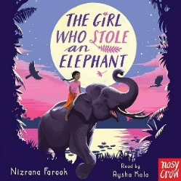 | 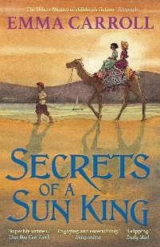 | 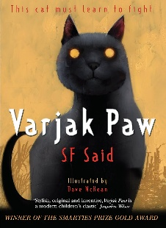 | 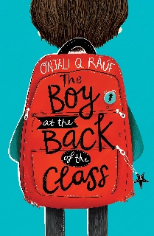  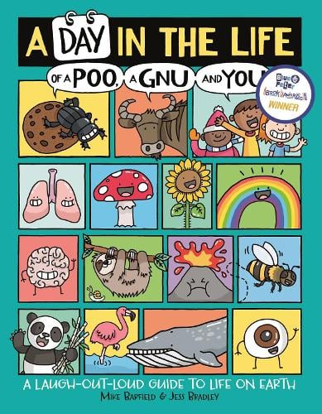 | 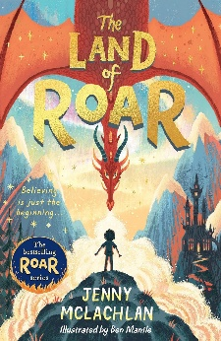 | 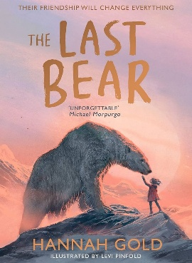
Texts | 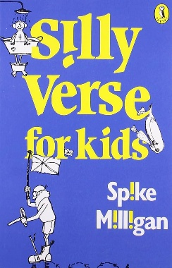  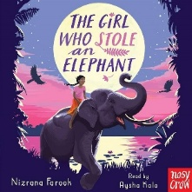 | 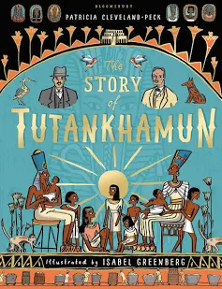  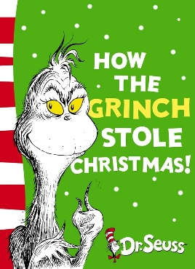  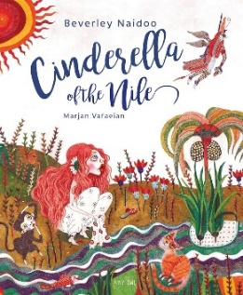 | 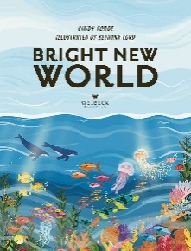  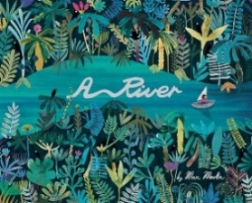  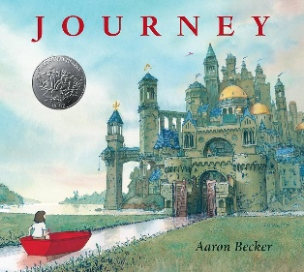 | 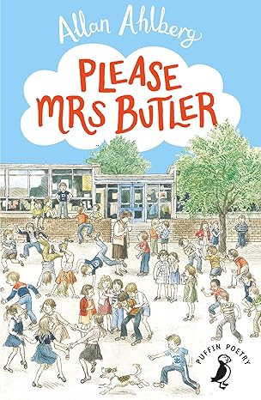  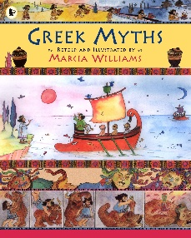 | 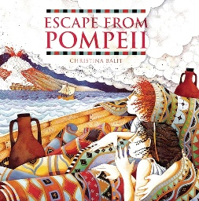  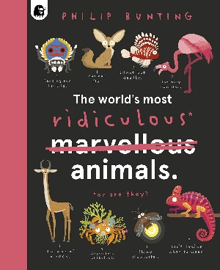 | 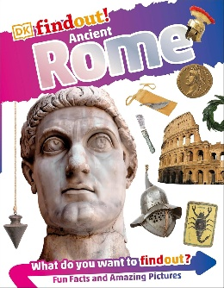  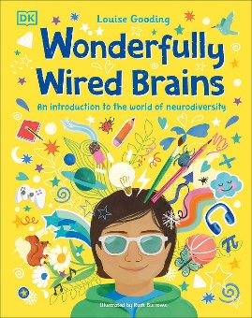
Writing Outcomes | 1. BASIC SKILLS WEEK – AIM: Revise and build component knowledge required to access current year group’s grammar objectives.  TASK: Review of previous year groups’ grammar knowledge using class Novel as stimulus.  2. Journal Entry (2.5 Weeks)  Text: The Girl Who Stole an Elephant by Nizrana Farook  Outcome: to write a journal excerpt as Chaya after she gets home from stealing the jewels, and a contrasting one after she sees Bala being accused of the theft.  R – to understand the character’s motivations and emotions better.  A – our peers.  F – first person, present perfect tense, adverbs, prepositions and conjunctions for time, manner and place, expanded noun phrases, paragraphs, apostrophes for possession (singular and plural),  b – mirror the text (contrast between the two entries).  GDS – make careful language choices to really evoke Chaya’s contrasting feelings between the two excerpts.  3. Story – Characterisation and Dialogue (2 weeks)  Text: The Girl Who Stole an Elephant by Nizrana Farook  Outcome: to re-tell the story from Neel’s point of view, from him being accused to him and Chaya escaping into the jungle.  R – to entertain our audience and help them understand Neel’s character.  A – children who have read the book previously.  F – clear paragraphs, description of setting and characters, use conjunctions, prepositions and adverbials for time and cause, fronted adverbials with commas, use a variety of sentence forms, inverted commas and beginning to vary reporting clauses.  T – mirror the text, but with Neel’s differing point of view.  GDS – begin to show Neel’s emotions and reactions clearly through dialogue, using the reporting clause to show his body language.  4. Americas Project Presentation.  OR Poetry unit:  Poetry – Limericks – written and oral outcome (1 week)  Text: Silly Verse for Kids by Spike Milligan  Outcome: to write and perform limericks in the style of Spike Millgan.  R – to entertain our audience.  A – our friends.  F – limerick form, correct demarcation, word choices for effect, speak audibly, use gesture and expression to engage the audience.  T – humorous.  GDS – experiment with their word and content choices to add humour. | 1. Report: Ancient Egyptian inventions, Tutankhamun or mummification (2.5 Weeks) (choose own area to research and write about).  Outcome: to write a report about the topic.  R – to inform our audience about Egyptian practices.  A – KS2 children in a class book to go in the library.  F – introduction, organisational devices, facts organised into paragraphs, conclusion, rhetorical questions, technical vocabulary, fronted adverbials, followed by a comma.  T – informative, interesting, formal, factual.  GDS – to include narrative-style first person speech bubbles from the perspective of the Egyptian.  2. Story re-tell with innovated setting. (2.5 Weeks)  Text: Cinderella of the Nile (Myths and legends)  Outcome: retell of an Ancient Greek myth including some dialogue (staff to have choice of myth based on children’s engagement over the previous terms).  R - to entertain our audience and show our understanding of Ancient Greek myths.  A – our families.  F – appropriate tense dependent on narration/speech, range of conjunctions, prepositions and adverbials, use of punctuation for speech and reporting clauses which show character’s expression or action, use of pronouns for clarity, varied description of characters and setting.  T – historical, tense, exciting.  GDS – write the myth from the monster/god’s perspective.  3. Instructions/Explanation (2 Weeks)  Text: How the Grinch Stole Christmas by Dr Seuss/Grinch film.  Outcome: to write an explanation/Instructions of how the Grinch stole Christmas and present this information verbally.  R – to teach others about the character and story of The Grinch.  A – our families.  F – clear, logical steps in chronological order, technical vocabulary, fronted adverbials, time conjunctions, possessive apostrophes, consider the layout of the overall text to support clarity and engagement for the audience, e.g. subheading, diagrams.  T – informative, beginning to write more formally.  GDS – begin to control formality, making choices as to how to engage the reader, e.g. humour, asides to the reader. | 1. Persuasive letter (2.5 Weeks) Texts: Bright New World – river pollution + sewage release  Outcome: to write a letter persuading our local MP to do more to combat river pollution and ban sewage release.  R - to persuade our MP to support efforts to clean up our river system and ban sewage release.  A – local MP  F - first person, introduction stating aims, paragraphs – each one including a key point and discussion around it, evidence and statistics to back up points, superlative language, imperative verbs, rhetorical questions, adverbials to extend arguments/points.  T – passionate and persuasive.  GDS – include more statistics to support their argument.  2.Comparative Poetry (1.5 Weeks)  Texts: A River by Marc Martin and  Once Upon a Raindrop: The Story of Water  Outcome: children to write a comparative poem (one verse on polluted river and one verse on unpolluted river) using simile and metaphor.  R - to entertain our audience whilst educating them about the impact of pollution on rivers.  A – school community.  F - noun phrases to add detail, comparative language, emotive language, adverbials and prepositions for time and cause, use pronouns for clarity and to avoid repetition.  T – positive (unpolluted) and negative (polluted).  GDS – write an additional verse showing the transition between being polluted/unpolluted.  3. Narrative Re-Tell (2 Weeks)  Text: Aaron Becker—Journey  Outcome: Innovate the story where the girl saves herself from falling in the boat.  R – to entertain our reader and paint a picture of the setting throughout.  A – the author (book is wordless).  b – clear sentence demarcation, use conjunctions of time and fronted adverbials to enhance coherence, expanded noun phrases, descriptive verbs, range of conjunctions, beginning to use prepositions  T – Descriptive  GDS – include references to the girl’s emotions at different points of the story | 1. Journal Entry (2 Weeks)  Text: The Boy at the Back of the Class by Onjali Q Rauf  Outcome: to show the perspective of Ahmet when he has been at school for a week to show how hard it is but to also say how much better it is that what he has fled from.  Optional second journal (GDS) to show development of character at a later point in the story.  R – to understand a character’s emotions and motivations more deeply.  A – our peers (share outcomes).  F – appropriate use of adverbs, prepositions and conjunctions to sequence events, paragraphs, emotive language, range of conjunctions, expanded noun phrases, possessive pronouns, beginning to avoid repetition.  T – emotive.  2. Narrative with Dialogue (3 weeks)  Text: Greek Myths by Marcia Williams  Outcome: to write a retell of an Ancient Greek myth including some dialogue (staff to have choice of myth based on children’s engagement over the previous terms).  R - to entertain our audience and show our understanding of Ancient Greek myths.  A – our families.  F – appropriate tense dependent on narration/speech, range of conjunctions, prepositions and adverbials, use of punctuation for speech and reporting clauses which show character’s expression or action, use of pronouns for clarity, varied description of characters and setting.  T – historical, tense, exciting.  GDS – write the myth from the monster/god’s perspective.  3. Poetry (1 Week): Please Mrs Butler or List Poem e.g. The Magic Box by Kit Wright or The Sound Collector by Roger MCGough (to be adapted by teacher)  Outcome: children to write a list poem based on the magic box and/or the Sound Collector  R - to entertain our audience  A – Class assembly or presentation.  F - noun phrases to add detail, comparative language, emotive language, repetition, rhyme, rhythm use, use pronouns for clarity and to avoid repetition.  T – positive and negative versions of the poem  GDS – write an additional verse to change the theme of the sounds in the Sound Collector. | 1. Setting Description (2.5 Weeks)  Text: Escape from Pompeii by Christina Balit  Outcome: To write a setting description of Pompeii as the children are escaping. Drama/playscript mini-task within unit to act out the event.  R – to inform people through storytelling what it was like during the volcano in Pompeii.  A – children in other Year 4 classes.  F – expanded noun phrases, range of conjunctions, fronted adverbials for narrative, descriptive vocabulary, rhetorical devices and figurative language, apostrophes for plural possession, appropriate chice of noun or pronoun.  T – exciting, suspenseful, scary.  GDS – Develop the mood through tension using literary techniques.  2. News Report (2.5 Weeks)  The Creature (news report)  Text: The World’s most ridiculous animals.  Outcome: to write report focused on the discovery of an animal/plant species.  R - to report about the discovery of a new species of animal.  A – website visitors.  F - introduction, conclusion, appropriate tense choices, use noun phrases to convey complicated information concisely, technical vocabulary. Formal subordinate clause structure, adverbials for cohesion.  T – factual but showing amazement at the discovery.  GDS – focus on showing a different voice for the anchor and scientist. | 1. Journal (2.5 Weeks): The Last Bear by Hannah Gold  (Journal focused on log entries).  Outcome: to write a journal from April's perspective in the form of log book entries at key points from the story.  R – to show how April felt at different parts of the story.  A – Year 4 Children.  F – conjunctions for time and place, prepositions, expanded noun phrases, paragraphs, first person, range of conjunctions., technical vocabulary, subordination at the beginning of sentences.  T – personal, emotive.  GDS – Write contrasting journal entries  2. The Last Bear –  Narrative re-tell.  Outcome: To continue the story from the part where April realises that Bear is weak and needs help. Pupils decide what she will do.  R – to create our own versions of the story  A – Year 4 Children.  F – conjunctions for time and place, prepositions, expanded noun phrases, paragraphs, third person, range of conjunctions, subordination, literary technique such as simile, description, technical vocabulary.  T – exciting, gripping, story-like.  GDS – Use models to extend authorial technique e.g pathetic fallacy.  3. Non-chronological report (2.5 Weeks)—informational tone Roman amphitheatre  Text examples (N-F Texts available in school): See Inside Ancient Rome by by Katie Daynes or DK Find out – Ancient Rome  R – to inform our readers about Roman Buildings.  A – children at school (class magazine).  F – sections, headings and sub-headings, appropriate use of present/past tense, correct sentence demarcation, range of conjunctions including subordination, expanded noun phrases to specify, commas in lists.  T – animated, informative, clear.  GDS – use statistics and more technical information to add detail  4. Transition Task (1 Week) Wonderfully Wired Me explanation/labelled diagram  Text: Wonderfully Wired Brains by Louise Gooding  Outcome: to explain the way our brains work with a bit about how we learn best explained.  R- to share with our new teacher how we learn best  A- New teachers and Tas and our classmates  F- apostrophes for possession, fronted adverbials (place), noun phrases to create exciting language, full sentences which engage the reader possibly including word-play.  T- informal, witty, informative.  GDS – Create a witty ‘disclaimer’ to showcase what happens if they don’t get their learning needs.

