 | Autumn 1 | Autumn 2 | Spring 1 | Spring 2 | Summer 1 | Summer 2
Consolidation | - Using phonics knowledge to spell words  - Writing some irregular common words  - How words can combine to make sentences  - Begin the separation of words with spaces  - Begin to show awareness of capital letters and full stops  - Writing sentences |  | - Letter formation  - Finger spaces  - Capital letters  - Full stops  - Application of phonics  - Spelling of common exception words  - Suffixes and prefix un-  - Nouns and Verbs |  | - Finger spaces  - Capital letters  - Full stops  - Application of phonics  - Spelling of common exception words  - Conjunction: ‘and’  - Question marks  - Exclamation marks  - Suffixes and prefix un-
Class Novel and Readers  https://www.thereaderteacher.com/year1  Y1 Reading River | 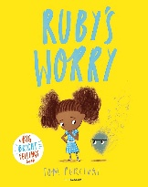  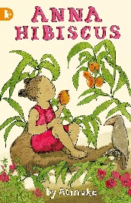 | 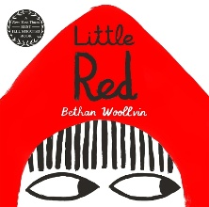  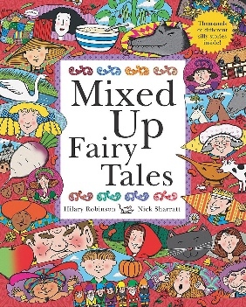 | 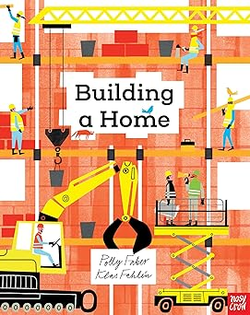  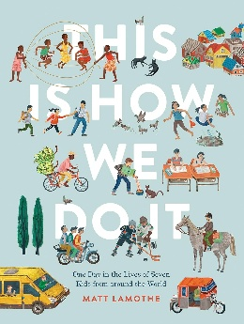 | 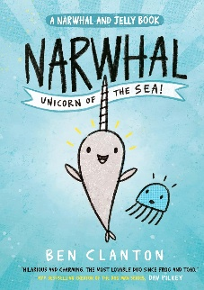  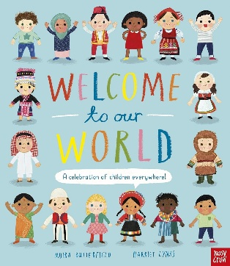 | 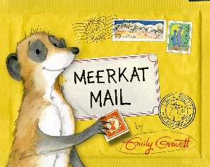  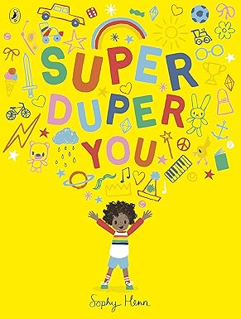 | 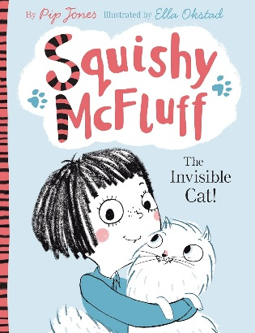  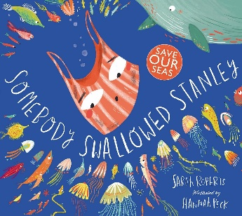
Texts | 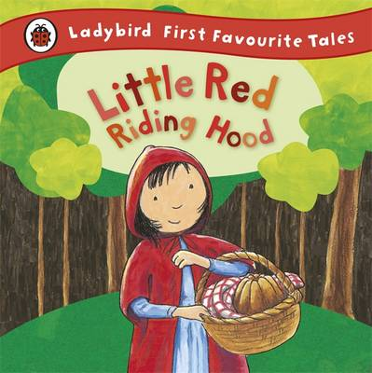  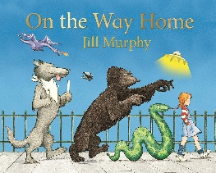  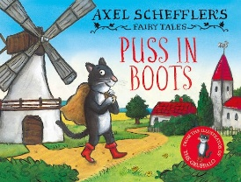 | 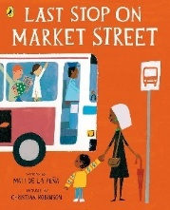  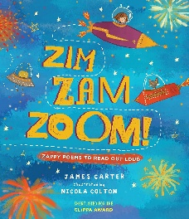  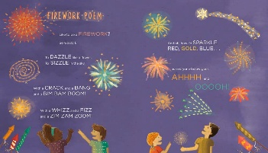  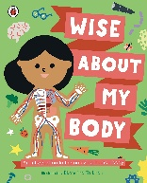  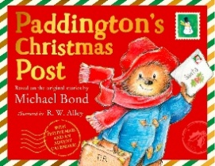  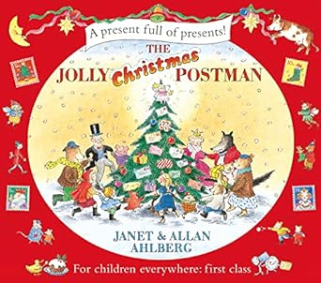  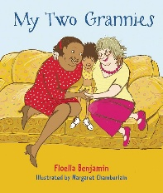 | 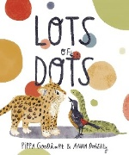  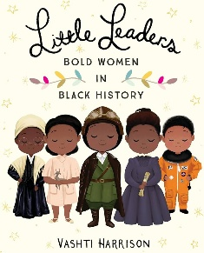  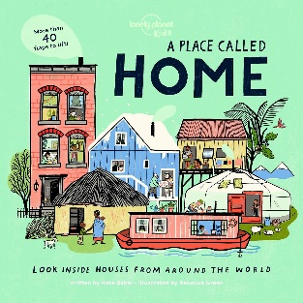  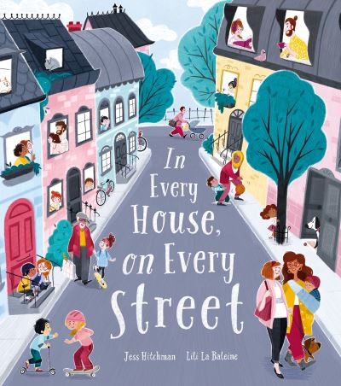 | 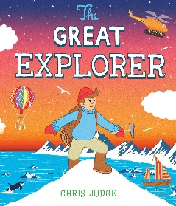  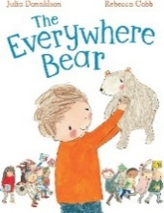  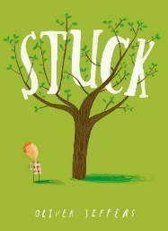 | 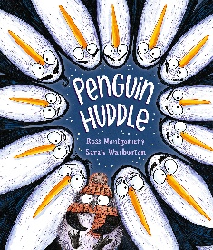  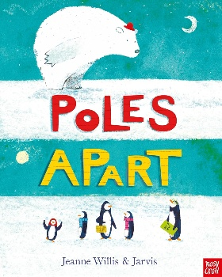  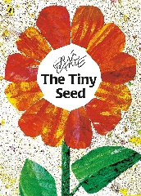  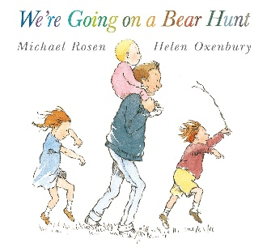 | 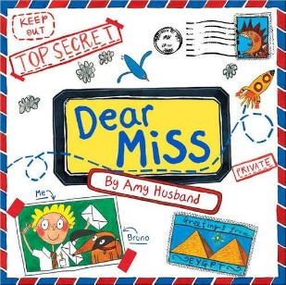  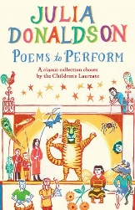  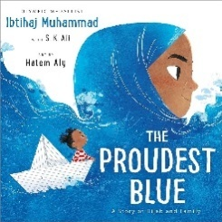  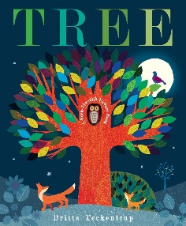  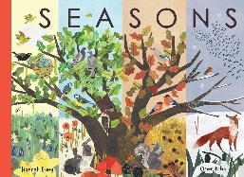
 | 1. BASIC SKILLS WEEK  AIM: Revise and build component knowledge required to access current year group’s grammar objectives.  TASK: Review of previous year groups’ grammar knowledge using class Novel as stimulus.  2. Recount – oral outcome (2 weeks)  Text: On the Way Home by Jill Murphy  Outcome: to orally compose a recount of our trip around local area.  R – to recount what we did on our trip and tell our headteacher all about it.  A – our headteacher.  F – orally retell the main events in sequence, simple sequencing language, use appropriate vocabulary, begin to use ‘and’ to join words, speak audibly.  T – enthusiastic.  GDS – begin to use expression when speaking (link to exclamation marks).  3. Story Re-tell/Captions  Little Red Riding Hood with party invitation (Supporting text: The Jolly Postman)  Outcome: Write simple sentences to re-tell the story with pictures (some may only draw/write captions and/or tell orally)  R - to entertain our audience and inspire them to read it themselves.  A- the author and illustrator.  F – Transcription skills, simple story language, third person, some accurate sentence demarcation, checking it makes sense.  T- story-like  GDS – range of vocabulary choices.  4. Story – Re-tell a Fairy Tale – captions/short sentences (2 weeks)  Text: Axel Scheffler's Fairy Tales: Puss in Boots by Axel Scheffler  Outcome: to retell the traditional tale of Puss in Boots using oral rehearsal before writing.  R – to share the story with EYFS children.  A – EYFS classes.  F – how words combine to make sentences, some correct sentence demarcation (CL and FS) when writing in sentences, checking writing makes sense, third person, past tense, story language, use the vocabulary from the text, use and to join words, capital letters for proper nouns.  T – mirrors the text.  GDS - to write in simple sentences, sometimes using a capital letter and a full stop to demarcate. | 1. Poetry (1 Week) –  Text: Firework Poem from Zim, Zam, Zoom by James Carter  Outcome: Write an onomatopeic firework poem  R- to entertain our audience in year group assembly  A- Assembly audience  F- Creative vocabulary choices, letter formation, spacing, poem layout, reading with correct voice level and with enthusiasm for perfomance.  T- fun, energetic  GDS – Write in the style of the author  2. Story – Re-tell - short sentences (2 weeks)  Text: Last Stop on Market Street by Matt de la Pena and Christian Robinson  Outcome: to retell the story of Last Stop on Market Street with/without drawings.  R – to entertain our families and inspire them to read the book themselves.  A – our families- create own book version to take home.  F – third person, past tense, some correct sentence demarcation, retell the main events in sequence, story language, use the vocabulary from the text, some to begin to use and to join clauses, verbs, capital letter for proper nouns.  T – mirrors the text.  GDS – include additional details from the text.  3. Letter to Inform (2 weeks)  Text: My Two Grannies by Floella Benjamin and Margaret Chamberlain  Outcome: to write a letter to a child in KS2 telling them about us and our families.  R – to inform our readers about our lives.  A – a specific child in KS2 (buddy up).  F – simple organisational features of a letter (date, salutation and ending), first person, past/present tense as required, some to use coordinating conjunctions ‘and’ ‘but’, ‘so’, some use of ‘because,’ some accurate sentence demarcation- capitals for names.  T – showing their personality.  GDS – include questions (correctly demarcated) for the reader.  4. Diagram – labels and oral outcome (1 week)  Text: Wise About My Body: An Introduction to the Human Body by Libby Walden & Ekaterina Trukhan  Outcome: to label a diagram of my body and be able to talk about it.  R – to show what we know about our bodies.  A – Display for school community.  F –form lower case letters in the correct direction, common nouns, capital letter at the start of own name, vocabulary for topic, joining sentences with conjunctions.  T – factual.  GDS – use a greater range of vocabulary.  5. Letter (optional 1 week task)  Text: The Jolly Christmas Postman by Allan and Janet Ahlberg and/or Paddington’s Christmas Post by Michael Bond  Outcome: Write captions or sentences to describe what they would like for Christmas.  R- To ask for christmas presents  A – Parents/FC  F- Capital letter for I, joining sentences with and (for some), letter formation and spacing.  T- polite with explanation  GDS- Write reasons why they would like the items. | 1. Instructions – short sentences (2 weeks)  Text: Lots of Dots by Pippa Goodheart and Anna Doherty  Outcome: to write short instructions for the reader on how to play a playground game.  R – to teach our friends/siblings how to play a playground game with us.  A – our friends in another class/our siblings.  F – Numbered instructions (NB. Number of instructions dependent on cohort but suggest 3-5), verbs, in sequence with some simple sequencing vocabulary, some correct sentence demarcation (CL and FS), use of and to join words, plurals using -s and -es, form digits 0-9.  T – clear and informative.  GDS – add more detail to the instructions so that they are clearer to the reader.  2. Fact file ( 2 Weeks) – Text: Little Leaders: Bold Women in Black History by Vashti Harrison  Outcome: Write a fact file about their chosen author  R – to inform others about significant people/authors  A- Readers of our class book  F- Third person, sentences joined by ‘and’, capital letters for proper nouns, appropriate sentence demarcation.  T- factual and informative  GDS - Develop content into full sentences  3. Description (2 Weeks)  Text: A Place Called Home – Lonely Planet Kids and Kate Baker, Home by Carson Ellis and In Every House in Every Street by Jess Hitchman (*predict session based on this text)  Outcome: Link to Houses and Homes – write a description of their own home.  R – to tell our audience about different houses and homes using our own as an example  A – parents/carers/ class project display  F – first person, past tense, capital letters for personal pronoun ‘I’,  T – clear and detailed.  GDS – Write about another house that is different to theirs as well. | 1. Recount (2 Weeks)  Text: The Everywhere Bear by Julia Donaldosn  Outcome: Write a recount/retelling of the Everywhere Bear’s Trip.  R – to entertain our friends and record our writing orally.  A – our families/friends .  F – retell the main events in sequence, simple story language, use the vocabulary from the text, speak audibly, past tense.  T – mirrors the text.  GDS – to speak at an appropriate volume.  2. Narrative (2 Weeks) Text: The Great Explorer by Chris Judge (read The Way Back Home alongside this)  Outcome: Write an adventure they have been on to rescue something/ re-tell the story from the book.  R – to understand more about being an explorer  A – next year’s Year 1 children.  F – first/third person, present tense, clear sentences joined by ‘and,’ use of full stops, consistent use of capital letters for proper nouns.  T – descriptive.  GDS - effective choice of language for the reader  3. Narrative Story – Re-tell with Innovated Plot (2 weeks)  Text: Stuck by Oliver Jeffers  Outcome: to retell the story of Stuck making at least one change to what gets stuck in the tree.  R – to entertain our audience.  A – to be shared with the other Year 1 classes.  F – third person, past tense, write in order, clear sentences joined by ‘and,’ use of full stops, use of capital letters for proper nouns, time words, plurals, exclamation marks.  T – humorous, entertaining.  GDS – making imaginative choices to what gets stuck in the tree and the reaction of the characters. | 1. Story – Re-tell (2 weeks)  Text: Penguin Huddle by Ross Montgomery  Outcome: to retell the story of Penguin Huddle until the penguins reach the city. NB. Only read up until this point until completing the task.  R – to entertain our audience.  A – to be shared with our families.  F - third person, past tense, written in order, clear sentences joined by ‘and,’ use of appropriate sentence demarcation, use of capital letters for proper nouns, time words, plurals.  T – mirrors the text.  GDS – focus on the penguins’ emotions at different points in the story.  2. Factfile- or Letter – Thank You Card (2 weeks)  Text: Poles Apart by Jeanne Willis  Outcome: to write a thank you card to the author telling them what they enjoyed about the book and asking questions.  R – to express our opinions about the book we’re reading.  A – the author.  F – first person, past tense and present tense as required, clear sentences joined by ‘and,’ capital letters for proper nouns, use of appropriate sentence demarcation. questions, and some question marks.  T – polite and inquisitive  GDS – to explain their reasons for their opinions, starting to use subordinating  3. Instructions (2 weeks)  Text: Tiny Seed by Eric Carle  Outcome: To write a set of instructions on how to grow a plant linked to our Science lessons.  R – to inform our audience.  A – children who haven’t grown a plant before.  F – A ‘what is needed’ list, numbered instructions, imperative verbs, chronological order, clear sentences joined by ‘and,’ time words.  T – informative, clear, easy to follow.  GDS – to sequence multiple sentences for each instruction.  4. Poetry - Performance Poetry – oral outcome (1 week)  Text: We’re Going on a Bear Hunt by Michael Rosen  Outcome: to innovate, learn and perform We’re Going on a Bear Hunt  R – to entertain our peers with a filmed performance to be put on the school website.  A – the school community.  F – learn the words by heart, appropriate volume, actions to match the text.  T – enthusiastic and mirrors the text.  GDS – Perform with expression/ lead. | 1. Fact File –  Text: Tree by Bretta Treckentrup and Seasons by Hannah Pang  Outcome: to write captions for the illustrations of the seasons in our class text.  R – to show our knowledge of how each season is different.  A – our peers.  F – common nouns, verbs for movement, leave spaces between words, correct lower case letter formation, singular plural ‘s.’  T – positive but changing depending on the season and children’s opinions.  GDS – use a greater range of vocabulary.  Curriculum Link – Seasons (Autumn 1)  2. Poetry - List Poems (1 week)  Poem example : Question Time by Julia Donaldson  Outcome: to write a short (2 verse) list poem in the style of Julia Donaldson, asking questions and telling my reader about me.  R – to ask the author questions and tell them about me.  A – Julia Donaldson  F – correct letter formation, questions, and some question marks, begin to use ‘and’ to join words and clauses, capital letters, plurals using -s and -es.  T – mirrors the text.  GDS – ask a greater range of questions and consistently punctuate them.  3. Character Description (2 weeks)  Text: The Proudest Blue by Ibtihaj Muhammad  Outcome: to write a character description about Asiya.  R – to understand more about Asiya’s personality and characteristics.  A – next year’s Year 1 children.  F – third person, present tense, clear sentences joined by ‘and,’ use of full stops, consistent use of capital letters for proper nouns.  T – descriptive.  GDS - effective choice of language for the reader.  4. Letter to New Teacher (1 week)  Dear Miss by Amy Husband  Outcome: Write a letter to their new teacher to tell them about what they like doing.  R – to inform new teacher about us.  A – New teacher.  F – simple organisational features of a letter (date, salutation and ending), first person, past/present tense as required, some to use coordinating conjunctions ‘and’, some use of ‘because,’ some accurate sentence demarcation- capitals for names. T – informative, clear, easy to follow.  GDS – to sequence multiple sentences for each instruction. Use but’, ‘so’ and ‘because’ as well as ‘and’.  GDS- Write a funny letter saying why they might be late because of an adventure

