 | Autumn 1 | Autumn 2 | Spring 1 | Spring 2 | Summer 1 | Summer 2
Consolidation | - Oral rehearsal  - Phonics Phase 5 – alternative vowels  - Letter formation (direction and size of CL/LC)  - Spacing between words  - Model re-reading your sentence (teacher)  - Pencil grip/sitting at a table  - Capital letters and full stops. |  | - Understanding noun and verb  - Conjunctions (and, but, and or) to write two-clause sentences  - Use familiar punctuation (full stops, capital letters, question marks correctly)  - Tenses  - Suffixes -ing -ed -er  - Commas in a list |  | - Conjunctions (and, but, and or) to write two-clause sentences  - Subordination (using when, if, that, because)  - Use familiar punctuation (full stops, capital letters, question marks correctly)  - Using noun phrases effectively  - Use apostrophes for singular possession
Class Novels and Readers  https://www.thereaderteacher.com/year2  AM Reading River | 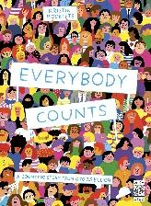  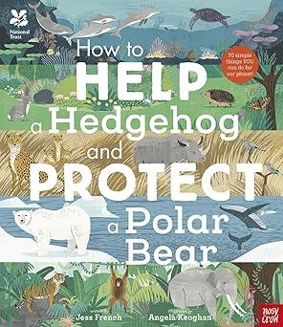 | 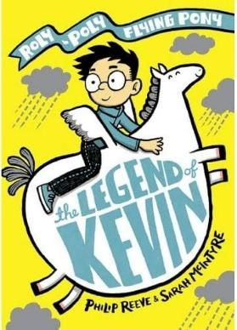 | 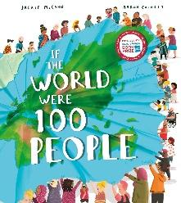  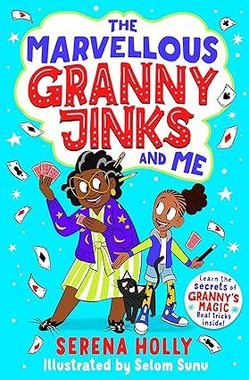 | 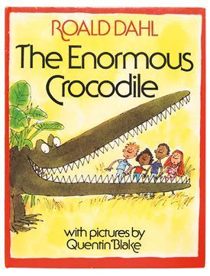  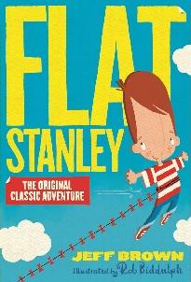 | 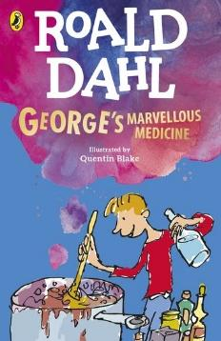 | 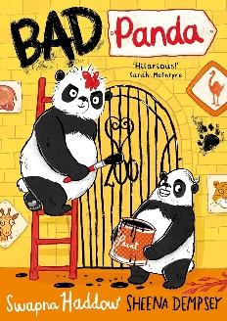  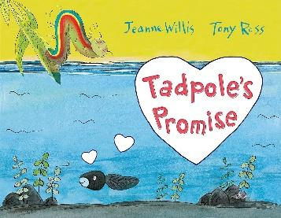
Texts for Writing Units | 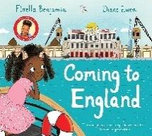  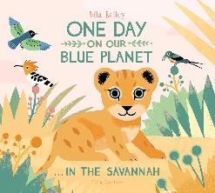  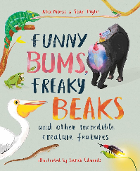  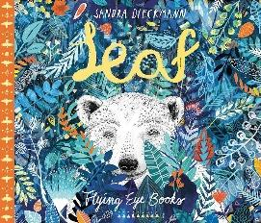 | 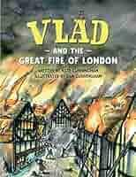  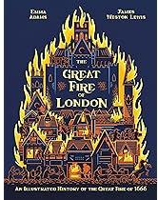  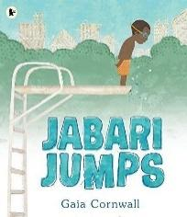 | 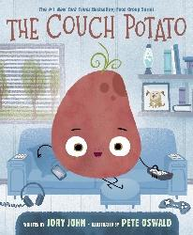  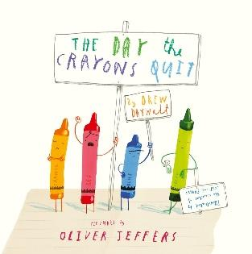  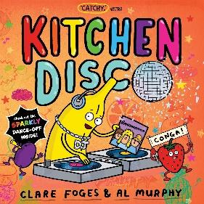 | 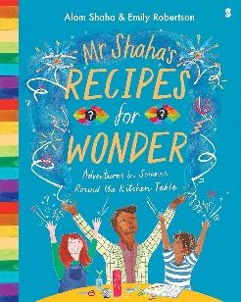  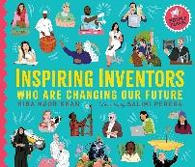  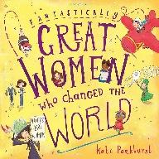  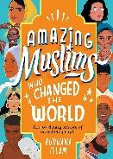 | 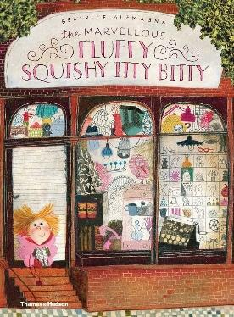  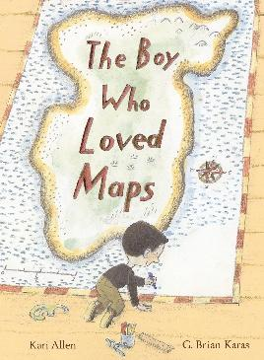  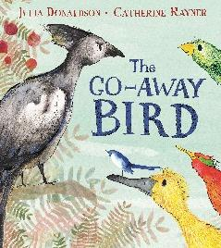 | 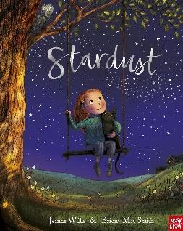  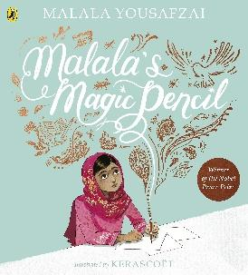  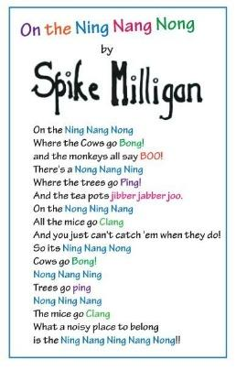
Writing Outcomes | 1. BASIC SKILLS WEEK  AIM: Revise and build component knowledge required to access current year group’s grammar objectives.  TASK: Review of previous year groups’ grammar knowledge using class Novel as stimulus.  2. Re-tell (2 weeks)  Text: Leaf by Sandra Dieckmann  Outcome: to re-tell the pupils’ experience of looking for the polar bear themselves OR to re-tell the story of ‘Leaf’ in their own words.  R – to tell our audience about the most memorable parts.  A – children in Year 3 (who will have gone on to learn about habitats last year)  F – first person, past tense, some accurate sentence demarcation (CL and FS), coordinating conjunction ‘and’, checking it makes sense.  T – sad, serious story-telling.  GDS – range of conjunctions to join more than one sentence. Written versus oral.  3. Letter – (2 Weeks)  Coming to England by Floella Benjamin  Outcome- Write a letter to Floella to ask her about her experiences of moving to a new place.  R – to share experiences of coming to a new country.  A – Floella Benjamin.  F – first person, past tense, some accurate sentence demarcation (CL and FS), range of coordinating conjunctions, checking it makes sense.  T – Truthful and honest.  GDS– add additional  detail to explain their feelings at different points.  4. Fact File (2 weeks)  Text: One Day on Our Blue Planet…Funny Bums and Freaky Beaks by Alex Morss  Outcome: to write a fact file about animals on a different continent.  R – to inform our audience about an animal from a different continent.  A – To put in library for other pupils  F – introductory sentence, present tense, third person, technical vocabulary, use of ‘and, some accurate sentence demarcation.  T – factual.  GDS – include a greater range of technical vocabulary. | 1. Poetry – Performance Poetry – oral outcome (1 week)  Text: London’s Burning by Anon  Outcome: to shared write an additional verse, learn, and perform London’s Burning  R – to entertain our peers with a choral performance.  A – other Year 1 and 2 classes.  F – learn the words by heart, appropriate volume, appropriate pitch, different groups performing different parts chorally.  T – enthusiastic.  GDS - perform with intonation and expression.  2. Non-Chronological Report (2 weeks)  Text: An Illustrated History of the Great Fire of 1666 by Emma Adams  Outcome: to write a report about the Great Fire of London.  R – to inform our audience on how the fire started and how it spread.  A – a ‘class book’ highlighting our writing for KS1 children to read in the library.  F – introduction, subheadings, conclusion, present tense, third person, technical vocabulary, conjunctions to extend sentences.  T – informative, factual, formal.  GDS – use of ‘did you know’ questions speaking directly to the reader to engage them.  3. Setting Description (2 Weeks)  Text: Vlad and the great fire of London  Outcome: Write a London’s burning setting description  R – to show our audience what London looked and felt like during the Great Fire.  A – School community through a display in school.  F - third person, past tense, accurate sentence demarcation, use of exclamations, expanded noun phrases, range of conjunctions, checking it makes sense.  T – informative, descriptive.  GDS – drawing on their reading to make effective vocabulary choices.  4. Story – Re-tell – oral and written outcome (2 weeks)  Text: Jabari Jumps by Gaia Cornwall  Outcome: to re-tell the story of Jabari Jumps verbally and in a written format.  R – to entertain our audience and help them to do hard things.  A – our school community.  F – simple story language, past tense, some accurate demarcation, coordinating and subordinating conjunction ‘because,’ some simple description of main character, adjectives, capital letters for proper nouns, checking it makes sense.  T – emotive (tracking Jabari’s changing emotions throughout the story).  GDS – greater range of vocabulary choices. | 1. Leaflet (2 Weeks) Text: Couch Potato by Jory John  Outcome: Orally re-tell the story and make a healthy habits leaflet  R – to entertain and teach our audience.  A – to be shared with the other ks1 classes.  F – third person, past tense, write in order, clear sentences joined by ‘and,’ use of full stops, use of capital letters for proper nouns, time words, plurals, exclamation marks.  T – humorous, entertaining.  GDS – making imaginative choices to fully develop the vocabulary with extra information on benefits and pitfalls of not eating healthily  2. POETRY: Blow a Kiss, Catch a Kiss by Joseph Coelho - ‘My Favourite Food’(2 Weeks)  & Text: Kitchen Disco by Clare Foges and Al Murphy  Outcome 1: To orally describe their favourite healthy food/ draw and label then create fruit kebab. Write instructions with explanation of why they chose their fruits (GDS).  Outcome 2: perform an innovated version of Kitchen Disco - Classroom Disco OR own/ class version of My Favourite Food ( POETRY: Blow a Kiss, Catch a Kiss book by Joseph Coelho - ‘My Favourite Food’)  https://www.youtube.com/watch?v=Hq8nTB36F8E (JC Poetry prompts- explains how to do it)  R – to entertain our school community and tell them about our favourite foods.  A – our school community.  F – descriptive words, learn the words by heart, appropriate volume, actions to match text, onomatopoeia T – enthusiastic. Apostrophes for possession.  GDS – perform with expression, considering body language.  3. Letter (2 Weeks)  Text: The Day the Crayons Quit by Oliver Jeffers  Outcome: To write our own version of one of the letters in role as a crayon.  R- To entertain our peers by making our own version of the book.  A – Create a class book for the library  F - simple organisational features of a letter (address, date, salutation and ending), first person, past/present tense as required, range of coordinating conjunctions, some use of ‘because,’ some accurate sentence demarcation, creative vocabulary.  T: Funny and forthright, showing their personality  GDS – include questions (correctly demarcated) for the reader. | 1. Innovate a Story Section/ Write an explanation (2 Weeks)  The Enormous Crocodile-by Roald Dahl  Outcome: Write their own page for the story to describe how the Enormous Crocodile hides from the children and what happens when they discover him.  R - to entertain our audience with a story with a twist.  A - to share with other classes  F- exciting opener, third person, accurate sentence demarcation, range of conjunctions, description of main characters, expanded noun phrases, adverbs, contractions, checking it makes sense.  T- dramatic, descriptive  GDS – to choose powerful verbs  2. Instructions for Hand Puppet (DT link) (2 Weeks)  Text Stimulus: Mr Shaha’s Recipes for Wonder by Alan Shaha  Outcome: Write instructions in the style of Mr Shaha.  R - to write a set of instructions to teach our readers how to make our puppet.  A- Peers in another year group (to explain orally)  F- second person, present tense, sequenced and numbered steps, use of coordinating and subordinating conjunctions as needed, imperative verbs.  T - clear and instructional  GDS – children to use subordination to explain why some steps are being completed.  3. Explanation Text/ Biography Style (2 Weeks)  Text Possibilities: Inspiring Inventors who are changing our future by Hibba Noor Khan, Amazing Women who changed the World by Kate Pankhurst, Amazing Muslims who Changed the World by Burhana Islam/ Little People Big Dreams books.  Outcome: Write a text about a significant person who has changed the world.  R- to inform about our  learning and ask them for answers to our questions.  A – Subjects (email questions)  F- introduction stating the reason for writing, paragraphs, conjunctions, adverbs, and prepositions as required to express time and cause, multiclause sentences, possessive apostrophe, closing statement.  T – informative and inquisitive  GDS – write a clear conclusion, including summing up their content  4. Poetry (1 Week)  Poem: If I were in Charge of the World – Free Verse Poetry  Outcome: write a free verse poem  R- To entertain our audience  A- Class mates  F- Variety of vocabulary, planning and orally rehearsing before writing, using poem layout, evaluating vocabulary choices, checking and revising to improve. Adhering to poetry features of free verse.  T- Clear message to inspire  GDS – Develop ideas at length and ensure they link from beginning to end. | 1. Narrative (2 Weeks) – Text: The Marvellous Fluffy Itty Bitty by Beatrice Alemagna  Outcome: to re-tell the story with innovation  R- To develop a story ourselves to entertain the author.  A- To share with the author to see if they like our idea.  F- third person, past tense, exciting vocabulary, progressive verb forms, subordination, use of full stops, use of capital letters for proper nouns, time words, exclamation marks.  T- Funny, from child’s perspective.  GDS – add extra detail to add humour.  2. Instructions for Making a Bird Feeder (1 week)  Text: e.g. The Go Away Bird by Julia Donaldson  Outcome: write instructions to go with making their bird feeder in Science  R – to write a set of instructions to teach our readers how to follow a map to a special place.  A – our families.  F – second person, present tense, sequenced and numbered steps, use of coordinating and subordinating conjunctions as needed, imperative verbs, commands.  T – clear and instructional.  GDS – Children to use subordination to explain why some steps are being completed.  3. Report/Explanation  The boy who loved Maps by Karri Allen  Outcome: Draw a map and write an explanation of the local area.  R- To inform others about the local area  A- Leaflet to be put in the school foyer  F– third person, past tense, write in order, clear sentences joined by conjunctions, some subordination, some explanatory language, use of full stops, use of capital letters for proper nouns, time words, commas for lists.  T- Clear, explanatory, motivating  GDS -include extra information about how we can help to preserve our local area. | 1. Letter to advise  Text: Star Dust – Jeanne Willis  Outcome: to write a letter to the character to help her understand how important she is.  R – To empathise with a character  A – Main chararacter  F – simple organisational features of a letter (address, date, salutation and ending), first person, past/present tense as required, range of coordinating conjunctions  Subordination (using when, if, that, because) ,more accurate sentence demarcation.  T – Caring, advising, comforting and motivating.  GDS- Write some instructions within letter to help her with what to do when she feels sad.  2. First Person Speech  Texts: Speak Up! By Nathan Byron  Greta and the Giants by Greta Thunberg  Outcome - write as Greta to explain about concerns and her wishes for a better the future for all children (as if an interview or a speech)  R-To put themselves in the place of an activist  A- School Community (class display)  F - first person, past tense, accurate sentence demarcation, range of conjunctions, checking it makes sense, past progressive.  T – passionate.  GDS – suffixes (-ly).  3. Poetry – Nonsense Poetry – written and oral outcome (1 week)  Text: On the Ning Nang Nong by Spike Milligan  Outcome: to write our own nonsense rhyming couplets in groups and recite them to our class.  R – to entertain our peers.  A – our class.  F – rhyming couplets, nonsense words, learn the words by heart, appropriate volume.  T – humorous, nonsense.  GDS – to maintain appropriate volume and tone when reciting their rhyming couplets.  4. Biographical Character Description (1 Week- Transition)  Text: How to be a lion  Outcome: Self – focus character description  R- write a character description about themselves to show why they are unique  A- New teacher in Y2  F – how words combine to make sentences, some correct sentence demarcation (CL and FS) when writing in sentences, checking writing makes sense, first person, present tense, use exciting adjectives with nouns, Commas in lists and apostrophes used correctly. Think, say then write the sentence.  T-Informal  GDS- check and improve punctuation. Include an exclamation.

