 | Autumn 1 | Autumn 2 | Spring 1 | Spring 2 | Summer 1 | Summer 2
Consolidation | - Capital letters and full stops to form sentences  - Using basic conjunctions  - Spacing between words  - Using statements, exclamations and questions  - Understanding noun and verb  - Phase 5 alternative spellings  - Common exception words  - Handwriting  - Aptness of word choices  - Introduction to paragraphs |  | - Use of capital letters, full stops, question marks and exclamation marks  - Commas in a list  - Apostrophes for contractions and singular possession  - Conjunctions to express time, place and cause  - Headings and subheadings  - Present perfect verb forms |  | - Adverbs  - Subordination  - Prepositions  - Paragraphs  - Figurative language  - Adjusting tense  - Secure sentence demarcation  - Plural possessive apostrophes
Class Novel | 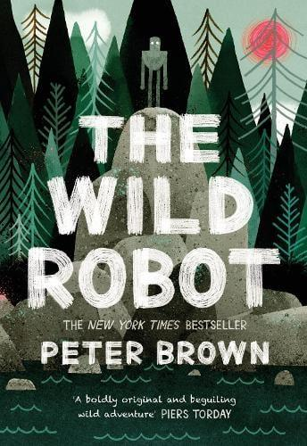  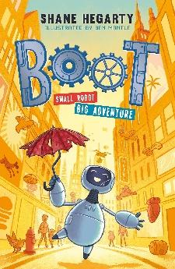 | 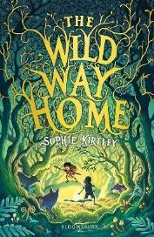  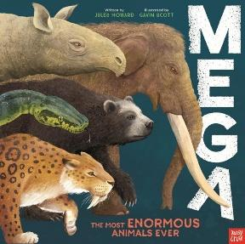 | 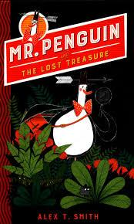  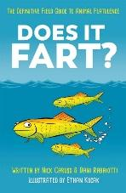 | 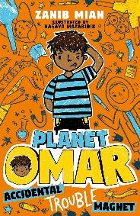  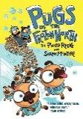  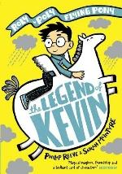 | 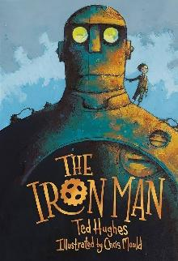  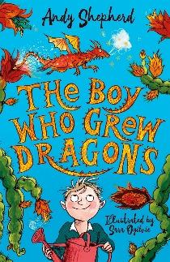 | Traditional – R.Dahl?  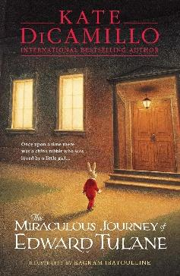  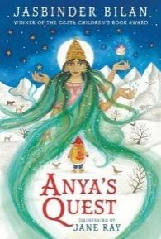  Fantasy
Texts | 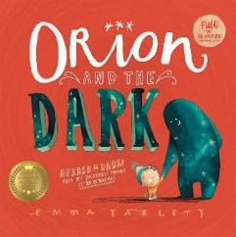 | 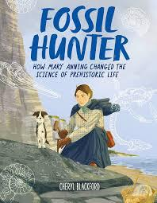  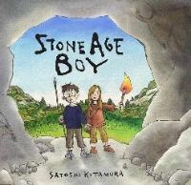  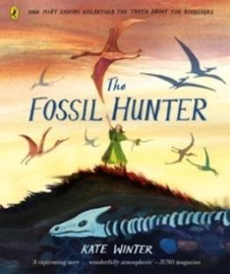 | 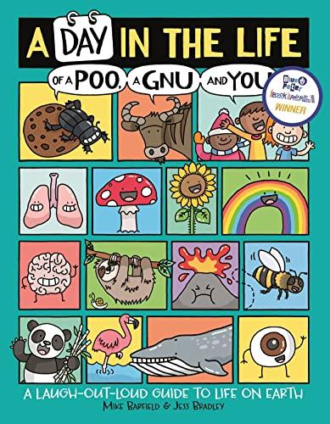 | 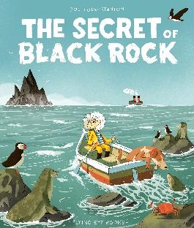 | 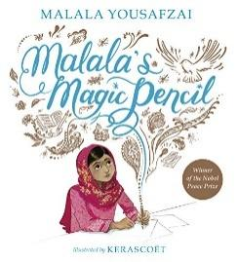 | 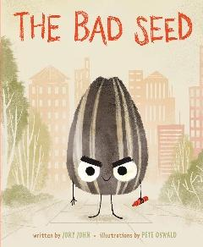  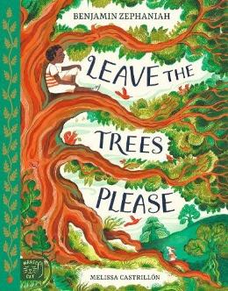  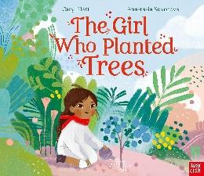  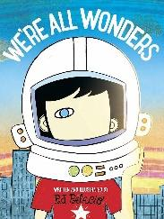
Writing Outcomes | 1. BASIC SKILLS WEEK – AIM: Revise and build component knowledge required to access current year group’s grammar objectives.  TASK: Review of previous year groups’ grammar knowledge using class Novel as stimulus.  2. Journal (2.5 weeks)  Text: Orion and the Dark by Emma Yarlett  Outcome: to write a journal entry from Orion’s perspective based on the text Orion and the Dark  R – to show how Orion felt at different parts of the story.  A – EYFS children.  F – conjunctions for time and place, prepositions, expanded noun phrases, paragraphs, first person, range of conjunctions.  T – exciting, gripping, story-like.  GDS – to write a journal extract in response to one of the entries from Dark’s point of view  3. Instruction/ Explanation Text (2.5 Weeks)  Text: The Wild Robot by Peter Brown  Outcome: Non-fiction – design own Robot and explain what it does to help.  R – To explain ideas as a designer  A – Dragon’s Den style manufacturer Classmates  F – Imperative verbs, second person, subordinating conjunctions, adverbials for time, starting to use a and an appropriately, detailed explanation through subordinating and coordinating sentences. Labelled diagram if appropriate.  T – clear and concise.  GDS – add humour to engage the reader.  4. POETRY (1 Week)  Text: The Wild Robot by Peter Brown  Outcome: Shape Poem in relation to The Wild Robot where they have the island fire using a range of shape poems to inspire.  R – to illustrate the drama of the Island fire in The Wild Robot through poetry.  A – Year 3 and 4 (read aloud)  F- Use of relevant vocabulary, word play and figurative language technique, shape layout and related language content, appropriate intonation and expression, speak audibly.  T- Descriptive, emotive  GDS – Write from a character’s perspective in final verse. | 1. Setting Description (2 Weeks)  Text: Stone Age Boy by Satoshi Kitamura  Outcome: to write a setting description of the stone age setting to enahnce the text.  R: to entertain our audience and paint a picture of the setting.  A: our peers  F: past tense, correct sentence demarcation, expanded noun phrases, adjectives, descriptive verbs, range of conjunctions, beginning to use prepositions.  T: mirrors the text  GDS – begin to choose vocabulary for specific reasons.  2. Story Re-tell (2 Weeks)  Text: Stone Age Boy by Satoshi Kotamura  Outcome: to write a re-tell of the story  R: to entertain our readers with a more descriptive version of the story more appropriate for older children.  A: older children at school.  F: story language, third person, past tense, accurate sentence demarcation, range of conjunctions, description of setting, expanded noun phrases, some use of adverbs and prepositions, checking it makes sense.  T: exciting and engaging  GDS – include description of the main character.  3. Biographical Narrative: Mary Anning (2 Weeks)  Text: The Fossil Hunter: How Mary Anning unearthed the truth about the dinosaurs by Kate Winter  Outcome: to compose a biographical narrative of Mary Anning’s life to explain how her finding had impact.  R – to share the life story of an important figure in history.  A – the Mary Anning Museum.  F – subordinating conjunctions, use of adverbs, prepositions, paragraphs, past tense, expanded noun phrases, possessive apostrophes.  T – Informative and celebratory  GDS – include more reflection about the future, including using future tense appropriately.  4. Poetry (1 Week- can be reduced) – Text: Silly Verse for Kids by Spike Milligan  Outcome: to write and perform limericks poems in the style of the poet.  R: to entertain our audience  A: our friends  F: limerick form, similes with varied description, rhythm and rhyme, correct demarcation, speak audibly, use gesture and expression to engage the audience  T: humorous and descriptive, entertaining  GDS – experiment with their word and content choices to extend- extend to 2 verses. | 1. Innovate a portal story (3 Weeks)  The Wild Way Home by Sophie Kirtley  Outcome: to use the story structure to create their own portal story which takes them to another time of their choice.  R: to entertain our audience and show what we know about the different time periods.  A: Year 4 (who will have studied the text themselves in Year 3).  F: clear sentence demarcation, use a range of conjunctions, expanded noun phrases, prepositions, descriptive verbs, apostrophes for singular possession  T: Mirrors the text  GDS - continue the narrative following the character as they encounter aspects of the stone age.  2. Non-Chron  Text (3 Weeks)  Text: A day in the life of a Poo, a Gnu and You by Mike Barfield  Outcome: Non-fiction text that explains how something works e.g. volcanoes/Rocks/ Light  R- to explain how sedimentary rocks are formed to share our knowledge  A - Year 3 pupils next year  F- Title, subheadings, factual sentences, past tense, first person, questions, subordinating conjunctions after, before, until. Facts using topic vocabulary, adverbs.  T - informal, humorous, informal  GDS – technical description to add detail accurately used. | 1. Narrative Writing and Persuasive letter (4 Weeks)  Text: The Secret of Black Rock by Joe Todd-Stanton  Outcomes:  1) Write a description of Black Rock (short write)  2)Re-tell story from Erin’s perspective.  3) Persuasive letter to stop the destruction of Black Rock.  R- to entertain readers and teach them to find out the truth.  A- Writing competition?  F- expanded noun phrases, range of conjunctions, prepositions, adverbs, descriptive language for effect, subordination and coordination, apostrophes for possession.  F -Persuasion: Emotive language, imperative verbs, exaggeration, rhetorical questions, complex sentences to explain reasoning. Correct sentence demarcation. Introduction, main paragraph and summary paragraph.  T – With strong character voice.  GDS – Add descriptive vocabulary to demonstrate emotions.  DT-Link – (2 Weeks) Instructions for making a box gift.  Possible Text link or use own WAGOLLs: The Gift inside the Box by Adam Grant (watch online for fun if wanted)  Outcome: Write a set of instructions another child could follow to make the gift box.  R – to create instructions that can be followed to make a box.  A – our families.  F – Imperative verbs, second person, subordinating conjunctions, fronted adverbials for time, starting to use a and an appropriately.  T – clear and concise.  GDS – add humour to engage the reader | 1. Letter from a character (2 Weeks)  Text: The Iron Man by Ted Hughes  Outcome: Write a letter from Hogarth’s Father appealing for help explaining the plight of the Iron Man and its effect on the community.  R- To appeal for help as character in role  A- The Army  F- take on a character’s point of view, use of adverbs, conjunctions and prepositions, paragraphs to group ideas, present perfect tense, possessive apostrophes, clear sentence demarcation including !?, questions to appeal to the reader, persuasive technique.  T – persuasive, honest  GDS – offer a counter argument to persuade to act.  2. Re-write the ending of the Iron Man (2 Weeks)  Text: The Iron Man by Ted Hughes  Outcome: Before telling the pupils the end of the story, create an alternative ending where The Iron Man is the hero/villain.  R - To show the Iron man as a misunderstood hero  A – Publish for the school library/ foyer  F – third person, some direct speech, expanded noun phrases, fronted adverbials for time and place, subordinating clauses, range of conjunctions.  T – In the style of the author, creative, engaging  GDS – Develop plot with extra step of complexity  3. Biography (2 Weeks)  Text: Malala’s Magic Pencil  Outcome: Write a narrative biography of Malala’s life.  R: To inform people of Malala’s life as inspirational figure.  A: To tweet Malala on X (Twitter).  F: Precise verbs, accurate punctuation, apostrophes for contraction and possession , expanded noun phrases, fronted adverbials , inverted commas for speech, use rhetorical questions.  T: Factual and informative.  GDS : write possible interview questions and responses for Malala | 1. Character Description and innovated story (3 weeks)  Text: The Bad Seed by Pete Oswald  Outcome: to write a character description of The Bad Seed and continue the story/create own story with the Bad seed as the main character developing character traits.  R - to understand more about the Bad Seed’s personality and characteristics.  A – other Year 3 classes.  F – expanded noun phrases, range of conjunctions, fronted adverbials, descriptive language for effect, range of sentence structures. Plural possessive apostrophes.  T – mirror the text.  GDS – innovate own story content.  2. Persuasive Leaflet/ Factual Report Content (3 Weeks)  Text: Leave the Trees Please by Benjamin Zephaniah.  News Story – Tree that was cut down on Hadrian’s Wall 2024.  The Girl Who Planted Trees -by Caryl Hart  The Promise by Nicola Davies  Outcome: Create a persuasive leaflet including factual content to protect trees illustrating why they are so important.  R- To inform local people of the importance of conserving trees.  A – Local people- leave leaflets in local places e.g. library, Surestart centre etc  F- introduction stating the reason for writing, paragraphs, conjunctions, adverbs,  and prepositions as required  to express time and cause, multiclause sentences, possessive apostrophe,  closing statement.  T – Semi- formal, clear, direct  3. Poetry – Create own poems (1 Week)  Text: Leave the Trees Please by Benjamin Zephaniah  Outcome:  Create a poem linked to the Leave the Trees Poem about why it is important to plant  R- To spread a message  A- The rest of the school  F- learn a verse by heart,  appropriate volume,  expression appropriate  to the content (choral style), rhyming couplets/ chosen style by teacher, wide-ranging vocabulary, figurative language technique.  T- Engaging, expressive, passionate  4. Transition Task (1 Week)  Text: We’re All Wonders by RJ Palacio  Outcome: Create a poster about themselves to their new teacher to tell them about themselves and what makes them different  R- To share information about yourselves with your new teacher  A-New teacher  F- use emotive language, consistent tense in past or present, make precise language choices based on the writer’s voice, subheadings or layout features to engage the reader.  T- reflective, informative, honest  GDS - focus on describing the important events that have influenced their lives

