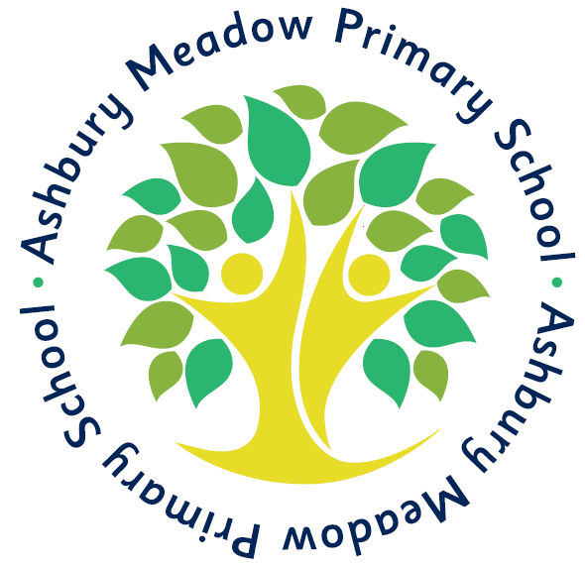
Ashbury Meadow Primary School

Rylance Street, Beswick, Manchester, M11 3NA

Tel: 0161 989 2999

www.ashburymeadow.co.uk

admin2@ashburymeadow.manchester.sch.uk

head@ashburymeadow.manchester.sch.uk

Headteacher - Mrs L Thomas

Deputy Headteacher – Mr N Long

Tuesday 13th October 2020


Dear Parent/Guardian(s),

Google Classroom is a free and secure learning network for teachers, students and schools. It provides a safe way for us to connect, share content, access homework, participate in discussions and receive class information. Following half term, we will be using google classroom to set homework and to provide home learning if your child or class bubble is isolating and has to learn from home.

Using Google Classroom allows you and your child to have access to work at any time through the Internet and is accessible online and through any mobile devices with Internet capabilities—including iPhone, iPad and Android devices. It can also be accessed from a computer or a laptop.

Additionally, the use of Classroom will help keep students and parents informed of due dates and assignments.

Google Classroom is used as an educational tool will be used strictly for educational purposes.
Guidelines for using Google Classroom are as follows:

- Students will be required to use appropriate grammar instead of texting language.
- The site will be used to discuss school-related content only.

Your child’s account details will be sent out in due course.

If your child be accessing from a mobile device or tablet, please download the following apps from App Store or Play Store:

Google Classroom Google Docs Google Slides
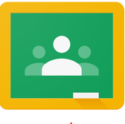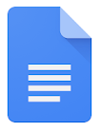
Thank you so much for being a part of our implementation of technology into our curriculum. Feel free to reach out with any questions or concerns.

Yours sincerely,

Ashbury Meadow Primary School

