Week 3 | 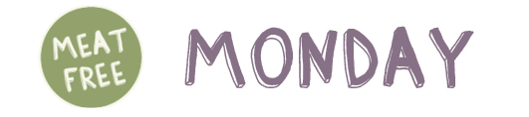 |  |  |  | 
 | 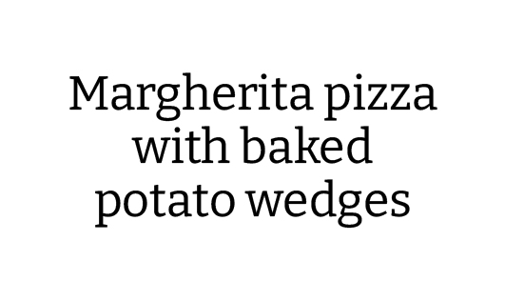 | BBQ Chicken Fillet  With Rice | Sausages With  Creamy Mash Potato  & Gravy | Chicken Fijitas With  Coleslaw & Salad | 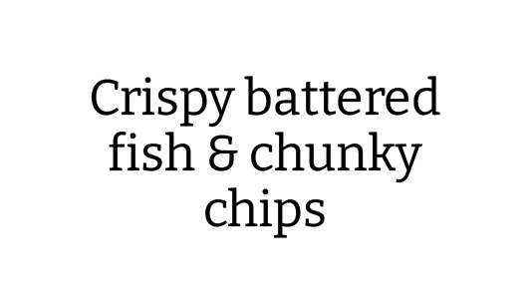
   | 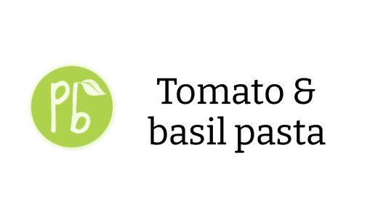 | Quorn Fillet &  Coleslaw | 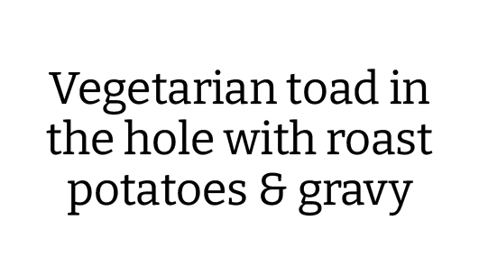 | 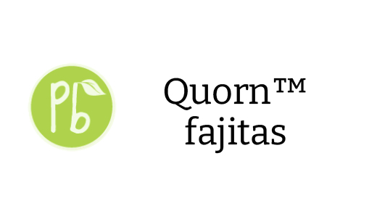 | 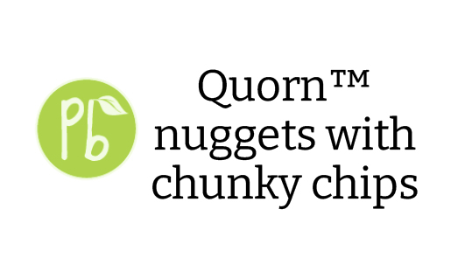
   | Baked Beans  . . . . . . . . . . . . . . . . . . .  Salad Bar | Green Beans & Carrots  . . . . . . . . . . . . . . . ..  Salad Bar | 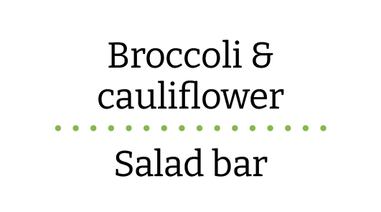 | Sweetcorn  . . . . . . . . . . . . . . . . . .  Salad Bar | Peas  . . . . . . . . . . . . . . . . . .  Salad Bar
 | Shortbread Biscuit | 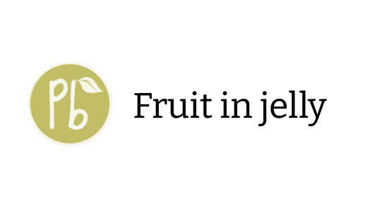 | Ginger Biscuit | Vanilla Sponge Cake | 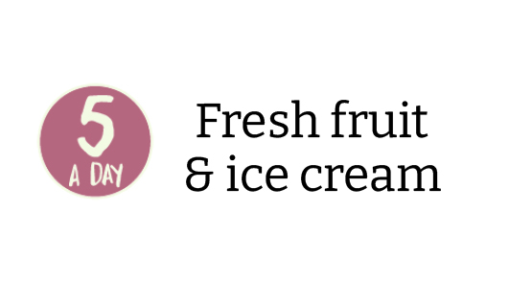
  or | 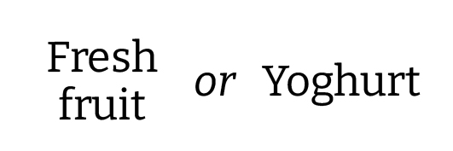
Jacket potato and  sandwich selection | Pasta Of The Day | Cold Sandwich Selection | Cold Sandwich Selection | Cold Sandwich Selection | Pasta Of The Day

