Week 2 | 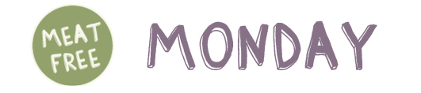 | 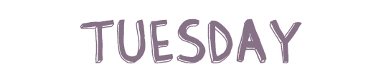 | 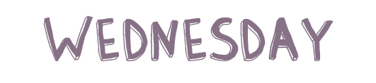 | 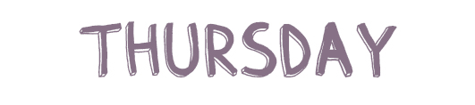 | 
 | Cheese & Tomato Pizza with Potatoes | Chicken Tikka Curry & 50/50 Rice | Hot Dog &  Wedges | Spaghetti Bolognaise  With Garlic Bread | 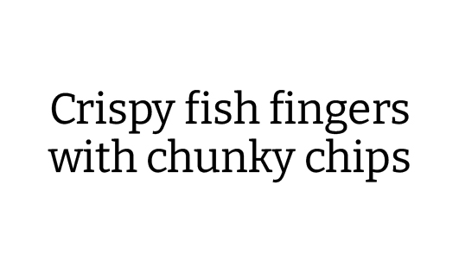
   | Cheese & Tomato Pizza | 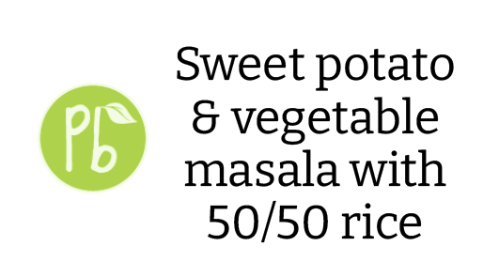 | Quorn Hot Dog | 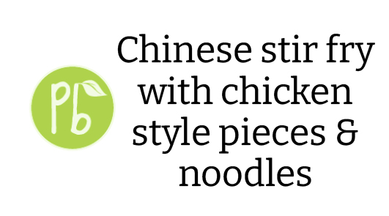 | 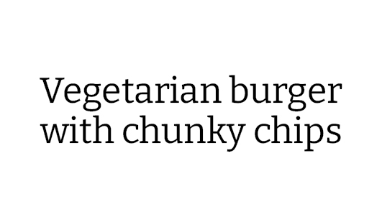
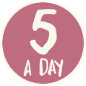   | Sweetcorn  . . . . . . . . . . . . . . . . . . .  Salad Bar | Green Beans  . . . . . . . . . . . . . . . . . . .  Salad Bar | Baked Beans  . . . . . . . . . . . . . . . . . . .  Salad Bar | Sweetcorn  . . . . . . . . . . . . . . . . . .  Salad Bar | Baked Beans  . . . . . . . . . . . . . . . . . .  Salad Bar
 | Orange & Lemon Buns | Cookie | Strawberry Moose | Fresh Fruit Slices | 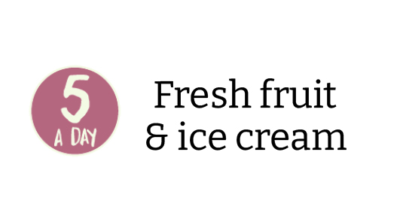
  or | 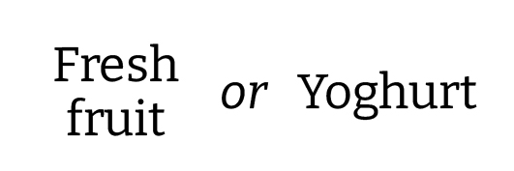
Jacket potato and  sandwich selection | Pasta Of The Day | Cold Sandwich Selection | Cold Sandwich  Selection | Cold Sandwich Selection | Pasta Of The Day

