 |  |  |  |  | 
 | Margherita Pizza with Baked Wedges | Chicken Tortilla  With Coleslaw | Sausage &  Creamy Mash Potato | Spagetti Bolognaise  Garlic Bread | Fish Fingers  Chunky Chips
   | 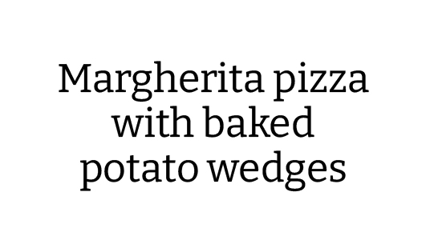 | Vegetarian Strips  & Coleslaw | Quorn Sausage With  Creamy Mash | Quorn Bolognaise  Garlic Bread | Vegetarian Nuggets  With Chunky Chips
   | Baked Beans  . . . . . . . . . . . . . . . . . .  Salad Bar | Sweetcorn  . . . . . . . . . . . . . . . . . .  Salad Bar | Baked Beans  . . . . . . . . . . . . . . . . .  Salad Bar | Green Beans & Carrot Sticks  . . . . . . . . . . . . . . . ..  Salad Bar | Peas  . . . . . . . . . . . . . . . . . .  Salad Bar
 | Ginger Biscuit | Watermelon & Fresh  Fruit Slices | Baked Sponge | Strawberry Jelly | Ice Cream
  or | 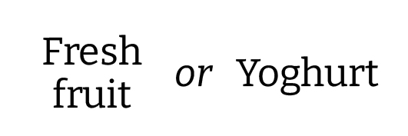
pasta and  sandwich selection | Pasta Of The Day | Cold Sandwich Selection | Cold Sandwich  Selection | Cold Sandwich Selection | Pasta Of The Day

