Year 1 Geography: People and their communities
Key Vocabulary
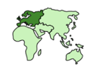  continent | A large area of solid land.
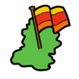  country | Land that has a government controlling it.
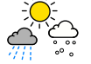  climate | A pattern of weather.
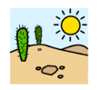  desert | A place that is hot and dry.
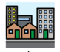  city | A large place for people to live.
  capital city | An important city where leaders made decisions.
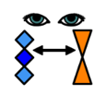  compare | What is the same and what is different.
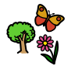  physical geography | Parts of the world that are natural such as a river.
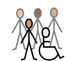  human  geography | Parts of the world that humans made such as a house.
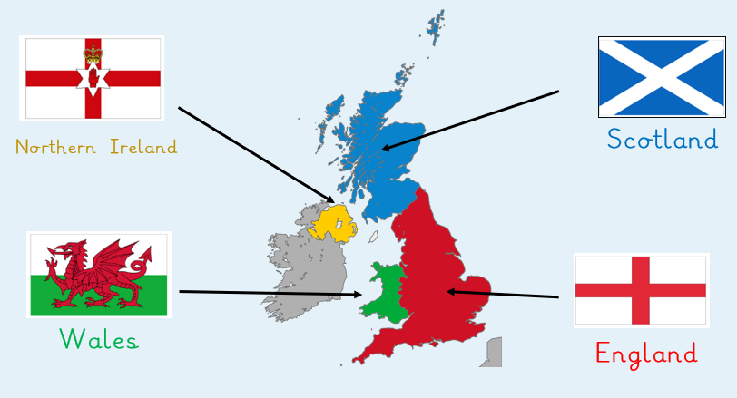
Jobs related to geography:
weather presenter explorer

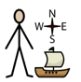
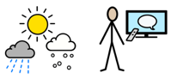

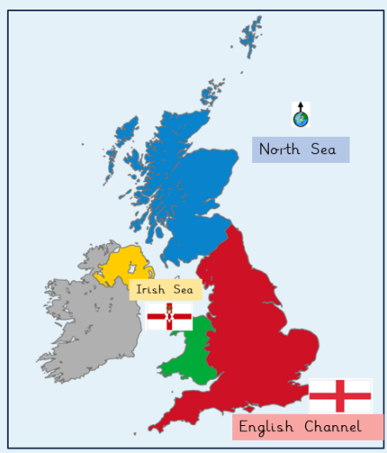

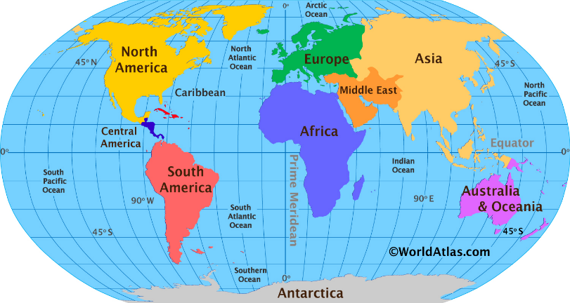

United Kingdom Mali
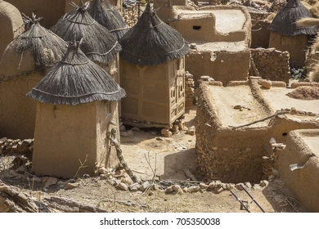
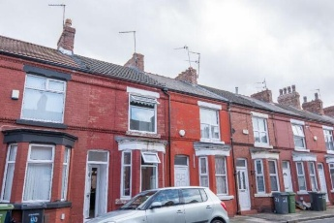
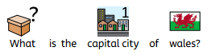

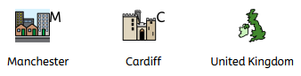
At the end of this topic, I will be able to understand why people do not live in the same houses.

