|  |  |
| --- | --- |
| **Key Vocabulary** | |
| **A two buildings with flags  Description automatically generated with medium confidencecity** | a large town |
| **A green and black map  Description automatically generatedstate** | a nation or territory considered as an organized political community under one government. |
| **A building and flag on flags  Description automatically generated with medium confidencecountry** | a nation with its own government, occupying a particular territory. |
| **A green and green map  Description automatically generatedcontinent** | any of the world's main continuous expanses of land (Europe, Asia, Africa, North and South America, Australia, Antarctica). |
| **North America**   | the northern portion of the continent. It includes the world's largest island Greenland and the sovereign states of Canada, the United States, and Mexico. |
| **South America** | a continent entirely in the Western Hemisphere and mostly in the Southern Hemisphere. It includes 14 countries including Argentina, Bolivia, Brazil, Chile, Colombia, Ecuador and Peru, |
| **compass** | A compass is a tool for finding direction. A simple compass is a magnetic needle mounted on a pivot, or short pin. |
| **A globe with arrows pointing to the earth  Description automatically generatedcompass points** | The directions on the compass. The 4 main points are North, South, East and West. Halfway between each of these is North-East, South-East, South-West and North-West. |
| **equator** | an imaginary line around the middle of a planet or other celestial body. It is halfway between the North Pole and the South Pole, at 0 degrees latitude. |
| **A grey and white sphere  Description automatically generatedhemisphere** | is half of a sphere, or ball. People use the word to describe one half of Earth. These are the Northern and Southern hemispheres. |
| **Biome** | is a large area on Earth where certain types of plants and animals live, and the climate is similar |
| **Tourism** | is when people travel to different places for fun, to explore, or to relax. |

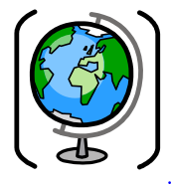

**The Americas Knowledge Organiser**

We will be learning about the North and South American continents

**Key concept:** Investigating Places

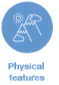

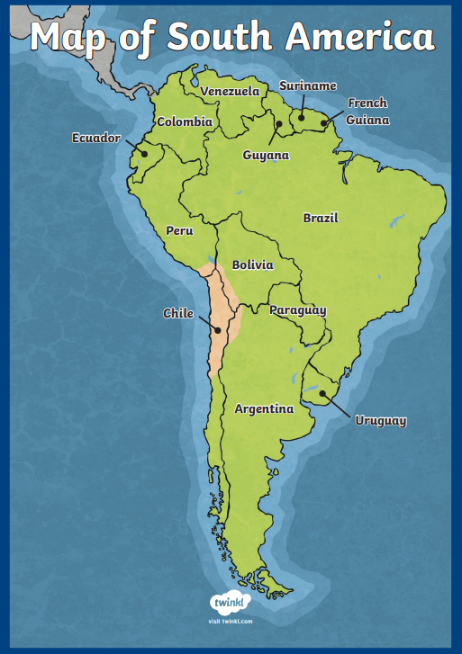

Map of South America

**What will I learn?**

By the end of this topic, I will know:

* how to distinguish between the key terms such as ‘continent’, ‘country’, ‘state’ and ‘city’
* how to identify key cities and states in North and South America
* how to use images, interactive maps and atlases to research key cities, compare the built environments and settings, through them, identify some key regions of the American continents

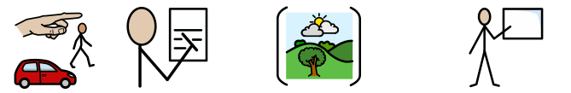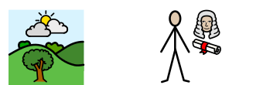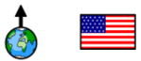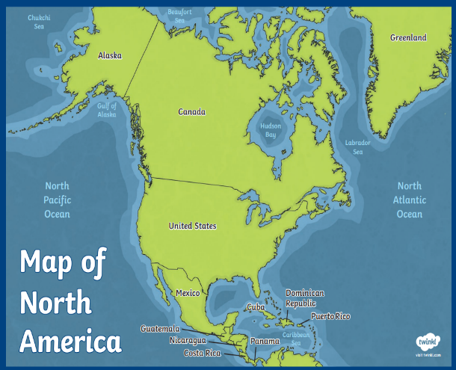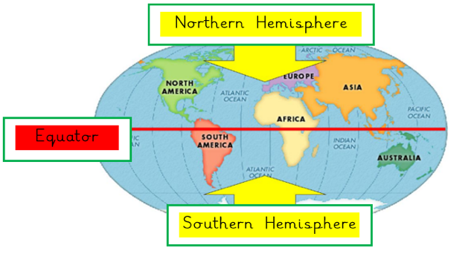

Careers linked to this unit of learning:

Travel journalist Environmentalist Teacher Environment Lawyer

Map of North

America

**Did you know?**

* There are 50 states in the United States of America.
* South America has 14 countries including: Brazil has the largest population of all countries in South America with 212,559,417 people!

(2020)