Ashbury Meadow Primary School

Rylance Street, Beswick, Manchester, M11 3NA

Tel: 0161 989 2999

www.ashburymeadow.co.uk

admin2@ashburymeadow.manchester.sch.uk

head@ashburymeadow.manchester.sch.uk

Headteacher - Mrs L Thomas

Deputy Headteacher – Mr N Long

10.7.25

Dear parents and carers,

During year 4, your child will take part in the Primary School Swimming Programme. We will be going swimming every Monday at the East Manchester Leisure Centre. The first lesson will take place on Monday September 8th.

Please note:

* Children will be accompanied by school staff and parents are not permitted to watch
* Children must wear appropriate clothing. Please see overleaf for examples
* No jewellery is allowed whilst swimming, e.g. earrings, bracelets and necklaces
* Girls and boys with long hair must wear a swimming hat
* Swimming lessons are compulsory – they are a requirement of the National curriculum and are not optional.

Changing Arrangements

Children will get changed in designated same sex changing rooms. The changing rooms are not accessible to the public. For safeguarding reasons, children either change in a large same sex group changing room or a smaller same sex group cubicle.

If you have any questions, please speak to your child’s class teacher.

Many thanks,

Miss Rothwell and Mrs Drury

Year 4 Class Teachers

………………………………………………………………………………………………………………

Please complete the permission slip to state your consent for your child’s attendance at swimming

I give permission for my child to attend swimming lessons every week at East Manchester Leisure Centre. I understand and agree that they will be walking there and back every week (tick to show consent)

Child’s Name: _________________________________ Class ______________________

Parent Signature: _________________________________ Date: __________________

East Manchester have specific requirement for the swimwear that your child should wear due to safety reasons. If your child does not wear the correct swimwear they will not be allowed to swim. It is very important that children wear exactly what is asked of them to avoid disappointment, children missing out on their learning and having to spend additional money re-buying swimwear.

Boys swim shorts must be tight fitting rather than baggy. If wearing full coverage costumes they must be light swimming costume material as opposed to the heavier weight wetsuit material.

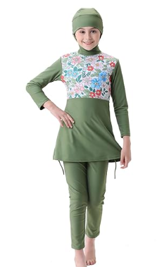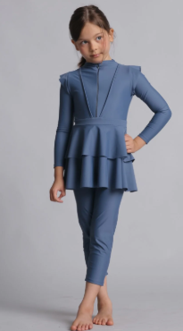Examples of appropriate clothing:

