
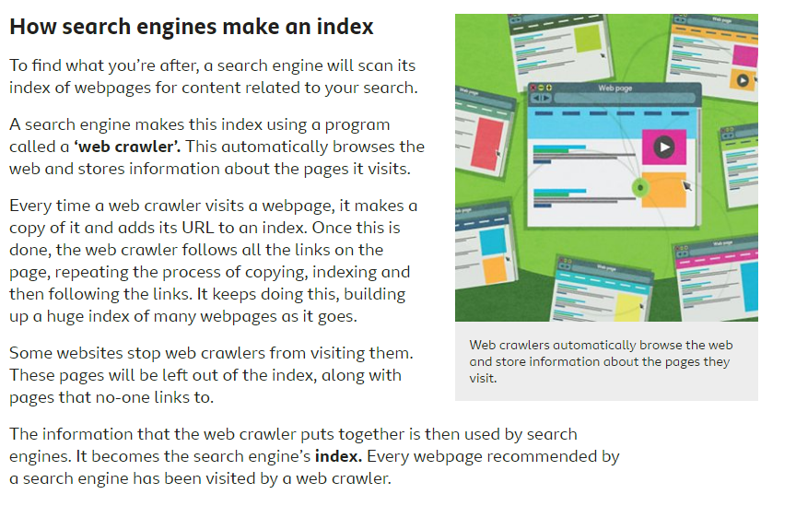
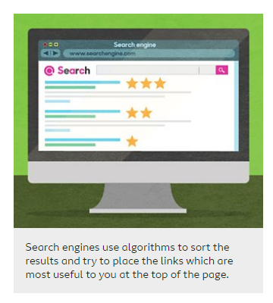
Watch this clip again Evaluating digital content
Can you think of some questions to ask about the ancient Mayas. Look at several of the websites for the results. Are they always the same? Which ones do you think are the most accurate and reliable?
Think of at least 3 questions and record the results from more than 1 site. Make them quite precise questions. Write them down to compare the answers. Then write some top tips you think might help someone else when searching for answers.
Example
Question | Result website 1 | Result website 2 | Which I think is most reliable and accurate and why
What was the Mayas’ favourite food?

How were the pyramids made?

Who was the most famous Maya?



