

The world wide web is a big place. If you know the web address, or URL, of a site you can find it by typing it into the address bar along the top of your browser. But what if you don’t know the URL?
You can find pages by following links from other pages but usually it is easier to search for things using a search engine.
These are programs that search an index of the world wide web for keywords and display the results in order.
A search engine uses web crawlers to find information and send a copy of each page back.
Algorithms are used to find the best match and then sites are ranked according to may factors including how well the site is written, how frequently it is used and how popular it is.
Watch this link about how search works. How search works
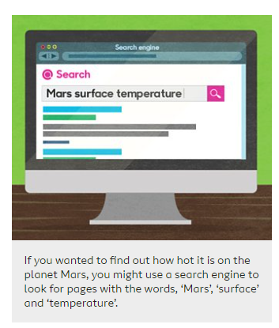

Think about the number of key words that you use. If you use too few keywords you could get too many results and they won’t all be relevant. However, if you use too many keywords, you might get no results at all.
Filtering Results
To help make your search more specific, you can use “quotation marks” around a set of words to find an exact phrase. If you add a minus symbol (-) before a word it will exclude pages that contain that word.
Making Sense of Results
Once you have a list of results, you need to choose which links to click on. Look at the information and then use your best judgement.
Usually the top links are the most relevant to your search. However, it can be worth scrolling down the page because you might find something better further down. Sometimes the top links are adverts for companies who have paid to be listed at the top. They will pay for every click they get, so may not be the best sites.
Evaluating content and being critical
Once you have chosen a site always be critical of what you read. Unlike most non fiction books that you get from a library, many sites are not checked for accuracy. If you have doubts about how reliable a piece of content is you can check it by looking at other sites. If they all say the say thing it is probably accurate. This is called ‘verification’.

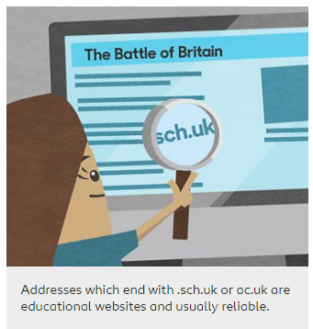

Some websites might be biased or could give only one side of an argument. These sites might give their opinion as fact.
Watch this link Evaluating digital content
Task - Use a search engine to find sites that tell us what games and toys the ancient Mayas played with. Write down how many results each search brings up.
If you word the search slightly differently, do different results come back? Why do you think this is?
Find out which keywords you can use to search, that come up with the best results. Are the results aimed at your age? What can you add to your search to make sure they are?

