Welcome to Suffolk County Music Service Remote Learning for WCET Classes.
WCET Lesson 4 w/c 1 February 2021
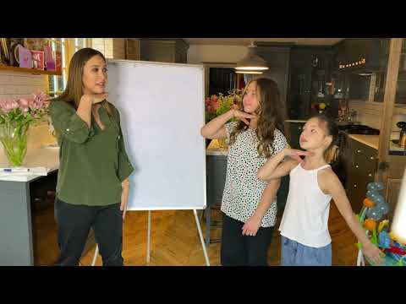
Here are some musical activities for you to do at home or in school, and a new piece for you to learn to play on your instrument if you have it. If you don’t have your instrument, don’t worry! Listen to the piece instead and learn what it sounds like so that when you come back into school you can play with your class. Have fun!
Activity 1: Learn how to turn your name
into a rhythm with Myleene Klass
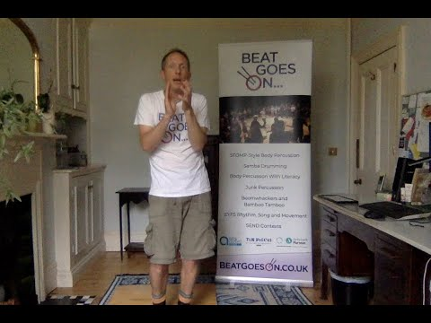
(ctrl + click on the link or click the picture)
The one where we learn basic rhythms and then play your name - YouTube Activity 2: Turn your rhythm name into Body Percussion with Ollie Tumner
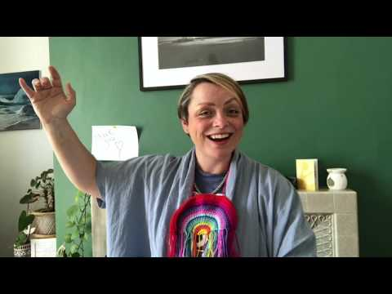
Activity 3: Sing https://www.youtube.com/watch?v=leeyYjcrspU

Sing Up teaches "I can see clearly now" - Learn the song with Beccy Owen - YouTube

Activity 4: Here’s your piece for this week:

