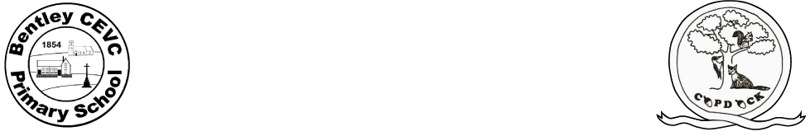
Weekly Plan Foxes
Week Beg: 18.1.21
 | Monday | Tuesday | Wednesday | Thursday | Friday
Phonics/Spelling/ Grammar (30 mins)  9-9:30 | Joe Wicks workout | Words ending /ably/  Practise on Spelling Shed | Joe Wicks Workout | Spelling Shed – column 3 year 5/6 words or Year 3/4 words or Year 2 common exception words | Joe Wicks Workout
Literacy (45 mins)  9:30-10:15 | Writing - Follow today’s activity on the writing activities sheet – sentences with time clues. | Writing - Follow today’s activity on the writing activities sheet – write complex sentences about comforting things in your bedroom. | Music – Complete the activities on the sheet | Writing - Follow today’s activity on the writing activities sheet – write sentences about Conor looking at the clock with embedded relative clauses. | Writing - Follow today’s activity on the writing activities sheet – write sentences about the moon with personification and alliteration.
Break, snack
Numeracy (45 mins)  10:45-11:30 | Year 5  Video divide 2 digits by 1 digit  Divide 2 digits by 1 digit worksheet  Year 6  Video fractions to decimals  Fractions to deciamls worksheet | Year 5  Video divide 3 digits by 1 digit  Divide 3 digits by 1 digit worksheet  Year 6  Video fractions to decimals  Fractions to decimals worksheet | Year 5  Video divide 4 digits by 1 digit  Divide 4 digits by 1 digit worksheet  Year 6  video Subtract mixed numbers  Subtract mixed number worksheet | Year 5  Video divide with remainders  Divide with remainders worksheet  Year 6  Video subtract fractions  Subtract fractions worksheet | Year 5  Multiplication/division mini assessment  Year 6  Video mixed addition and subtraction  Mixed addition and subtraction worksheet
Reading (15 mins)  11:30-11:45 | A Monster Calls reading comprehension | A Monster Calls reading comprehension | Follow the link on today’s discussion to listen to chapter 2 of A Monster Calls | A Monster Calls reading comprehension | Follow the link on today’s discussion to listen to Chapter 3 of A Monster Calls
Lunch
Topic (45 mins)  1:00-1:45 | Art – Look at the ancient Maya masks powerpoint on the blog. Use the template on the blog to design your own mask. Decide whether it will be an event mask or a death mask. | PSHE - : Jobs and Salaries. Use the occupation cards from the blog and put the occupations in the order of what you think is each one earns annually (yearly). You can check the average salaries for each occupation in Suffolk using this salary checker https://www.checkasalary.co.uk/  How important is salary when choosing a job? If possible, discuss this with an adult at home. What else is important? Write down at least six things (not salary) that are important when choosing a job.  PE - Use some of the activities from getset4pe | RE – Hinduism – How do questions about Brahman and atman influence the way a Hindu lives?  Enquire -  Watch this story  The Blind Men and the Elephant  Does it explain why Hindus have different views about God?  Look at the ppt on the blog and then complete the sheet about different views of God.  Think about the views of God in other religions using the mind map to help you.  Complete the questions in the last page. | Topic – Ancient Mayas – Gods and Religion  Look through the powerpoint on the blog. Complete one set of the activity sheets, either 1,2 or 3 stars about ancient Maya Gods.  PE – Use some of the activities from getset4pe | Science – Properties of materials for a festival.  Camp Bestival  Complete the food preparation challenge.  .
TEAMS Assembly 2:15pm | Active Assembly Mrs Windmill/ Mrs Collins | Values Assembly Mrs Austin | Open the Book Assembly Mrs Rudge/ Mrs Duff | Live Book Read  KS1 Mr Ross or  KS2 Mrs Robinson | Foxes learning review 2.30pm
Reminders/ advice |  |  |  |  | Homework due in today

