Welcome to Suffolk County Music Service Remote Learning for WCET Classes.
WCET Lesson 1 w/c 11 January 2021
Here are some musical activities for you to do at home or in school, and a new piece for you to learn to play on your instrument if you have it. If you don’t have your instrument, don’t worry! Listen to the piece instead and learn what it sounds like so that when you come back into school you can play with your class. Have fun!
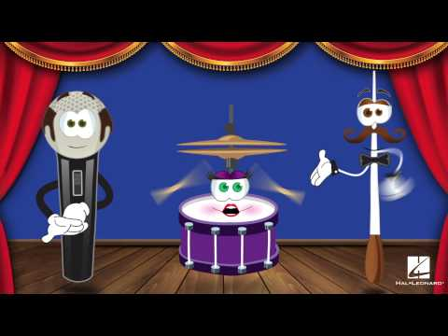
Activity 1: Wake up with some rhythm work. Follow this link to see what it is: (ctrl+click on the link or click the picture)
The Music Show - Beat is the Heart of Music
Activity 2: Let’s listen or do the composition activities too.
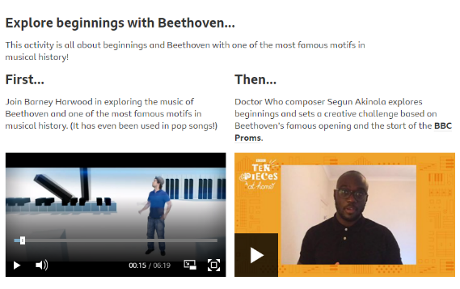
BBC 10 Pieces Tasters - Beethoven
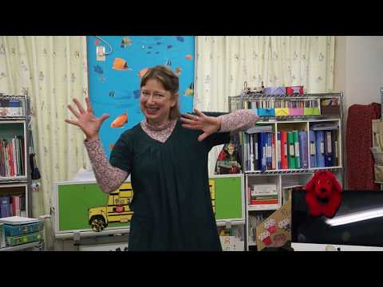
Activity 3: Wake your voice and body up with a song
Head and Shoulders Baby

Activity 4: Here’s your piece for this week: If you don’t have your instrument, remember to listen, and learn the tune and rhythms anyway to play in class later. First do some warmups: Take your time learn this over this half term.
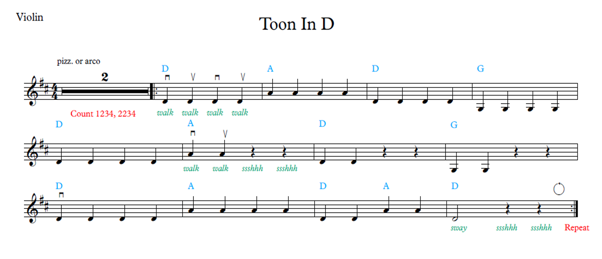
See if you can work out the notes to CAB’s

