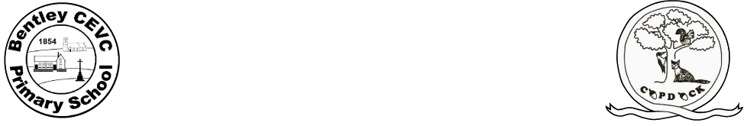
Home learning during school closure or self-isolation Kittens (Reception)
Summer Term 2 – Week Beginning: 22.6.20
 | Monday | Tuesday | Wednesday | Thursday | Friday
Maths | What are doubles:  https://classroom.thenational.academy/  lessons/understanding-the-concept-of-double  Resources 10 objects | What is half?  https://classroom.thenational.academy/  lessons/understanding-the-concept-of-half  Resources: number cards 1-10, tens frame  See Monday’s blog for Maths resources for the week if you want to print them out | What is half?  https://classroom.thenational.academy/  lessons/understanding-the-concept-of-half-f622a4  Resources: number cards 1-10, tens frame, part-whole model  See Monday’s blog for Maths resources for the week if you want to print them out | What is half?  https://classroom.thenational.  academy/  lessons/understanding-the-concept-of-half-479f36  Resources: Part – whole model  See Monday’s blog for Maths resources for the week if you want to print them out | Understanding doubling and halving  https://classroom.thenational.  academy/lessons/applying-understanding-of-doubling-and-halving
Writing  Please use the document found on Monday’s Class Blog page –Max’s Jungle Adventures | Max’s Jungle Adventures  With a grown-up read the story on pages 4-5. Please complete pages 14. | Max’s Jungle Adventures  With a grown-up read the story on pages 4-5. Please complete pages 15 and 16. | Max’s Jungle Adventures  With a grown-up read the story on pages 4-5. Please complete pages 17 and 18. | Max’s Jungle Adventures  With a grown-up read the story on pages 4-5. Please complete pages 19 and 20. | Max’s Jungle Adventures  With a grown-up read the story on pages 4-5. Please complete pages 21 and 22
Reading | Enjoy Max’s Jungle Adventure.  This is an audio version. | Enjoy the story of Handa’s Surprise. Ask your child to talk about their favourite fruits and why they like them. | Choose a book from Oxford Owl  Login = WSR12 password = bcps  Share a story from online Storytime – see attached PDF on blog page | Choose a book from Oxford Owl  Login = WSR12 password = bcps  Share a story from online Storytime – see attached PDF on blog page | Use an atlas or a map and locate countries that make up the UK. Your child can then locate a contrasting country such as Brazil or Kenya. What is different? What is the same?
Spellings/phonics  https://www.youtube.com/  channel/UCP_FbjYUP_UtldV2K_-niWw  The above link is to a YouTube Letters and Sounds page where new phonic lessons are updated daily at 10am. This may offer you more resources to support your child at home. | Continue to use teach your monster to read.  www.teachyourmonst  ertoread.com  (free to set up an account on laptop/home computer)  Phase 3 - revision: - ur  https://www.bbc.co.uk/bitesize  /topics/zvq9bdm/articles/zjv4vk7unds  Follow up sound using games on Phonics Play:  https://new.phonicsplay.co.uk/ | Continue to use teach your monster to read.  www.teachyourmonst  ertoread.com  (free to set up an account on laptop/home computer)  Phase 3 sounds revision: - er  https://www.bbc.co.uk/bitesize/topics  /zvq9bdm/articles/zvmnmfr  Follow up sound using games on Phonics Play:  https://new.phonicsplay.co.uk/ | Continue to use teach your monster to read.  www.teachyourmonst  ertoread.com  (free to set up an account on laptop/home computer)  Phase 3 sounds revision:- ear  https://www.bbc.co.uk/bitesize/topics  /zvq9bdm/articles/z4p3pg8  Follow up sound using games on Phonics Play:  https://new.phonicsplay.co.uk/ | Continue to use teach your monster to read.  www.teachyourmonst  ertoread.com  (free to set up an account on laptop/home computer)  Phase 3 sounds revision: - air  https://www.bbc.co.uk/bitesize/topics  /zvq9bdm/articles/zj39382  Follow up sound using games on Phonics Play:  https://new.phonicsplay.co.uk/ | Continue to use teach your monster to read.  www.teachyourmonst  ertoread.com  (free to set up an account on laptop/home computer)  Phase 3 sounds revision: - ure  https://www.bbc.co.uk/bitesize/topics  /zvq9bdm/articles/zh828xs  Follow up sound using games on Phonics Play:  https://new.phonicsplay.co.uk/
Topic  Music  PSHE  Art | Flags:  Look at flags from around the world. Discuss which are your child’s favourites and why? Ask your child to design and make their own flag using 2d shapes.   | MFL:  Speak the  Language- There are lots of different ways to say hello around the world. Learn how to say hello in Spanish, French, Mandarin, German, Arabic and Italian with your child using Google Translate. Practise writing hello using the colours of the flag for each country.   | PE:  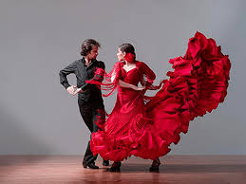  Dance Around the World- Watch the following dances: Diwali Stick Dance, Maypole Dancing and Spanish Flamenco Dancing. Encourage your child to have a go at some of the moves used in these videos. Record the dances and ask your child to evaluate what they did well and what they could do even better when watching them back. Can your child recreate one of the costumes using items from their wardrobe? Perform the dance to a family member. | PSHE: Coping with emotions in change situations  Read The Grandad Tree by Trish Cooke, which talks about the death of an elderly relative.  Ask the children how the characters were feeling when Grandad died. Encourage them to use a range of vocabulary to describe the feelings. Ask them what sort of things helped the characters to cope with the loss of their special person.  Other changes you can talk about are the birth of a new baby. Read Aiden’s Surprise. Talk about the feelings of the characters at each stage of the story and how they coped with their feelings. | Food tasting:  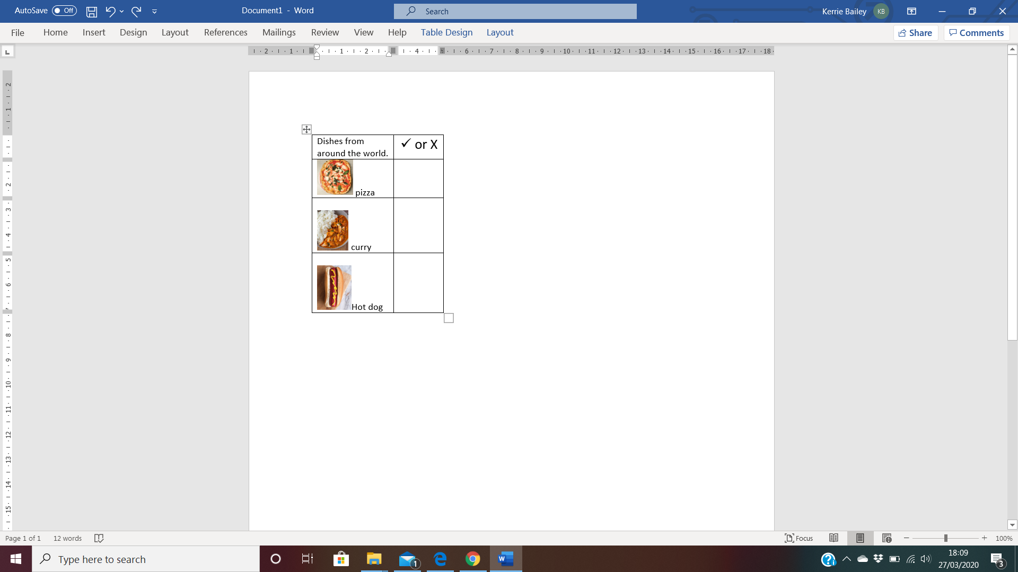  Find some different foods/fruits from around the world and taste each one. These might include: pizza (Italy), curry (India) and taco (Mexican) or the fruits from the story Handa's Surprise. Your child can create a chart putting a tick next to each food they like and a cross next to the foods they dislike over the course of the week.  Make your own Handa’s Surprise character puppet (see Monday blog page for stick  puppets)

Other suggestions for afternoon activities:
Where in the World?
Discuss with your child where your family comes from in the world. If you have them available, show your child photographs of where you, or their grandparents, grew up. This might be similar to where they live now or completely different. Encourage your child to think about the differences between the places.

Engineering Around the World – Bridges
A bridge helps people move over obstacles like a river, a valley or a busy road. The world’s longest bridge is in China and is 164.8km long. It would take more than two days to walk the length of this bridge. Do you have any bridges near your home? What do they look like?
Try building a bridge out of paper, Lego or any other building materials you might have at home. Your bridge needs to be big enough for a toy car or small toy to travel over.

PE Links
- PE with Joe Wicks every morning at 9am - www.youtube.com/channel/UCAxW1XT0iEJo0TYlRfn6rYQ
- Go Noodle, lots of fun dance resources - https://www.gonoodle.com/
- Youth Sport Trust have a range of resources to keep you active that you can access for free:
- Activity cards - www.youthsporttrust.org/pe-home-learning
- Active breaks - www.youthsporttrust.org/active-breaks
- 60 second challenge physical activity cards - www.youthsporttrust.org/60-second-physical-activity-challenges
- Cosmic Yoga - www.cosmickids.com/category/watch/ and use your print out of yoga moves.
- Create a circuit in your garden.

Collective Worship links:
https://www.thenational.academy/assembly
https://www.cofeguildford.org.uk/education/christian-distinctiveness/collective-worship/covid-19-resources

