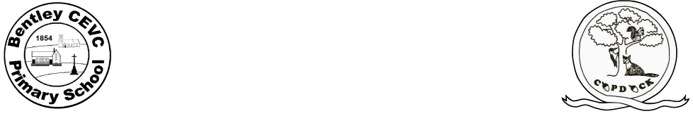Home learning during school closure or self-isolation Y1 & Yr2 Copdock
Week Beg:01.06.20
 | Monday | Tuesday | Wednesday | Thursday | Friday
Maths | Y2 Adding and subtracting two digit numbers and tens  Y1 Add and subtract by making 10 | Y2 Adding two digit numbers  Y1 Subtract within 20 | Y2 Subtracting two digit numbers  Y1 Addition and subtraction word problems | Y2 Bonds to 100  Y1 Comparing number sentences | Y2 Weekly maths challenge  And TTRockstars  Y1 Weekly maths challenge  And TT rockstars
Writing | Y1 Download Sydney Spider booklet  Read the story p3 and 4, and do p5 and 6.  Y2 Download The Magical Teaching Box booklet  Read the story p4 and 5 only, and draw what the box looked like. | Y1 Reread the story and do p7 and 8  Y2 Reread p4, 5 and continue with activities on p6, 7. | Y1 p9 and write your own sentence using each word.  Y2 Reread from p4 again and continue the story with activities on p8, 9. | Y1 p10 find the rhyming words, write some rhyming word lists of your own.  Y2 Reread the whole story again p4-9. Draw a story map to show the sequence and use it to tell someone the story with your own actions. | Y1 p11. (This booklet will be continued next week)  Y2 p 10 and 11. (This booklet will be continued next week)
Reading | Y1 and Y2 Choose a book from Oxford Owl  Login = WSR12 password = bcps | Y1 and Y2 Listen to ‘How the Whale got his Throat’. Draw a comic strip of the events. | Y1 and Y2 Read along with ‘There’s a Hole in the Bottom of the Sea’ Draw a comic strip to retell the events of the story. | Y1 and Y2 Choose a book from home | Y1 and Y2 Choose a book from Oxford Owl.  Login = WSR12 password = bcps
Spellings/phonics | Yr 1 and Yr 2 please log on to Spelling Shed where your new spellings linked to phonics have been set. | Yr 1 and Yr 2 please log on to Spelling Shed where your new spellings linked to phonics have been set. | Y1 Practise spelling the days of the week and then use them in a sentence.  Y2 Practise spelling the months of the year and then use them in a sentence. | Yr 1 and Yr 2 please log on to Spelling Shed where your new spellings linked to phonics have been set. | Y1 Phase 5  Y2 Phase 6  Phonics play website  Click on Resources then Phase 5 or 6
Topic  Music  PSHE  Art | Science: Guess Who?  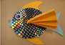  Write fact cards about animals from under the sea. Use books or websites to find out about the appearance, habitat and diet of each creature. After this, play a game of ‘Guess Who?’ using the cards and yes/no questions. | Geography: The Oceans of the World- Using an atlas or the web, identify the world’s oceans. Year 1 children may need some support with this. Can they find out what animals live in each ocean? This game allows you to practise naming and locating the oceans.  PSHE: Talk about changes  List what you can do now that you couldn’t do as a baby. List things you have learnt since you have been at school. Talk about some changes we like and some we don’t, but that change is a normal part of our life and sometimes we can’t do anything about it. | IT: Unplugged Coding  Watch this video.  Create a simple under the sea obstacle course or draw an obstacle course on a piece of paper. Write simple code to guide the submarine around the obstacles found under the sea. E.g. Rocks, shipwrecks, sleeping octopus. E.g. →→↓→→↑→ etc. | Art: Junk Modelling-Using junk or recycling materials from around the home, design and make a Sea Turtle or another sea creature.  OR:  Put Your Goggles On- Visit this website and watch a live stream of a tropical reef. Whilst watching, sketch all of the animals that you can see; look at the shapes and patterns on each creature. | Music: Visit this BBC website for more sea themed music and learning ideas. Can you add percussion to your songs?
PE Links:
- PE with Joe Wicks every morning at 9am - www.youtube.com/channel/UCAxW1XT0iEJo0TYlRfn6rYQ
- Go Noodle, lots of fun dance resources - https://www.gonoodle.com/
- Youth Sport Trust have a range of resources to keep you active that you can access for free:
- Activity cards - www.youthsporttrust.org/pe-home-learning
- Active breaks - www.youthsporttrust.org/active-breaks
- 60 second challenge physical activity cards - www.youthsporttrust.org/60-second-physical-activity-challenges
- Cosmic Yoga - www.cosmickids.com/category/watch/ and use your print out of yoga moves.
- Create a circuit in your garden.
Collective Worship links:
https://www.thenational.academy/assembly
https://www.stalbans.anglican.org/schools/worship-at-home/

