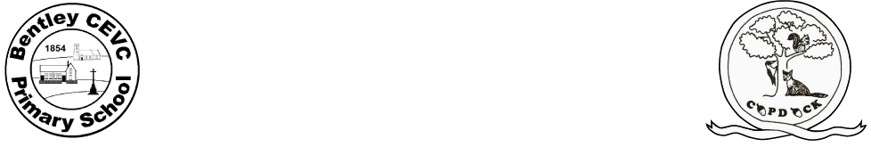
Home learning during school closure or self-isolation – Y3/4
Under The Sea
Week Beginning: 1.6.20
 | Monday | Tuesday | Wednesday | Thursday | Friday
Maths  (Make sure you spend some time on Times Table Rockstars each day) | Perimeter of a Rectangle – Follow the link below to BBC Bitesize and try some of the activities on the perimeter of a rectangle. https://www.bbc.co.uk/bitesize/articles/zbcnf4j | Perimeter of a Rectangle – Watch the video tutorial below https://kids.classroomsecrets.co.uk/resource/perimeter-of-a-rectangle-video-tutorial/  Then have a go a playing this interactive game  https://kids.classroomsecrets.co.uk/resource/year-4-perimeter-of-a-rectangle/ | Perimeter of Rectilinear Shapes – Follow the link below to BBC Bitesize and try some of the activities on rectilinear shapes https://www.bbc.co.uk/bitesize/articles/zkhwqp3 | Area by Counting Squares - Follow the link below to BBC Bitesize and try some of the activities on area https://www.bbc.co.uk/bitesize/articles/zjf2xyc | Area and Perimeter Investigation - On an A4 piece of paper and mark out a rectangle 12cm by 24cm. Design a vegetable patch to include the following areas: A carrot zone with a perimeter of 32cm, a pea zone with an area of 12cm squared, a strawberry zone with an area of 20cm squared and a perimeter of 18cm.
Writing | Using the Talk4Writing link complete the activities on pgs.2-6 on connectives and comprehension.  https://www.talk4writing.co.uk/wp-content/uploads/2020/04/Y4-Unit.pdf | Using the Talk4Writing link complete the activities on pgs.7-9 on word definitions.  https://www.talk4writing.co.uk/wp-content/uploads/2020/04/Y4-Unit.pdf | Using the Talk4Writing link complete the activities on pgs.10-11 on comprehension and spellings.  https://www.talk4writing.co.uk/wp-content/uploads/2020/04/Y4-Unit.pdf | Using the Talk4Writing link complete the activities on pgs.12-13 on grammar.  https://www.talk4writing.co.uk/wp-content/uploads/2020/04/Y4-Unit.pdf | Using the Talk4Writing link complete the activities on pgs.14-15 on box planning a story.  https://www.talk4writing.co.uk/wp-content/uploads/2020/04/Y4-Unit.pdf
Reading | Read your own book for pleasure whilst listening to these sea noises. https://safeyoutube.net/w/cPB6 | Try researching and reading online about an ocean creature of your choice - here are some interesting facts about turtles to get you started! | Listen to and read along with two of the poems in the Under the Sea collection here. Compare the different uses of language in each one. | Can you make an under the sea themed bookmark or reading area? Can you include some of the new vocabulary you have collected over the week. | Read this extract from Ocean Emporium. Can you use a dictionary to clarify any unfamiliar vocabulary.
Spellings  (Make sure you spend some time on Spelling Shed each day) | Learn to spell the names of all of the world’s oceans. Can you write these in sentences of your own? | Alphabetical order: List each letter of the alphabet and try to think of a sea related word that corresponds with each letter. | Practise spelling your weekly words that are on Monday’s daily blog. | Put these words in alphabetical order and then use a dictionary to find the meanings of each word: marine, barnacle, crustacean, coral, mangrove & barracuda. | Practise the Year 3/4 Common Exception words or spelling rules for Year Year 3/4 . Can you include some of these words in your writing tasks?
Topic  Music  PSHE  Art | Exploring the Blue Abyss - Can you remember the oceans of the world? Find out about the five different layers of the ocean (Sunlight Zone, Twilight Zone, Midnight Zone, Lower Midnight Zone or Abyss and the Trenches). Sea creatures adapt incredibly to live in specific layers where the conditions, such as the temperature and light levels, can change. Can you explore the creatures that are found in each layer of the ocean and create a fact file for each ocean layer with a labelled diagram? | Submarine Sculptures/Stem Science - Look at pictures of real submarines for inspiration and create your own model submarine from different materials found at home e.g. plastic bottles, paint, coloured pencils, string, paper mache, sweet wrappers, tin foil and cardboard. As you are collecting your materials, think about the suitability of each material. Alternatively, follow the link below and create your own layers of the ocean. https://fun-science.org.uk/layers-of-the-ocean-visual-experiment/ | Wind Down Wednesday - Try some yoga using the Cosmic Kids YouTube channel. There are lots of ‘Under the Sea’ themed yoga workouts and even a Moana-themed adventure! Or simply get stretching to some relaxing deep sea sound effects. | Reef Research - The Great Barrier Reef is the only living thing which is visible from space! Encourage your child to take a virtual tour of the reef using AirPano and create a poster or video to promote the Great Barrier Reef. Ask them to use scientific language relating to the habitats and species groups found in the reef. Can your child identify the main threats to The Great Barrier Reef and include these too? | Creature Collage – Can you create your own fishy mosaic using recyclable materials. Have a look at the pictures below for inspiration.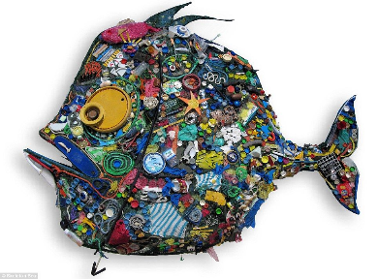  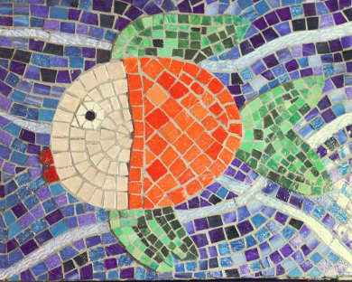

PE links: Make sure throughout the day you get fresh air and you are physically active every day for at least 60 minutes. You can do this by:
- PE with Joe Wicks every morning at 9am - https://www.youtube.com/user/thebodycoach1
- Go Noodle, lots of fun dance resources - https://www.gonoodle.com/
- Youth Sport Trust have a range of resources to keep you active that you can access for free:
- Activity cards - www.youthsporttrust.org/pe-home-learning
- Active breaks - www.youthsporttrust.org/active-breaks
- 60 second challenge physical activity cards - www.youthsporttrust.org/60-second-physical-activity-challenges
- Cosmic Yoga - www.cosmickids.com/category/watch/ and use your print out of yoga moves.
- Create a circuit in your garden or in a large space using the ideas given to you in your printed pack before half term.


