Answer Wednesday 6th May
Year 5 Maths Timetables
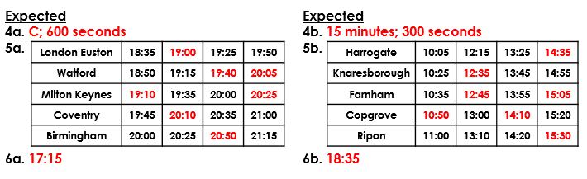
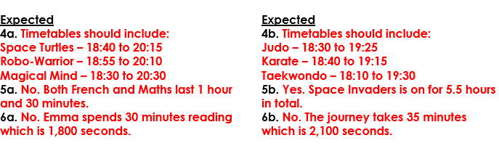
Year 6 Maths Calculate with Metric Measures
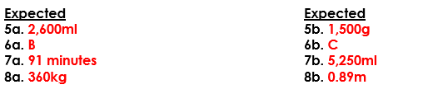
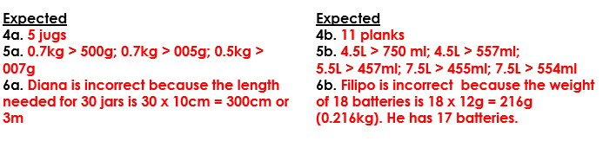

Reading The Water Tower

