Answers Thursday 30th April

Grammar – Parenthesis for Clarity

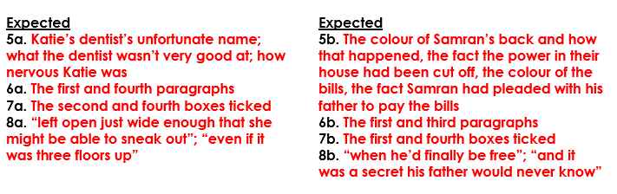

Maths Year 5 – Metric Units
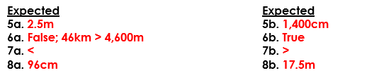
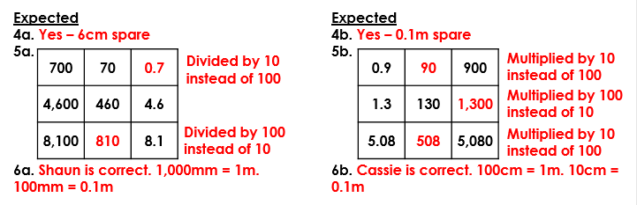

Year 6 Maths – Volume of a Cuboid
