Answers Monday 27/4/20
Reading The Wexbridge Crier
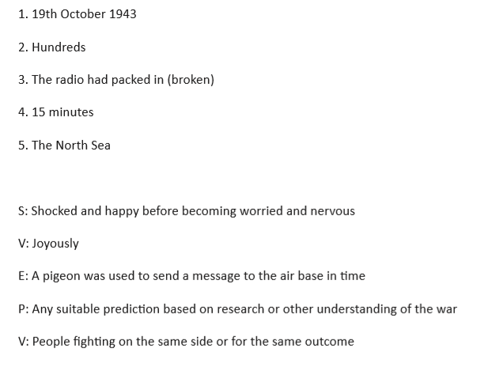
Year 5 Maths

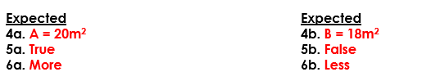

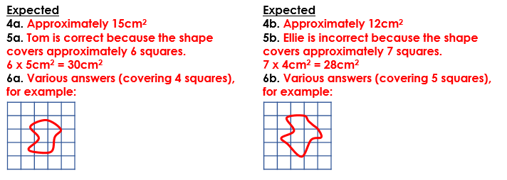

Year 6 Maths
