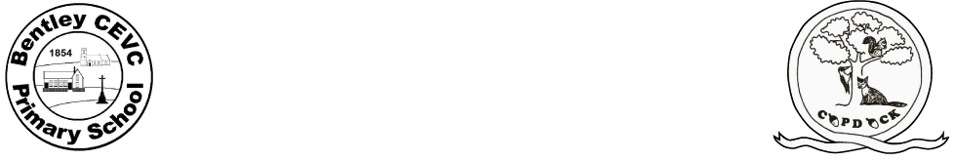
Weekly Plan Y3 & Yr4
Week Beginning: 07.06.2021
 | Monday | Tuesday | Wednesday | Thursday | Friday
Daily morning activity  8.50 – 9.15 | PD DAY – NO SCHOOL | Daily Literacy  Vocab words: ‘lifecycle' and 'supreme' | Daily literacy  Once upon a picture (see separate document) | Daily Maths  Hedgehogs – Mental Arithmetic | Daily Maths  Hedgehogs – Ultimate times tables test
Phonics/ Spelling/ Grammar  9.15 – 9.35 |  | Hedgehogs – Spelling test | Hedgehogs –  Teach spelling rules | Hedgehogs – SPaG- Apostrophes | Hedgehogs – SPaG  Apostrophes
Maths  9.35 – 10.00 |  | Maths – 9.30-10.25  4G–2 Identify regular polygons, including equilateral triangles and squares, as those in which the side-lengths are equal, and the angles are equal.  See separate plan for details | Maths – 9.30-10.25  4G–2 Find the perimeter of regular and irregular polygons.  See separate plan for details | Hedgehogs – The Boy Who Grew a Dragon book.  Read Chapter 12 & 13 and begin VIPERS  SH Group | Hedgehogs – The Boy Who Grew a Dragon book.  VIPERS  SH Group
Numeracy  10 – 10.30 |  |  |  | Hedgehogs – Recap on previous learning about the water cycle. Using the template, plan an independent piece of writing about rivers. Refer back to grammar used on the ‘thinking side’. | Hedgehogs – begin to write independently using the planning document. Throughout the lesson, ask children to reread their writing and edit. At the end of the lesson, peer assess and share writing.
10.30 – 11.00 Assembly
Break
Literacy / Numeracy  11 - 12 |  | RE WOW DAY  ENGAGE with the idea someone moving you from dark to light.  Hedgehogs- 11.30-12 Singing Practise | RE WOW DAY  EXPLORE (2) how the Granth is a living Guru (Sikh community practice)
Lunch
Topic  1:00-2.00 |  | RE WOW Day  ENQUIRE into the idea of Nanak as a Guru. | Singing practise | Active Listening Activity | Active Listening Activity
Topic  1:00-2.00 |  | EXPLORE (1) How Nanak became a Guru (Sikh narrative) | Hedgehogs –1:20 – 2:00 Homework check and new homework.  2:00 – 3:00 PE: Netball | Hedgehogs – Romans  Who were the Romans?  Place events in chronological order on a timeline.  Ask and answer questions about the past, considering change, cause, similarity and difference and significance.  See separate plan. | Family Assembly  1.15pm
Hedgehogs – PSHE

To understand the main stages of the human lifecycle: birth, baby, child, adolescent, adult, middle age, old age, death.

To investigate perceptions of being ‘grown up’.

Topic
2.00 – 3.00
Story and get ready to go home
3.00 – 3.10
Reminders |  |  | Hedgehogs-Homework due in.  New homework set – due in Wednesday 16th June

