Tuesday 2nd March 2021
I can summarise the main ideas drawn from more than one account, identifying key details that support the main idea.
I can retrieve, record and present information from non- fiction
I can distinguish between statements of fact and opinion
 | For  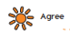 | Against  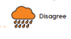
Senior viewpoint

Community Viewpoint


Pupil Viewpoint
