Islam Concepts and Key Questions covered
Key Stage 1 | Allah / mercy  How do some Muslims show Allah is compassionate and merciful?
Key Stage 2
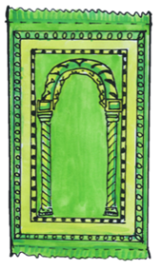  How does a Muslim show their submission and obedience to Allah? |   Why do Muslims call Muhammad the ‘seal of the prophets’? |   What does the Qur’an reveal about Allah and his guidance? | 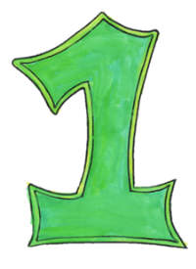  How does tawhid create a sense of belonging to the Muslim community?

End of phase Islam Core knowledge : What do we want pupils to know?
By the end of KS1, pupils are introduced to Islam through the stories of Muhammad who they learn is an important person to Muslims. They encounter the name ‘Allah’ and learn about other names used to describe him. Pupils explore the festival of Ramadan and Eid and learn the words ‘fasting’ and ‘sharing’ to talk about what Muslims do during these festivals.
.

By the end of KS2, pupils learn that at the heart of Islam lies obedience and submission to Allah as creator. Pupils learn that Muslims across the world respond to the call of prayer as an act of submission and recite words of importance such as the Shahadah, a statement of faith in Muhammad as God’s messenger, but also in the one-ness of God. These core beliefs are strengthened through the Global Islamic community, the ummah. Pupils encounter text from the Qur’an, understand how it is respected and revered, and learn about its importance as the revealed word of God.

