
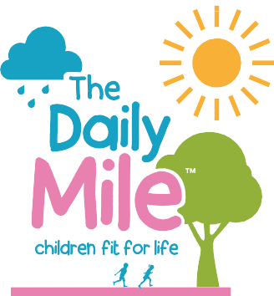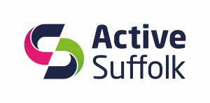


The Daily Mile Twilight Wave
6.30pm Friday 18th July 2025
Dear parent/guardian,
We are delighted to announce that we will be offering FREE places in this years ‘Daily Mile’ wave of the Ipswich Twilight race.
Your child’s school has been selected for FREE ENTRY as they are currently signed up and committed to delivering The Daily Mile, supporting children to live healthy and active lives.
As well as pupils having lots of fun, we hope that it will help to further raise the profile of The Daily Mile in Suffolk and encourage more schools to get moving!
The Daily Mile wave is a 2K run around Ipswich town centre, details of the event and route can be found at: www.ipswichtwilightraces.com




How to Enter
Entry Criteria
Children must be over the age of 4 on the day of the run and all children under the age of 8 must be accompanied on the run by a parent or guardian. Parents/guardians are not required to register to accompany children participating and will not be issued with a run number or receive a medal.
Parents/guardians not accompanying children on the run are requested to be at the finish line to welcome them home. All of the children taking part and completing the run will receive a medal as they cross the finish line.
To register your child/children click the link below, enter the code DM2025 and complete the entry form:

Twilight – Daily Mile Entry

We have 300 places available which will be allocated on a first come first served basis and participation is completely FREE OF CHARGE!
Places are expected to go very quickly so we would encourage early registration to avoid disappointment.

