The Graduated Response in Sefton



Guidance for Parents and Carers
Sefton SEN and Inclusion Service

SEN and Inclusion Service 2020

Contents
Section 1: Introduction
Key Practitioners
Local Authority Practitioners: SENIS
School Practitioners:
Whole School Ethos/Senior Leadership Team
Role of the SENDCO
Role of the Class Teacher

Section 2: What is the Graduated Response?

Section 3: Quality First:
What is Quality First?
Assessment practices
Planning for all learners
Making Reasonable Adjustments
Monitoring and Reflecting on your Quality First Offer

Section 4: SEN Support:
Identification of SEN Support pupils
Assessment
Areas of Need
Developing robust SEN Support Plans
Interventions
Monitoring and Reflecting on SEN Support Offer

Section 5 Education Health and Care Plans
Request for Assessment
EHCP Statutory Timelines
Review Process

Section 6 Appendix

Introduction
This booklet has been devised by Sefton Special Educational Needs and Inclusion Service. It is intended to support parents and carers in understanding the implementation of the Graduated Response in Sefton school settings.
Sefton is a fully inclusive authority and expects all school settings to promote a positive ethos of inclusion. Schools are expected to welcome all pupils with diverse needs with caring and understanding, and to fully support all pupils and their families, during their time in the setting. Senior Leadership Teams are expected to promote this ethos.

A Guide to Sefton SEN and Inclusion Service

Key Practitioners
This service is comprised of the following specialist teams. Practitioners work together, to support schools at each stage of the Graduated Response:

Early Years Team and Portage
The Early Years Team works closely with families, early years settings and other agencies. Work includes contributing to the assessment of young children’s needs, helping to plan and review interventions and monitor progress, providing support with transitions and delivering training. The team consists of Portage Advisors, a SEN Inclusion Officer, Early Years Inclusion Consultants and Educational Psychologists. Schools with Nursery provision are able to refer to the Team for support for their pupils and this support continues for a transition period into Reception (first term). Referrals to this team should be made no later than a term prior to the pupil’s entry to Reception.

Generic Inclusion Consultants
The Generic Inclusion Consultants are a small team of skilled educational practitioners, whose background is rooted in teaching and special needs. The team has experience of working with pupils and advising teaching professionals, including SENDCOs from Foundation Stage to Key Stage 4, in mainstream and in specialist settings.
The Inclusion Consultants support whole school staff in developing excellence in practice at Quality First and SEN Support Level. The team are currently working with SENDCOs and Senior Leadership at a strategic level, using a range of methods including Cluster Group Meetings, individual and team approaches, with training in SEND available to both Primary and Secondary settings. The Inclusion Consultants also support schools with pupil transition.

Complex Needs Team
The Complex Needs Team support and advise staff in Sefton schools and settings to facilitate the inclusion and academic progress of children and young people with physical, medical and complex needs. The team work closely with parents, carers and health professionals to consider the physical access needs of a physically disabled pupil in terms of the school site and the curriculum and to ensure that the educational implications of a pupil’s medical needs are understood. This supports enables settings to make reasonable adjustments to their practice to effectively include the child or young person.
The team receive referrals from schools, settings, Health Visitors and Therapy Services.

Sensory Team
The Sensory Needs Team are a team of qualified, experienced teachers with additional specialist qualifications in teaching children with Vision and Hearing Needs. This includes Qualified Teachers of Visual Impairment (QTVI), Qualified Teachers of the Deaf (QToD), an Educational Audiology (EdAud) and a Sensory Support Worker:
- Hearing Needs Team
The Hearing Needs Team facilitates the inclusion and academic progress of Children and Young People (CYP) with a clinical diagnosis of hearing loss from birth through to 25 years. This is done through direct support to families, settings and schools. The needs of each young person with a hearing loss are different, therefore we offer a personalised level of advice and support to ensure that each young person thrives in their setting.
- Visual Impairment Team
The Visual Impairment Team facilitates the inclusion and academic progress of Children and Young People (CYP) with a clinical diagnosis of Visual Impairment from birth through to 25 years. This is done through direct teaching and support and advice to educational settings (supporting Quality First Teaching and the Graduated Response) and Parents/Carers in the home. Anyone can refer to the Visual Impairment Service if they suspect a child or young person has a vision impairment including parents/carers and schools, but most referrals come to us via Alder Hey Ophthalmology Department. The Local Offer has been recently updated with information on how to refer a CYP to the service including the appropriate referral and consent forms.

Specialist Teachers
The Specialist Teachers deliver direct teaching to identified students in schools across Sefton who have specific learning difficulties particularly with aspects of literacy and numeracy. They are a team of experienced teachers with additional specialist qualifications and are able to assess students to establish areas of need, deliver a bespoke programme and measure impact through ongoing regular assessment. They can also work with teachers and teaching assistants to develop personalised programmes of work for students. The services of Specialist Teachers can be purchased by schools through a service level agreement.

Social Communication Team
The Autism and Social Communication Team offers support to children and young people with Social Communication Needs and Autism in mainstream settings. The team consists of a Lead Practitioner and Inclusion Support Workers, who are specialists in providing advice, support, training, modelling, coaching and resources to primary and secondary mainstream schools across Sefton. The team work closely with the Inclusion Consultants to provide this support.
The team offer INSET training within schools as well as bespoke centralised training, a training and networking support programme for Primary Teaching Assistants, and specialist transition support programmes for children moving from nursery to reception, and from Y6 to Y7.

Educational Psychology Service
Educational Psychologists are professionals trained and skilled in understanding the development of children and young people and in understanding what makes it more difficult for them to learn, make progress and experience positive well- being. They offer a range of services. They offer a range of services, which might include ongoing consultations and assessments, Statutory Assessments and advice in line with the SEND Code of Practice 2015, individual and group interventions, support to the Local Authority in strategic areas such as Mental Health and Wellbeing. The team is also commissioned to support children and young people Looked After by the Local Authority and support other services such as Youth Offending Team and Early Help. The Psychology team is accessed via schools through Planning Meetings.

The SEN Team
The Special Educational Needs Team is the part of the SEN and Inclusion Service is responsible for carrying out Education, Health and Care (EHC) Assessments, producing EHC Plans and carrying out the Annual Reviews of those EHC Plans. When an EHC Assessment is agreed the child has a Casework Officer and Casework Assistant allocated to carry out their assessment. They will be the main point of contact for the school and family during the assessment, with the Casework Officer able to attend meetings to co-produce the EHC Plan. The Casework Officer can also attend Annual Reviews of the EHC Plan when this is necessary. Each school has a Casework Officer and Casework Assistant specifically allocated to them who they can contact with any queries about the EHC assessment process or any children with EHC Plans that they have in their school.

The Virtual School

The Virtual School supports Looked After Children, through their education journey to help them to overcome barriers to learning and achieve their potential. Every Looked After Child has a Personal Education Plan, which is developed by the Social Worker, the Looked After Child, the school and the carer. The Virtual School will check that the plan is ambitious, focused and detailed enough to be effective, and will pay a Pupil Premium Plus grant to the school to help with the cost of carrying out the plan. The plan is monitored each term and adjusted as needed. Each Looked After Child has an Education Coordinator who will monitor their progress and work with the child, and any professionals who are involved in their care, to ensure successful outcomes in education.

Post-16 Support
Post 16 support in Sefton is designed to help young people prepare for adulthood by increasing independence and identifying suitable progression routes relating to education, training and employment. Sefton commissions Career Connect to provide information, advice and guidance IAG) to young people between the ages of 16-24 where the young person has additional needs and has or had an Education Health and Care Plan (EHCP).
Career Connect delivers a range of support from Year 9 onwards, dovetailing with existing school Careers Education Information Advice and Guidance arrangements, and wider partner support for the young person. Specialist advisors link with schools and the Sefton SEN team to identify and provide support for those young people who are identified as being at risk of becoming NEET (not in Education, Employment or Training).
Career Connect helps prepare young people for the transition to their next steps in education, training or employment. This support will begin 3 years ahead of the transition with young people who are moving on at 16 receiving support from Year 9 and those who are leaving the school at 19 offered support from Year 11.
By age 25, young adults will have been prepared for adulthood and received help to meet their outcomes. Where ongoing Career Advice and Employment support is required clients can access support via National Career Service, Sefton@Work and DWP.

Schools: Roles and Responsibilities

Headteacher
The Headteacher should take overall responsibility for whole school SEND provision. In doing this they must ensure:
- The SENDCO has sufficient time and resources to carry out their duties
- They work with the SENDCO and School Governors to ensure that the school meets its’ responsibilities under the Equality Act (2010) with regard to reasonable adjustments and access arrangements
(Code of Practice, 2015: 6.91)

The Governing Body
The School Governing Body is a statutory body of parents, educators and non-teaching staff who work together to promote the wellbeing and effectiveness of the school community.
‘The governing board’s role is to make sure:
- The vision, ethos and strategic direction of the school are clearly defined
- The headteacher performs their responsibilities for the educational performance of the school
- The use of the school's financial resources is sound, proper and effective’
The Key for School Leaders

All schools should have either a member of the Governing body or a committee, with specific oversight of the schools’ arrangements for special educational needs and disabilities. All Governing Bodies have statutory duties towards pupils with special educational needs. The Governing Body must do its’ best to ensure that the school makes the necessary provision for every pupil with SEND. Schools should have information for parents and carers on the membership of their Governing Body, on their website.

Role of the Special Educational Needs Co-ordinator (SENDCO)
The SENDCO has a critical role to play in ensuring that children with Special Educational Needs and Disabilities within a school receive the support they need. The types of responsibilities a SENDCO has are:
- Overseeing the daily operation of the school’s SEN Policy
- Supporting the identification of children with special educational needs
- Coordinating provision for children with SEN
- Liaising with parents of children with SEN
- Liaising with other providers, e.g. Educational Psychologists and external agencies
- Meet with parents of SEND pupils on a termly basis (to share relevant SEN paperwork, e.g. SEN Support Plan)
The statutory requirements around this role are set out in the Children and Families Act (2015), the SEND Regulations (2015) and The SEND Code of Practice (DfE, 2015).
Parents/Carers may also request documentation relating to their child at any time.

Responsibilities of the Class Teacher:

The child or young person’s teacher(s) are responsible for their progress. The Special Educational Needs and Disability Code of Practice (2015) is very clear about this:

‘The class or subject teacher should remain responsible for working with the child on a daily basis. Where the interventions involve group or one-to-one teaching away from the main class or subject teacher, they should still retain responsibility for the pupil. They should work closely with any teaching assistants or specialist staff involved, to plan and assess the impact of support and interventions and how they can be linked to classroom teaching.’ (DfE, 2015:101).

Class teachers should provide regular updates on progress and strategies in place for SEN pupils in their class. Class teachers should ensure that they involve parents/carers and pupils in planning and reviewing progress, by seeking their views. The Code of Practice is clear that every teacher is a teacher of SEN.

What is the Graduated Response?
The Code of Practice, 2015 provides guidance on a ‘graduated response’ to identify and support pupils with a range of differences across the developmental spectrum. Sefton SEN and Inclusion Service supports schools in fulfilling their statutory duties at each level of the Graduated Response (see below).

Definition of Special Educational Needs:
‘A pupil has SEN where their learning difficulty or disability calls for special educational provision, namely provision different from or additional to that normally available to pupils of the same age.’ Code of Practice, 2015, 6.5

‘These [in school assessments] should seek to identify pupils making less than expected progress given their age and individual circumstances. This can be characterised by progress which:

- Is significantly slower than that of their peers starting from the same baseline
- Fails to match or better the child’s previous rate of progress
- Fails to close the attainment gap between the child and their peers
- Widens the attainment gap’ (Code of Practice, 2015, 6.17)

Schools use these definitions of SEN to identify pupils who may have special educational needs. Some pupils may have a diagnosis but may not require additional and different support and may be making good progress. Schools monitor these pupils carefully and make ‘reasonable adjustments’ as and if they are required. Schools support their pupils using the Graduated Response model. The child/young person does not need a diagnosis of a condition to be considered to have SEN, they may have difficulties in the above identified areas.

Definition of Disability

Children and young people may have a disability, defined by the Equality Act 2010 as:
‘…a physical or mental impairment which has a long-term and substantial adverse effect on their ability to carry out normal day-to-day activities’.

The SEND Code of Practice (DfE, 2015: xviii) outlines that:
‘This definition provides a relatively low threshold and includes more children than many realise: ‘long-term’ is defined as ‘a year or more’ and ‘substantial’ is defined as ‘more than minor or trivial’. This definition includes sensory impairments such as those affecting sight or hearing, and long-term health conditions such as asthma, diabetes, epilepsy, and cancer. Children and young people with such conditions do not necessarily have SEN, but there is a significant overlap between disabled children and young people and those with SEN.’

Quality First Teaching and Learning

Quality First Teaching is the school’s universal offer of excellent teaching to all pupils.

The Code of Practice 2015 states that Quality First Teaching is the first step schools must take in achieving the best outcomes for their pupils. Quality First Teaching is defined as:

‘High quality teaching, differentiated for individual pupils, is the first step in responding to pupils who have or may have SEN. Additional intervention and support cannot compensate for a lack of good quality teaching. Schools should regularly and carefully review the quality of teaching for all pupils, including those at risk of underachievement. This includes reviewing and, where necessary, improving, teachers’ understanding of strategies to identify and support vulnerable pupils and their knowledge of the SEN most frequently encountered’. Code of Practice, 2015, 6.37
For further information regarding what is classed as quality first provision and what is additional to and different from provision, there is a document on the Local Offer that sets out Sefton’s expectations on Quality First.

SEN Support Level
Should pupils not make expected progress from their starting points even with a robust Quality First offer, schools in consultation with parents and other professionals where appropriate, may then decide to move the pupil to SEN Support Level. Pupils at SEN Support Level may require additional or different approaches to enable curriculum access and progress to be made.

This forms the next layer of the Graduated Response:

SEN Support is the system by which schools should assess the needs of children and then provide appropriate support. The system should follow four stages, often referred to as the Graduated Approach (see below).

The Graduated Approach:
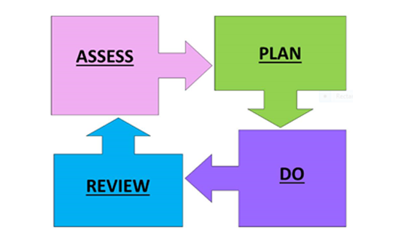

Using this approach teaching staff, SENDCO’s and the school leadership team closely monitor all their pupils to ensure they make expected progress, and plan and implement an effective curriculum to ensure this is progress is sustained. The review informs the next learning steps for the pupil.

Identification
For some children, SEN can be identified at an early age. However, for other children and young people difficulties become evident only as they develop. All those who work with children and young people should be alert to emerging difficulties and respond early. Parents know their children best and it is important that all professionals listen and understand when parents express concerns about their child's development. They should also listen to and address any concerns raised by children and young people themselves.

Persistent disruptive or withdrawn behaviours do not necessarily mean that a child or young person has SEN, however this should always be considered as a possible causal factor. If it is thought housing, family or other circumstances may be contributing to the presenting behaviour a multiagency approach, such as the Early Help Assessment, may be appropriate. In all cases, early identification and intervention can significantly reduce the use of more costly intervention at a later stage.
Slow progress and low attainment could be an indication of underlying SEN Need. If a pupil is working a year below age related expectations, responsive in-class intervention together with Quality First approaches may be sufficient to move a child or young person on. However, if a pupil is working significantly below the age-related expectations (this may be more than two years plus, below expectations), more robust planning and intervention will be required to support this pupil in accessing learning at SEN Support Level. Some pupils (for example those with an ASD profile) may achieve highly in curriculum areas but display significant social communication difficulties which require support and intervention in the school setting.

Assessment
Schools have in place a raft of assessment, monitoring and tracking systems which can be used to identify limited progress and attainment of their SEND pupils. Schools also use formal statutory assessments and informal assessment materials such as NFER Tests, Phonic Screening Test, SATS, CAT Assessments, Reception Baseline Assessment.

Referral to Outside Agencies:
Outside Agencies also play a key role in assessing and understanding pupils’ needs. Schools must put in place timely referrals to the appropriate agencies, with parental permission. External agencies may include health-based agencies such as the Community Paediatrician, Speech and Language Services, Occupational Therapy Services, or may be local authority-based services such as the Educational Psychology Service, the Social Communication Team or the Complex Inclusion Team. Referrals to the Visual Impairment and Hearing Needs Team are usually generated through Alder Hey Hospital. It is important that recommendations from these services are put into place to provide the appropriate support for pupils within the school setting. Schools may also make referrals to Social Care and can signpost parents to Special Educational Needs and Disability Information Advice and Support Service (SENDIASS) and Independent Parental Special Education Advice (IPSEA) for support and guidance.

Example of process for referral to outside agencies (SALT, OT):

The Four Areas of Need
When reviewing and managing special educational provision the broad areas of need and support outlined below may be helpful, and schools should consider how well equipped they are to provide support across each area.
The SEND Code of Practice (DfE, 2015:97-98) identifies ‘four broad areas of need’. These are:

- Communication and interaction
- Cognition and learning
- Social, emotional and mental health
- Sensory and/or physical

In practice, individual children or young people often have needs that range across all these areas and may change over time. The support provided to an individual should always be based on a full understanding of their developing strengths and needs and seek to address them all using well-evidenced interventions targeted at their areas of difficulty and where necessary specialist equipment or software.

Communication and Interaction Needs
Children and young people with speech, language and communication needs (SLCN) have difficulty in their receptive language (listening and understanding), expressive language (spoken language) skill or have difficulty with social communication skills. Assessment by a Speech and Language Therapist is required to identify where the difficulties lie, and in developing appropriate supportive programmes of learning. The profile for every child with SLCN is different and their needs may change over time. Children and young people within the Autism Spectrum are likely to have difficulties with social interaction. They may also experience difficulties with language, communication and imagination, which can impact on how they relate to others. Sometimes, the way in which language is used in the classroom and around school may impact on their learning. Pupils with Hearing Needs may also experience difficulties in this area.

Cognition and Learning Needs
Learning difficulties cover a wide range of needs, some pupils experience significant difficulties in acquiring basic skills to move their learning forwards in curriculum areas. These children are likely to need support in all areas of the curriculum and at SEN Support Level appropriate in-class and out of class interventions should be implemented to promote positive progress. Interventions must be linked closely to classroom learning, and pupils should apply learning from interventions in classroom sessions.
Educational Psychologists offer a range of cognitive assessments which enable school staff and parents to understand the underlying learning needs a pupil may have and can suggest ways forward to support these pupils. Some children and young people may present with specific learning difficulties (SpLD), which affect one or more specific aspects of learning. This encompasses a range of learning differences such as dyslexia, dyscalculia and dyspraxia. A diagnosis of a specific learning difficulty requires detailed assessment by an appropriately qualified professional. Many pupils experience difficulties with spelling, it should be noted that not all pupils with spelling difficulties have dyslexia. The needs of some pupils with these learning differences can sometimes be met through Quality First adjustments.
Some pupils may experience significant learning difficulties and a diagnosis may be given by an external professional (e.g. Paediatrician, Certified Assessor).
Children with diagnoses (for example those with Attention Deficit Disorder, Attention Deficit Hyperactivity Disorder, Autism Spectrum Condition, diagnosed physical/medical needs) may also experience some learning differences, impacted upon by their conditions.

Social, Emotional and Mental Health Needs (SEMH)
Children and young people may experience a wide range of social and emotional difficulties which can manifest themselves in many ways. These may include becoming withdrawn or isolated, or displaying challenging behaviour. These behaviours may reflect a range of underlying mental health difficulties such as anxiety or depression, self-harming, substance misuse, eating disorders or physical symptoms that are medically unexplained. Other children and young people diagnosed with learning difficulties Attention Deficit Disorder (ADD), Attention Deficit Hyperactive Disorder (ADHD) or Attachment Disorder (AD) may present with co-occurring behavioural manifestations which could fit within the category of SEMH. External agencies will be involved in the diagnosis of these conditions.

Sensory and/or Physical Needs
Some children and young people may have a sensory impairment such as visual impairment (VI), hearing needs (HN) or a multi-sensory impairment (MSI). This may require specialist support and/or equipment to enable access to learning.
Some children and young people with a physical disability (PD) may require additional ongoing support and equipment to access all the opportunities available to their peers. These pupils may require access assessments to ensure that the school environment is appropriately adapted to meet their needs.
Pupils may also have difficulties with the processing of sensory information. This refers to our ability to perceive sensory information, interpret and process this information in our brains. This may prove to be a significant barrier to learning for some pupils who find the busy classroom very challenging to learn and engage in due to their responsiveness to noise, light, movement. Some children and young people within this area of need will not have learning needs whereas others may also have associated needs within the area of Cognition and Learning.

SEN Support Plans
The Special Educational Needs & Disability (SEND) Code of Practice 2015 states:
“Where it is decided to provide SEN support, and having formally notified the parents, the practitioner and the SENDCO should agree, in consultation with the parent, the outcomes they are seeking, the interventions and support to be put in place, the expected impact on progress, development or behaviour, and a clear date for review. Plans should take into account the views of the child. The support and intervention provided should be selected to meet the outcomes identified for the child, based on reliable evidence of effectiveness, and provided by practitioners with relevant skills and knowledge.” (P86 para 5.40 SEND Code of Practice 2015)

This can be achieved by using a SEN Support Plan to implement the graduated approach (assess, plan, do, review) in your setting. This document can be used to record and evidence specific inclusion strategies for a child as well as the SMART targets. The SEN support plan should be viewed as a “working document” which is constantly reviewed in line with the child’s development and progress, in a collaborative approach between the setting SENDCO, keyperson and parents.

SEN Support Plan Criteria:
- Plan led by class teacher (with SENDCO support as appropriate)
- Should include a pupil profile
- Details of Quality First strategies and approaches used
- The plan should be outcomes led with interventions accessed detailed
- There must be a clear timescale (termly) for reviewing plan
- The plan should be shared with all members of staff working with the pupil
- School must engage with parents throughout process and parents may seek additional information at any point
- Parent’s and pupil's view must be taken into account

Education, Health and Care Plans

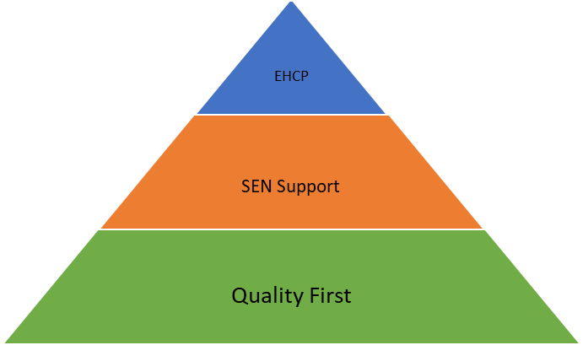
The majority of children and young people with SEN or disabilities will have their needs met within local mainstream early years settings, schools or colleges. Some children and young people may require an Education, Health and Care (EHC) needs assessment in order for the local authority to decide whether it is necessary for it to make provision in accordance with an EHC plan. This should be requested where the provision cannot reasonably be provided from the resources normally available to mainstream or FE settings. In the majority of cases the setting should have already implemented the support available from its own resources. If the pupil is not making appropriate progress despite this support, then an EHC needs assessment should be considered.
For some pupils it may not be possible to demonstrate prior implementation of support in the setting (for example, when a pupil has moved to the school recently and clearly has complex needs). In these situations, requests for assessment can still be made by the setting or parents giving further information and context to explain the situation.
Requests can also be made by parents/carers at any time. Whilst a joint-application by parents/carers and the setting would usually ensure all relevant information is provided to the Local Authority in the initial request, there are situations where parents may wish to make the request themselves. In these situations, the setting will then be contacted to provide their relevant information and the request will be considered in the same way as any other request made.
If the request for assessment is agreed, information is gathered from stakeholders involved with the pupil, including the pupil and parent/carer, school, external agencies, health care and social care professionals. This information is then collated, and a decision made as to whether an EHC Plan is required for the pupil. If the decision is made that an EHC Plan is required, this statutory document is then drafted and issued. Schools are then required to implement this plan for the pupil and review outcomes with stakeholders on a yearly basis. If the resources required for the delivery of the EHC Plan exceed school resources (£6000), schools will be able to request additionality in order to fully meet their pupil’s needs. This will be undertaken through liaison between schools and their allocated Case Worker and will form part of the EHC Process.

Criteria and Thresholds
When considering whether or not an assessment is appropriate, the following should be considered;
- Has the young person had access to all relevant resources available from their educational setting, including universal & targeted health services and social care input?
- Is there evidence of a CYP with significantly greater need than others of the same age?
- Has the Educational setting sought advice from external professionals?
- Has the setting followed an Assess, Plan, Do, Review cycle with targets set based upon advice received?
- Has the setting provided detailed information about the targets set, reviews and adjustments and the progress made over time?
- Is the information current – within the last 6 months?
- Has the educational setting worked in partnership with parents?
- Has the educational setting provided information as to how existing resources have been used?
- Are all appropriate signatures and consents present?
- Where the request comes from a source other than an educational setting – it may be necessary to gather this information before proceeding with a decision. This is usually done before a request is placed before panel.
The process for application is shown below
Summary of EHC needs assessment process and statutory time scales
Parents/carers share views and concerns with school and collaborate in planning and reviewing progress. (Parents can request an EHC assessment at any time – see boxes below)

School implement SEN support in collaboration with child/young person and parents/carers.
Preparation for application

School consider EHC needs assessment.

Meet with parents to complete personal profile document and EHC application
Parents concerned about progress and SEN provision
They meet with school and share completed personal profile document.

Where school does not agree with an application for EHC assessment and parents/ carers do not have confidence in the schools provision the parents/carers requests EHC assessment.
They submit:
- Parental Request Form
- Personal Profile Document
School apply for EHC needs assessment.
School submits:
- EHC application
- Personal profile documents agreed with child/young person and parents/carers.
- Other reports/documents tracking provision and progress as appropriate

The local authority receives a request for an EHC assessment
(Where the parent/carer submits the EHC Application, the school will be contacted by the LA and required to submit their paperwork within 2 weeks to comply with statutory timeframes)
The parent/carer or yp will be allocated a named SEN Casework Assistant

Weeks 1 to 6

The EHC Assessment Panel consider the evidence and determine if an EHC assessment is appropriate
LA must notify parent/young person of the decision and their right of appeal within a maximum of 6 weeks from the request for assessment

Agreed Not agreed
Parents/carers and school meet to review SEN Support Plan Parents/carers have the right to request mediation/appeal to Tribunal

Weeks 6 to 16
Additional information and advice requested where necessary
The body concerned must comply with this request within a maximum of 6 weeks

The SEN Casework Officer considers the evidence provided in the application and subsequent information received and a decision is made to determine whether an EHC Plan is required.

Agreed Not agreed
Weeks 6 to 16 continued

The SEN Casework Officer will write to the parent and the referrer of the decision and provide information about the mediation and the right to appeal to SENDIST regarding the decision not to issue an EHC Plan
The LA must notify parents/young person of the decision and their right to appeal within a maximum of 16 weeks from the request for assessment

The SEN Casework Officer will share a draft EHC Plan and all the information gathered with the parent and all professionals involved with the child, to determine if there is agreement regarding the content of the EHC Plan

The SEN Casework Officer draws up the final EHC Plan. If there are no significant changes, the final EHC Plan will be issued to all involved

Parents are informed of their rights of mediation and appeal if they are not happy with the contents of the EHC Plan.

Plan finalised and subsequently implemented by all involved
The final EHC plan must be issued within 20 weeks from the request for assessment

Annual Review of EHC Plan

Weeks 16 to 20

A Plan meeting will be offered unless there is overall agreement that this is not required.
Parents/young person has 15 calendar days to comment on the draft plan and express a preference for an educational institution to be named
The Local Authority will consult with that preference and other settings it considers might be appropriate to decide on a suitable setting for the pupil.

A Summary Assessment will be written and this along with the accompanying evidence collected will be sent to parents and the professionals involved

Annual Review Process
- Annual Reviews must be held as a minimum every 12 months.
- The first review must be held within 12 months of the date when the EHC Plan was issued and then within 12 months of any previous review.
- The Local Authority must issue its decision after an annual review meeting to parents within 4 weeks of the review meeting (and within 12 months of date of issue of the EHC Plan or previous review.)

Annual Review Process: In terms of process this means it flows as below:
Timeframe from last Plan/Review

EHC Plan Issued/Last Annual Review meeting held

Up to 6 weeks before the review
School must seek advice and information about the child prior to the Annual Review meeting from all parties involved and send any advice and information gathered to all those invited at least two weeks before the meeting. This would include the pre-review paperwork.
8 weeks after notice to amend issued
Timeframe after review meeting
2 weeks
4 weeks
The Local Authority must issue the Amended Final EHC Plan within 8 weeks of the date it issued the notice that it was intending to amend the Plan.
If making amendments the Local Authority must send a copy of the current EHC Plan, a document with the proposed amendments and any evidence to support the proposed changes (eg. The review paperwork) to the family. They must allow 15 calendar days for them to respond.
The Local Authority must decide whether it proposes to keep the EHC Plan as it is, amend the Plan, or cease to maintain the Plan – and notify the parents and school within 4 weeks of the meeting.
School must submit the post-review paperwork to the Local Authority within 2 weeks of the Review meeting.
The Annual review meeting is held
Individuals relevant to the review must be invited and given at least 2 weeks’ notice of the date of the meeting
1 year
2 weeks before the meeting
11 months

Appendix

SEND Acronyms
SEN Support Plan (Annotated with Guidance)
SEN Support Plan Template (Primary)
SEN Support Plan Template (Secondary)
Key Contact Numbers

Lorraine Chester, Sophie Walsh 2020

SEND Acronyms

ADD: Attention Deficit Disorder
ADHD: Attention Deficit Hyperactivity Disorder
ASD/ASC: Autistic Spectrum Disorder or Condition
AWO: Attendance Welfare Officer
CAMHS: Child and Adolescent Mental Health Services
CP: Child Protection
C of P: Code of Practice
DDA: Disability Discrimination Act
EAL: English as an Additional Language
EHCP: Education, Health and Care Plan
EP: Educational Psychologist
HI: Hearing Impairment
IC: Inclusion Consultant
IEP: Individual Education Plan
LA: Local Authority
LAC: Looked After Children
LO: Local Offer
MLD: Moderate Learning Difficulty
MSI: Multi-Sensory Impairment
OCD: Obsessive Compulsive Disorder
ODD: Oppositional Defiance Disorder
OT: Occupational Therapy/Therapist
PD: Physical Disability
PDA: Pathological Demand Avoidance
PMLD: Profound and Multiple Learning Difficulties
PRU: Pupil Referral Unit
PSP: Pastoral Support Plan
PVI: Private, Voluntary and Independent (Nurseries)
QF: Quality First
SALT: Speech and Language Therapist
SEN: Special Educational Needs
SEND: Special Educational Needs and Disabilities
SENDCo/SENCO: Special Educational Needs and Disabilities Co-ordinator/Special Educational Needs Coordinator
SENDIASS: Special Educational Needs and Disability Information Advice and Support Service
SSENIS: Sefton SEN Inclusion Service
SLCN: Speech, Language and Communication Needs
SLD: Severe Learning Difficulties
SpLD: Specific Learning Difficulties
TA: Teaching Assistant
VI: Visual Impairment

Sample of Completed Termly SEN Support Plan

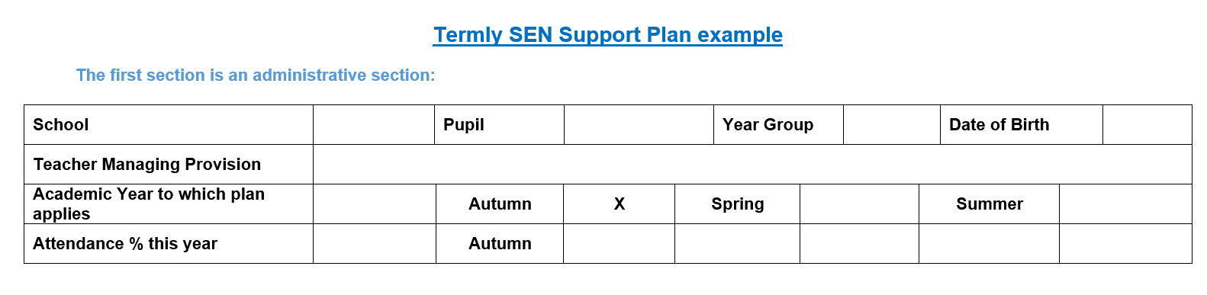

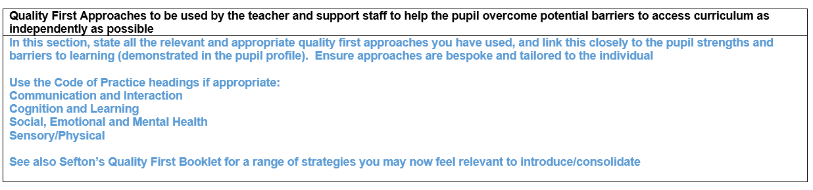

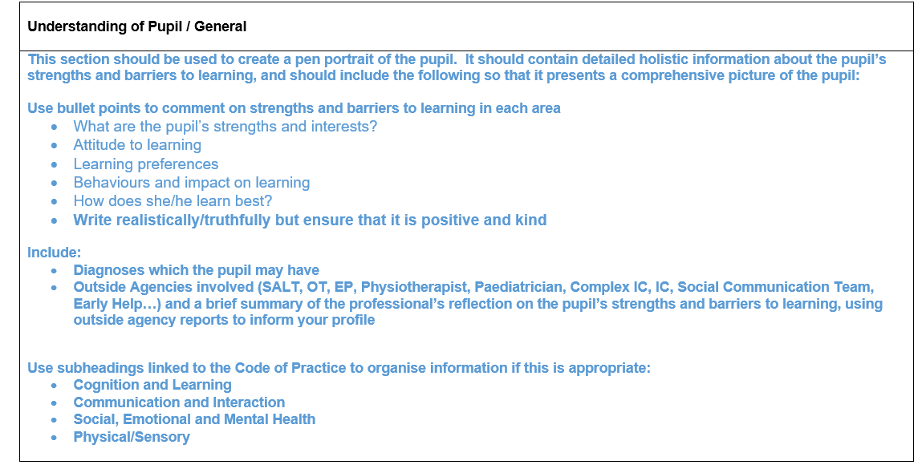
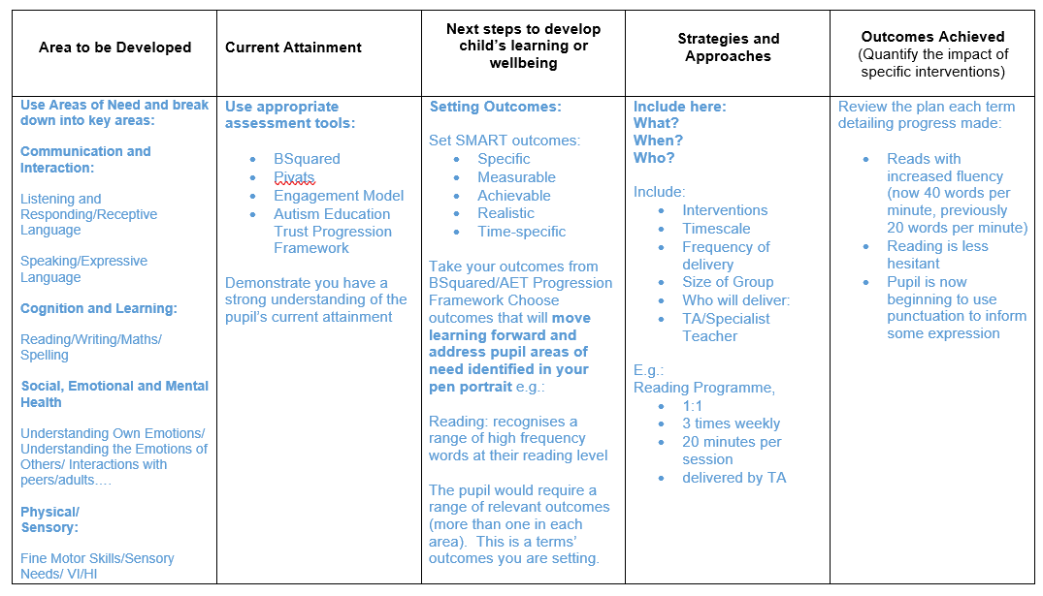

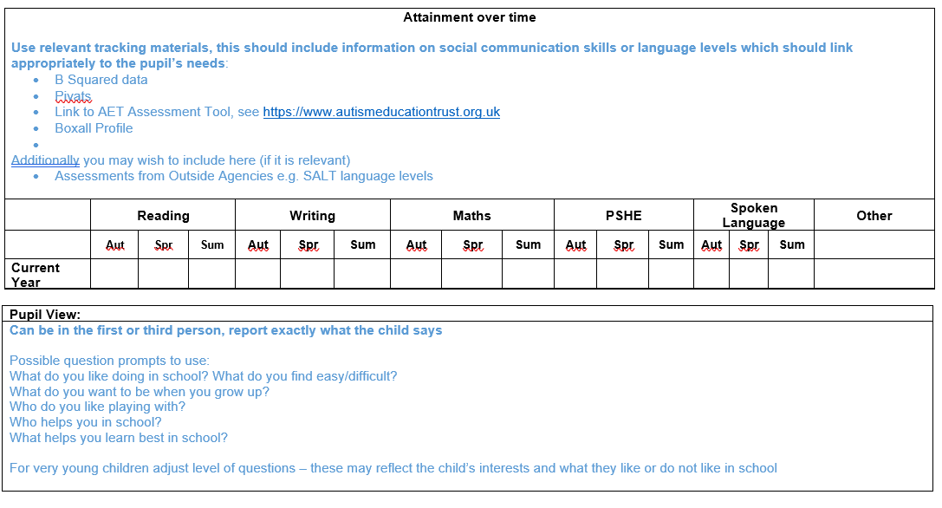

Contact Numbers:

Speech and Language:
Hoghton Street Clinic, (North Sefton Area), 52 Hoghton Street, Southport PR9 0PN:
01704 395884
Netherton Health Centre (South Sefton Area), Magdalen Square, Netherton, L30 5SP:
0151 247 6109

Occupational Therapy:
North Team, 52 Hoghton Street Southport, PR9 0PN:
01704 395895
South Team, Sefton Carers Centre, 27-37 South Road, Waterloo, Liverpool L22 5PE:
0151 252 5836

Community Paediatrics, Alder Hey Children’s NHS Foundation Trust:
0151 228 4811

SENDIASS (Special Educational Needs and Disability Information Advice and Support Service)
0151 934 3334

Sefton Parent Carers Forum:
07541 326860

SEN Team
SSENIS (Sefton Special Educational Needs and Inclusion Service) Admin:
0151 934 2347

