Northway Community Primary School LOOK WHAT’S COMING UP IN Y4 IN AUTUMN 1 2025

SUBJECT | TOPIC | FOCUS OF LEARNING
ENGLISH | 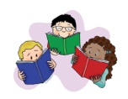  READING FOCUS | This term we will study these texts:  The Green Ship by Quentin Blake  The Iron Man by Ted Hughes
 |   WRITING FOCUS | Using the above text, we will write a variety of fiction and non-fiction:  Letter  Setting description  Character description
 |   SPELLING FOCUS | We will review the previous year group’s National Curriculum Spelling words  We will also learn the following Spelling Rules:  Adding the prefixes ‘mis’  Revising un-. im-, dis-
MATHS | NUMBER | We will be learning to read, write and understand the place value of numbers to 10,000. We will count in multiples of 25,50,100 and 1000. We will find 100 and 1000 more and less than a number and represent numbers in different ways.
 | CALCULATION | We will develop our mental addition and subtraction skills to calculate more efficiently. We will revisit column addition and subtraction to calculate with numbers with up to four digits. We will be learning the multiplication and division facts for the times tables to 12x12. We will use formal written multiplication to multiply two-digit and three-digit numbers. We will use written division methods to divide three-digit numbers.
 | FRACTIONS & DECIMALS | We will learn that fractions can be greater than a whole. We will learn about decimals and their equivalent fractions. We will be adding, subtracting, comparing and ordering fractions as well as finding fractions of larger quantities and numbers.
SCIENCE | STATES OF MATTER  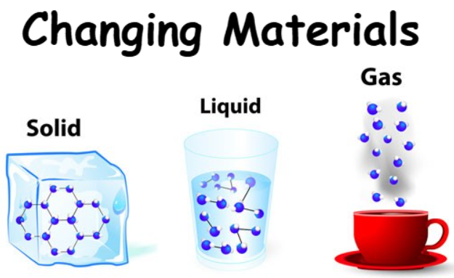 | We will:  - describe the characteristics of different states of matter group materials into solids, liquids and gases.  - describe how materials change state at different temperatures, using this to explain everyday phenomena, e.g. melting, freezing, evaporating and condensing.  - Relate change of state to explain the water cycle.
GEOGRAPHY | A NORTH WEST STUDY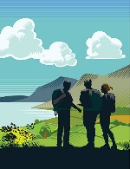 | We will learn that The North West is a region of the UK, there are different counties and cities in the North West and The North West region has a coastline meeting the Irish Sea. We shall compare land-use in The Lake District (Cumbria) with our local area (Merseyside). We shall learn about physical and human features We shall use 8-point compass points and four figure grid references.
COMPUTING | ESAFETY   | We will learn about how people can have different identities online and in real life. We will learn about the differences between facts and opinions that are shared online. We will discuss what private information is and how to keep it secure. We will identify who we can go to for help and support if we are concerned by anything that see online. We will learn about setting personal boundaries and understand influences on body image.
ART | TED HARRISON WATERCOLOUR  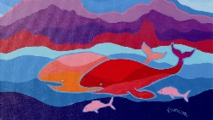 | We will develop our painting skills, using water colours to paint Lake District scenes. We shall study the work of Ted Harrison and experiment with using his bold style to paint landscapes.
PE | PERSONAL SKILLS  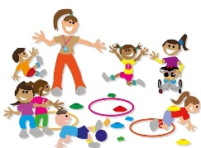 | We will focus on the fundamental movement skills of coordination & footwork and static balances on one leg. We will learn about how to challenge ourselves and react positively when things become difficult. We will learn how to persevere with a task and recognise how we can improve through regular practice.
PSHE | RELATIONSHIPS  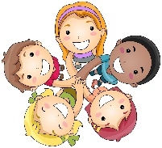 | We will learn about healthy friendships in person and online and how to solve disagreements within friendships. We will learn about the difference between joking, banter and bullying and how these can make people feel. We will learn about who our trusted adults are and who we can go to for support.
MUSIC | CREATIVE MINDS   | We will take part in lessons from Creative Minds across the Autumn and Spring Term. We will have an introduction to music by learning about key words in the form of contrasts. We will learn about reading, writing and playing rhythms using a variety of notes. Then, for the second half term, we will learn to play the recorder. We will work towards collectively composing a melodic three note song and perform as an ensemble.
FRENCH | LES COLEURS ET LES NOMBRES  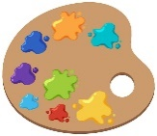 | We will learn to read and write colours in French. We will recognise numbers from 1-10 and count in French.
RE | 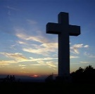  What does it mean to be Christian in Britain today? | We will think about what life is like for Christians today. We will investigate what Christians do at home, in church and in the wider community and why these things are important to them. We will consider how Christians and non-Christians help their community and look at the links between some of our local churches and the surrounding area.

