Nursery Long Term Plan 2026-27
“Children will have an abundance of opportunities to learn through play. We will ensure that learning will be fun, engaging and we will challenge and support all children whatever their starting point. As an EYFS team and effective role models, we will provide high quality interactions in order to develop and deepen the children’s learning opportunities. We will deliver our curriculum through a balance of adult led and child-initiated activities based on the EYFS Framework 21’ & children’s interests.”
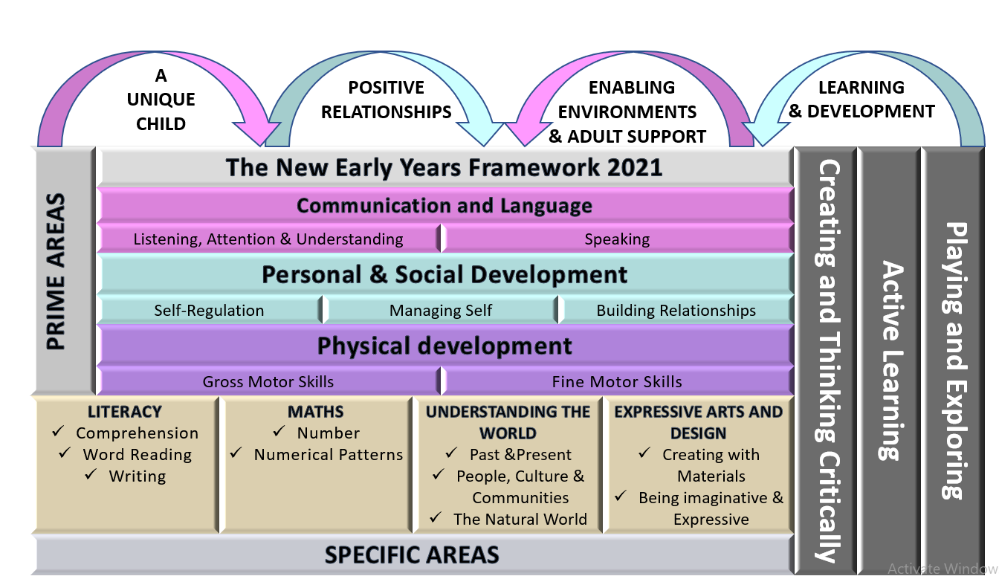
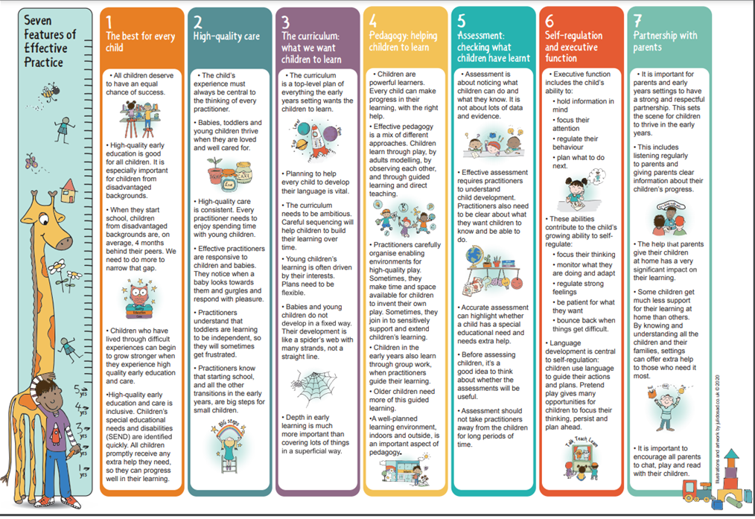
 | Autumn 1 | Autumn 2 | Spring 1 | Spring 2 | Summer 1 | Summer 2
Books  Cycle 1 | 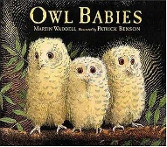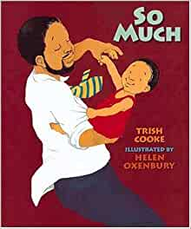  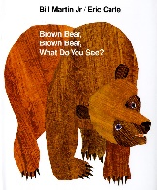 | 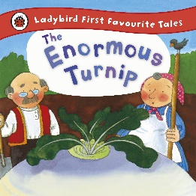  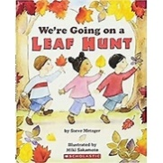  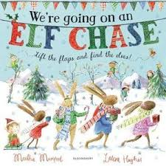 | 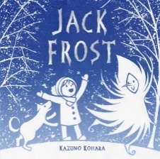  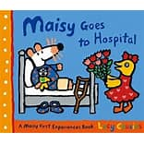  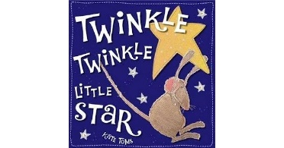 | 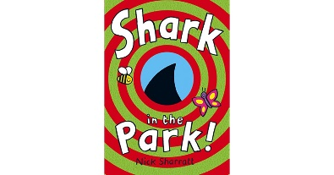  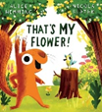  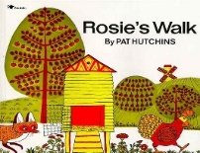 | 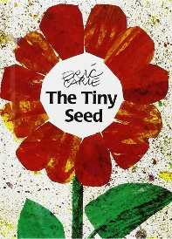  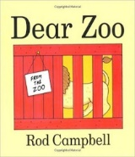  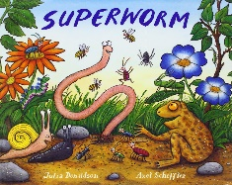 | 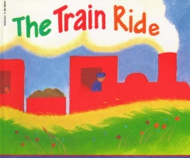  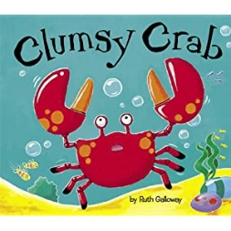  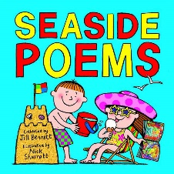
Vocabulary  Learn new vocabulary  *Use new vocabulary  in different contexts *Use new vocabulary  through the day in  discussions and  conversations.  *Learn new rhymes,  poems, and songs | family, Mum, hunting, trunk, twigs,feathers, hunting,branch, brave, lost, silent,flapped  Mum, Dad,Baby  Auntie,Uncle, Cousin  Nannie, Gran-Gran (Grandma, Nan, Grannie), wide, squeeze  Colours, bird, duck, horse, frof, cat, dog, sheep, goldfish | Enormous, turnip,seeds, hoe, row, swell, grow, bigger, huge, vast, budge, pull, thud, whack, thump, bump  Autumn, colourful, under, over, through, mountain, climb, forest, squish, squash, waterfall, lake, Oak, Birch, Hickory  Chase, elf, flap, polar bears, reindeer, sleigh | snow, hat, gloves, scarf, cold, winter, freezing, frozen, ice  people who help us  hospital  twinkle star, world, diamond, | telescope, testing, park, shark, crow, left, right, ground, around,  spring, flower, growing,  farm animals, across, around, over, past, through, under,  fence | growing, seed, life cycle, minibeast names,  fierce, tall, grumpy, scary, naughty, jumpy, perfect  zoo animals  lizard, crow, disaster, wiggle, squirm, lasso, well, drowning, juicy, honeycomb | summer, sand, sea, holidays, train, journey, meadow, tunnel, engine, lighthouse, station  clumsy, crab, huge, claws, tentacles, octopus, jellyfish, flippety, fins, turtle, pricked, scuttled, stumbles, shattered, squirmed, snipped, squiggled, wriggled, jiggled, slashing, slicing, shredded, dicing, swirling  seaside
Books  Cycle 2 2026-2027 | 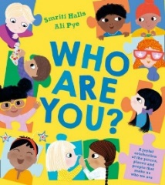  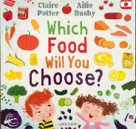  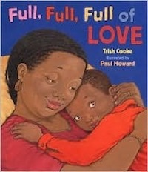 | 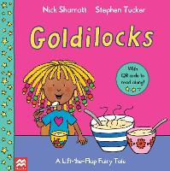  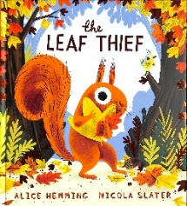  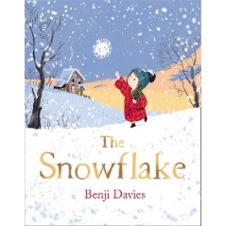 | 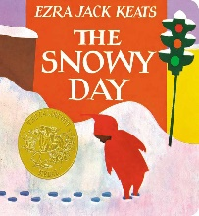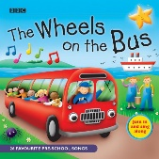  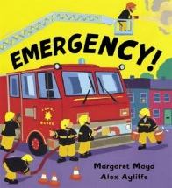 | 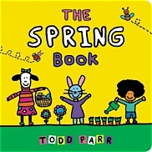  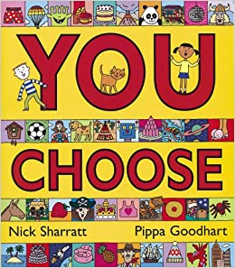  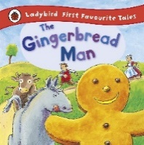 | 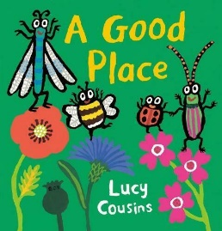  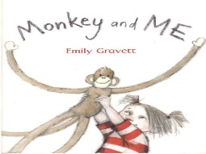  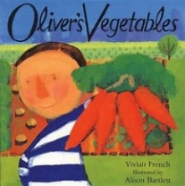 | 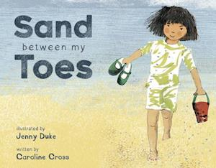  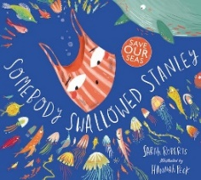  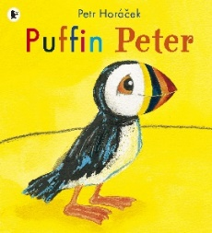
Vocabulary  Learn new vocabulary  *Use new vocabulary  in different contexts *Use new vocabulary  through the day in  discussions and  conversations.  *Learn new rhymes,  poems, and songs | exlpore, face, ears, eyes, twinkling, little, large, noses, curly, straight, long, short, family, care, adventures, aunties, mums, dads, uncles, cousins, family, clan, special ocassions, fancy, wear, live, visited, world, friends, places, food, delicious, salty, sour, sweet, favourtite, activities, family tress, past, present, likes, dislikes  choose, food, dinner, beige, supermarket, colours-red, green , yellow, orange, black  days of the week  gran, grannie, dad, mama, colourful, dishes, clank, clatter, wiggle, candy, struggle, juggle, snuggle, cuddle, uncles, aunties, cousins, friends, giggle, love | Goldilocks, funky, dreadlock, behind, house, barged, still, quiet, owners, snoop, bowls, porridge, biggest, frown, gobble, biggest, hard as iron, soft, smallest, middle, fancy, boring, perfect, snoring, bears, daddy, mummy, baby, greedy, growled, broken, clumsy, stroked, squeaked, stared, piercing scream,  Leaf, thief, nest, hazel nuts, red, gold, orange, missing, stole, mouse, squirrel, bird, woodpecker, collecting, relax, disaster, shakes, rustles, tree, wind, autumn, change, colours, blows  Snowflake, Noelle, Pappie, winter, snow, twirl, fall, cloud, hillside, tumbling, twisted, dizzy, nestled, crisp, cold, valleys, streams, whisked, window, star, shimmered, glistening , tree, decorated, swirled, proud, shone | snowy, snow, Peter, snowsuit, crunch, sank, pointedin/out, tracks, snowball fight, snowangels, slid, round, firm, warm,  wheels, bus, driver, wipers, round, swish, mummies, daddies, chatter, nod, lights, flash, doors, open, shut  emergency, 999, burglars, flashing, dashing, help, ambulance, speeding, sirens, screaming, lights, beaming, break down train, huge crane, boats, sinking, lifeboat, tossing, police motor bikes, scooping, tugging, snowplough, fire, hoses, helicopter, searching, breakdown truck, glowing, zooming  twinkle, little, world, high, sky, star, diamond | Spring, weather, trees, green, birds, nest, cleaning, new life  choose, words connected to -places, family and friends, homes, travel, belongings, food, clothes, shoes, hats, pets, animals, jobs, fun, beds  gingerbread man, old woman, old man, baked, run, children , cow, horse, sly, fox, snap | insects, Bee, Ladybird, Beetle, Dragonfly, flowers, leaves, dead wood, pond, place, live, busy, pavement, tiny, dirty, puddle, pile, rubbish, gorgeous, spluttering, fluttering, butterfly, wonderful, garden  monkey, me, penguins, kangaroos, bats, elephants, home, tea  Oliver, vegetables  Grandpa, wonderful garden, grow, chips, potatoes, carrots, days of the week, spinach, rhubarb, slugs, snails, cabbage, beetroot, peas, | sand, between, toes, water, glistens, Gulls, cry, wriggle, giggle, waves, crashes, splashes, seweed, shells, salty smells, ice cream, drips, beach chai, flis, spade, clashes, dashes, shelter, rips, bucket, tips, howls  somebody, swallowed, Stanley, swept, splash, splish, jellyfish, stripes, straight, tentacles, floated, terrible, rough, barnacles, vast, cave, hummed, low, brave, creature, soughed, spluttered, slimy, rush, rumble, burst, spout, bobbed, gently , calm . carefree, sharp, beak, beady, creature, pecked, snapped, nipped, flapping, squawking, ripped, scruffy, torn, sank, seafloor, flippers, skimmed, seabed, shell, gasped, spluttered, choke, stuck, beathe, turtle, stuck, helped, ocean, helped, kite  Puffin, Peter, Paul, rocky, island, diving, storm, whale, funny, noisy, parrot, feathers, black, white, penguins, cold, beak, colourful, toucan, sad, drifted, ocean, horizon, overjoyed
Possible Themes/Interests/Lines of Enquiry | Family  Autumn  Harvest  Black History Month  Halloween | Autumn  Bonfire Night Christmas / Nativity  Diwali  Hanukah  Black History Month  Remembrance Day  Children in Need  Anti- Bullying Week  Nursery Rhyme Week | Chinese New Year  LENT  Random Acts of Kindness Week  Valentine’s Day  Internet Safety Day | Pancake Day  Easter  Spring  Mother’s Day  Easter Egg Hunt  Easter Bonnet Parade | GROWING AND MINI BEASTS Life cycles – Frogs/butterfly/ plants etc Local Area Planting/ Gardening  Start of Ramadan  Eid | Summer holidays (past and present) Hot places Rockpools Mermaids  Father’s Day
Communication and Language (Listening and attention, understanding and speaking) | To listen to and discuss stories regularly.  To listen to and join in rhymes and songs regularly.  To follow simple instructions.  To talk about what/ who they are playing with.  To identify familiar objects and properties for practitioners when they are described. For example: Hassan’s coat’, ‘blue car’, ‘shiny apple’.  To develop vocabulary | To enjoy listening to longer stories and can remember much of what happens.  To continue listen to and join in rhymes and songs regularly.  To pay attention to more than one thing at a time, which can be difficult. To develop their communication.  To use a wider range of vocabulary. | To understand a question or instruction that has two parts, such as “Get your coat and wait at the door”.  To understand ‘why’ questions, like: “Why do you think the caterpillar got so fat?  To sing a large repertoire of songs.  To listen to and discuss stories.  To talk and ask questions as much as possible e.g. through their play or talking about past events. | To know many rhymes, be able to talk about familiar books, and be able to tell a long story.  To use a wider range of vocabulary. | To start a conversation with adults and friends  To enjoy listening to longer stories and can remember what happens in them.  To understand a question with two parts like “Can you get your coat and wait by the door please?”  To use talk to organise play e.g. “Let’s go on a bus...you sit there… I’ll be the driver”  To focus on a chosen activity for at least ten minutes | To be able to express a point of view and to debate when they disagree with an adult or a friend, using words as well as actions.  To use longer sentences of four to six words when talking  To know many rhymes, to be able to talk about familiar books, and be able to tell a long story.
Personal, Social and Emotional Development | To begin to gain independence to self-choose activities they wish to play with.  To play with increasing confidence on their own and with other children.  To begin to express a range of emotions.  To begin to follow rules and routines.  To tidy up their activities when they have finished. | To gain independence to self-choose  activities they wish to play with.  To tidy up their activities when they have finished.  To build positive friendships with new peers.  To begin to talk about their feelings.  To see themselves as a valuable individual.  To show an increasing desire to be independent, such as wanting to feed themselves and dress or undress. | To select and use activities and resources, with help when needed. This helps them to achieve a goal they have chosen, or one which is suggested to them.  To develop their sense of responsibility and membership of a community.  To become more outgoing with unfamiliar people, in the safe context of their setting.  To how more confidence in new social situations.  To play with one or more other children, extending and elaborating play ideas. | To increasingly begin to follow rules, understanding why they are important.  To not always need an adult to remind them of a rule.  To develop appropriate ways of being assertive.  To talk with others to solve conflicts.  To talk about their feelings using words like ‘happy’, ‘sad’, ‘angry’ or ‘worried’.  To begin to understand how others might be feeling | To be able to play in a group with friends, and make up ideas of things to do and games to play  To begin to manage feelings and talk about emotions  To understand how others might be feeling  . | To be responsible and be confident to be part of my community  To be ready for new experiences like starting school  To learn how to be assertive  To be able to follow rules and know why they are important  To begin to find solutions to quarrels and rivalries  To be able to follow the rules without an adult reminding me
Physical Development | To explore climbing apparatus, go up steps and stairs.  To continue to develop their gross motor skills-large muscle movements to wave flags and streamers, paint and make marks.  To skip, hop, stand on one leg and hold a pose for a game like musical statues | To be increasingly able to use and remember sequences and patterns of movements which are related to music and rhythm.  To choose the right resources to carry out their own plan. For example, choosing a spade to enlarge a small hole they dug with a trowel.  To use one-handed tools and equipment, for example, making snips in paper with scissors | With support collaborate with others to manage large items, such as moving a long plank safely, carrying large hollow blocks.  To use one-handed tools and equipment, for example, making snips in paper with scissors.  To use a comfortable grip with good control when holding pens and pencils.  To show a preference for a dominant hand. | To be increasingly independent as they get dressed and undressed, for example, putting coats on and doing up zips.  To start taking part in some group activities which they make up for themselves, or in teams.  To use a comfortable grip with good control when holding pens and pencils.  To show a preference for a dominant hand. | To go up steps and stairs, or climb up apparatus, using alternate feet  To continue to develop movement, balancing, riding (scooters, trikes and bikes) and ball skills  To use a comfortable grip with good control when holding pens and pencils. | To use one-handed tools and equipment, for example, making snips in paper with scissors.  To have an awareness of safety and manage own risks  Matches developing physical skills to tasks and activities. For example, to decide whether to crawl, walk or run across a plank, depending on its length and width.  To work with others to manage large items, like moving a long plank safely and carrying large hollow blocks.  To use a comfortable grip with good control when holding pens and pencils.  To be increasingly independent as they get dressed and undressed, for example, putting coats on and doing up zips.
Literacy | To join in and enjoy simple stories, songs and rhymes.  To enjoy mark making experiences and give meaning to their marks. commenting on what they have drawn or ‘written.  To begin to understand key concepts about print. | To join in and enjoy simple stories and rhymes.  To enjoy mark making experiences and give meaning to their marks. commenting on what they have drawn or ‘written.  To begin to understand key concepts about print. | To understand the five key concepts about print.  To listen to stories and comment on the main events, where it was set and the characters.  To give meaning to their marks, commenting on what they have drawn, ‘written’ or painted. | To understand the five key concepts about print.  To develop their phonological awareness, so that they can: - spot and suggest rhymes  To add some marks to their drawings, which they give meaning to. For example: “That says mummy.”  To clap out syllables in a word. | To use some print and letter knowledge in early writing. For example: writing a pretend shopping list that starts at the top of the page; write ‘m’ for mummy  To say what the marks, shapes, letters and pictures that they make mean.  To ‘map' out a familiar story through drawing  To know that stories have beginnings and endings and sometimes guess how the story will end  To have conversations about stories and learn new vocabulary  To hear and says the first sound in a word when you say the word.  To be able to make up own stories, with characters, a beginning, middle and an end  To recognise words with the same initial sound orally  *To write some letter sounds accurately | To write some or all of my name.  To write some letters accurately.  To talk about the places and people in stories and the important things that are happening  To have an understanding of a word, to know that when writing and reading it is different letters all placed together that make up a word  To understand that different words and print have different purposes  To be able to say lots of words that rhyme with a word like ‘cat’  To be able to Orally segment and Blend CVC words  To use some of their letter sound knowledge in their early writing.
Mathematics  New White Rose Nursery Maths Scheme | To compare quantities using language: ‘more than’, ‘fewer than’  To talk about and explore 2D and 3D shapes.  To notice patterns and arrange things in patterns.  To recite numbers past 5  To develop fast recognition of up to 3 objects, without having to count them individually (‘subitising’). | To recite numbers past 5.  To develop fast recognition of up to 3 objects, without having to count them individually (‘subitising’).  To understand position through words alone – for example, “The bag is under the table,” – with no pointing  To say one number for each item in order: 1, 2, 3, 4, 5.  To show ‘finger numbers’ up to 5.  To link numerals and amounts: for example, showing the right number of objects to match the numeral, up to 5  To describe a familiar route.  To discuss routes and locations, using words like ‘in front of’ and ‘behind’. | To develop fast recognition of up to 3 objects, without having to count them individually (‘subitising’).  To notice patterns and arrange things in patterns.  To talk about and identify the patterns around them. For example: stripes on clothes, designs on rugs and wallpaper. Use informal language like ‘pointy’, ‘spotty’, ‘blobs’, etc  To understand position through words alone – for example, “The bag is under the table,” – with no pointing.  To describe a familiar route.  To discuss routes and locations, using words like ‘in front of’ and ‘behind’. | Talk about and  identify the patterns around them. For example: stripes  on clothes, designs on rugs and wallpaper. Use informal  language like ‘pointy’, ‘spotty’, ‘blobs’, etc  Say one number for each item in order: 1,2,3,4,5.  Know that the last number reached when counting a  small set of objects tells you how many there are in  total (‘cardinal principle’)  Select shapes appropriately: flat surfaces for building, a triangular prism for a roof, etc. Combine shapes to make new ones – an arch, a bigger triangle, etc. Describe a familiar route.  Develop fast recognition of up to 3 objects, without  having to count them individually (‘subitising’).  Show ‘finger numbers’ up to 5  Compare  quantities using language: ‘more than’, ‘fewer than’. | Compare quantities using language: ‘more than’, ‘fewer  than’.  Talk about and  identify the patterns around them. For example: stripes  on clothes, designs on rugs and wallpaper. Use informal  language like ‘pointy’, ‘spotty’, ‘blobs’, etc  Talk about and explore 2D and 3D shapes (for example,  circles, rectangles, triangles and cuboids) using  informal and mathematical language: ‘sides’, ‘corners’;  ‘straight’, ‘flat’, ‘round’.  • Discuss routes and locations, using words like ‘in front  of’ and ‘behind  • Extend and create ABAB patterns – stick, leaf, stick, leaf.  Develop fast recognition of up to 3 objects, without  having to count them individually (‘subitising’).  • Show ‘finger numbers’ up to 5. | To know that the last number reached when counting a  small set of objects tells you how many there are in  total (‘cardinal principle’).  To show ‘finger numbers’ up to 5.  To link numerals and amounts: for example, showing the right number of objects to match the numeral, up to 5.  To extend and create ABAB patterns – stick, leaf, stick, leaf.  To notice and correct an error in a repeating pattern.  To begin to describe a sequence of events, real or fictional, using words such as ‘first’, ‘then...  To know that the last number reached when counting a small set of objects tells you how many there are in total (‘cardinal principle’).  To show ‘finger numbers’ up to 5.  To eExperiment with their own symbols and marks as well as numerals  To compare quantities using language: ‘more than’, ‘fewer than’.21
Understanding the World | To begin to make sense of their own life-story and family’s history.  To continue developing positive attitudes about the differences between people.  To explore their local environments, discussing plants and animals that they see.  To show interest in different occupations. | To continue developing positive attitudes about the differences between people.  To know that there are different countries in the world and talk about the differences they have experienced or seen in photos.  To explore their local environments, discussing plants and animals that they see. | To use all their senses in hands-on exploration of natural materials.  To begin to understand the need to respect and care for the natural environment and all living things.  To talk about the differences between materials and changes they notice.  To explore their local environments, discussing  plants and animals that they see.  To show an interest in different occupations | To talk about the differences between materials and changes they notice.  To continue to develop positive attitudes about the differences between people.  To show an interest in different occupations  To know that there are different countries in the world and talk about the differences they have experienced or seen in photos. | To use all of their senses to explore natural materials.  To plant seeds and care for growing plants.  To understand the key features of the life cycle of a plant and an animal.  To begin to understand the need to respect and care for the natural environment and all living things. | To explore and talk about different forces they can feel.  To know that there are different countries in the world and talk about the differences they have experienced or seen in photos.  To understand the key features of the life cycle of a plant and an animal.  To begin to understand the need to respect and care for the natural environment and all living things.
Expressive Arts and Design | To take part in simple pretend play, using an object to represent something else even though they are not similar.  To explore different materials freely, to develop their ideas about how to use them and what to make.  To experiment with mark making  To explore colour  To remember and sing entire songs. | To develop their own ideas and then decide which materials to use to express them.  To explore different sounds through singing and using instruments.  To join in with imaginative role-play.  To explore different materials.  To experiment with mark making | To join in movement to music and ring games e.g. ‘duck duck goose’, ‘farmer in the den’  To use small world toys to make up narratives and own stories.  To join different materials and explore different textures.  To draw with increasing complexity and detail, such as representing a face with a circle and including details. | To begin to develop complex stories using small world equipment like animal sets, dolls and dolls houses etc.  To begin to make imaginative and complex ‘small worlds’ with blocks and construction kits.  To sing the pitch of a tone sung by another person (‘pitch match’).  Sing the melodic shape (moving melody, such as up and down, down and up) of familiar songs.  To create their own songs or improvise a song around one they know. | To play instruments with increasing control to express feelings and ideas.  To remember and sing whole songs.  To mix paints together to make new colours, name the colours and begin to talk about the different shades such as light and dark | To safely uses and explores lots of different tools such as hammers, scissors and saws  To make up stories when playing, like superheroes rescuing people from a building  To choses the things they want to use to make something. If their ideas don’t work, they can choose something else or change the way they do something.  Can use different things like scissors, masking tape, sticky tape, hole punches and string to join and fix things together.  To begin to show different emotions in their drawings and paintings, like happiness, sadness, fear etc

