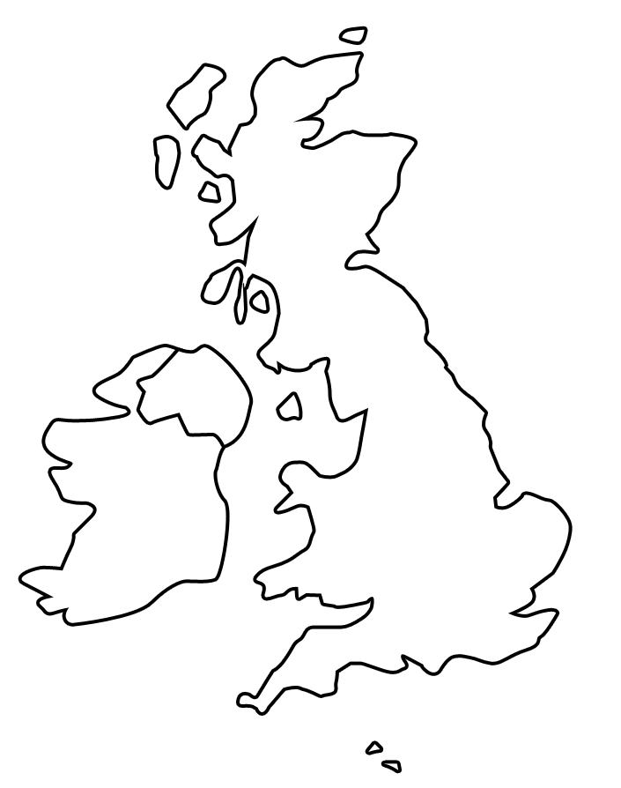
Can you mark St. Helens on your map?
Can you mark the cities of London, Edinburgh, Cardiff, Belfast, Dublin, Manchester and Liverpool on your map?
Where have you visited/been on holiday?
Can you mark these locations on your map?
Can you split the British Isles into England, Scotland, Wales, Northern Ireland and the Republic of Ireland?

