Reception Long Term Plan 2024-25
“Children will have an abundance of opportunities to learn through play. We will ensure that learning will be fun, engaging and we will challenge and support all children whatever their starting point. As an EYFS team and effective role models, we will provide high quality interactions in order to develop and deepen the children’s learning opportunities. We will deliver our curriculum through a balance of adult led and child-initiated activities based on the EYFS Framework 21’ & children’s interests.”
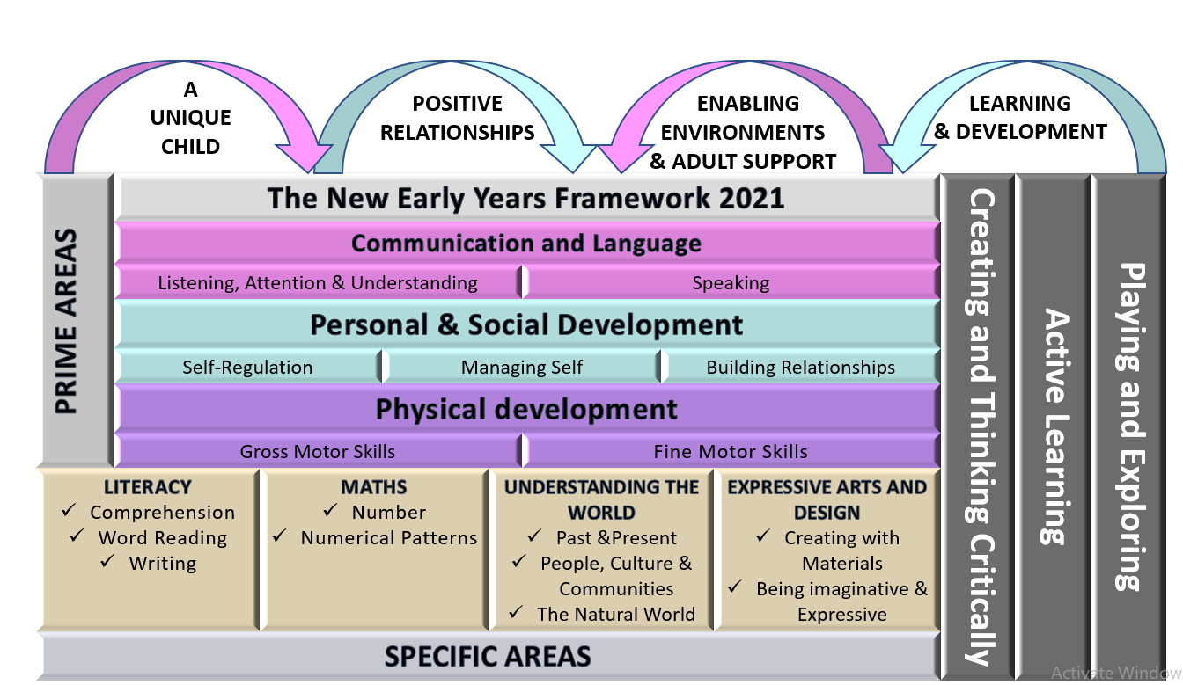
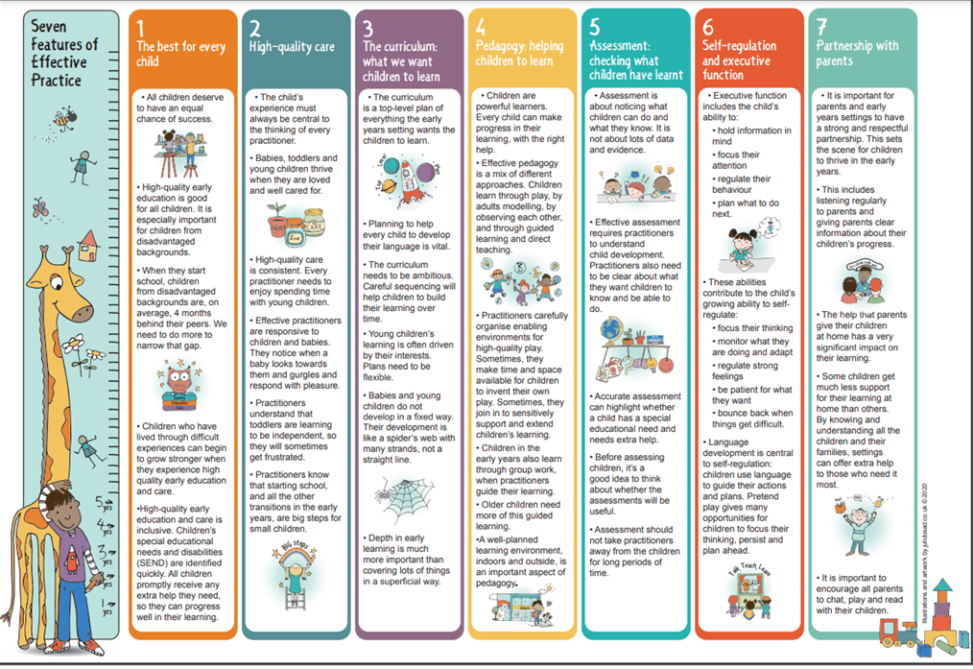
 | Autumn 1 | Autumn 2 | Spring 1 | Spring 2 | Summer 1 | Summer 2
Books  Cycle 1 | 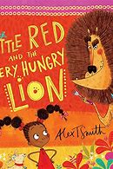  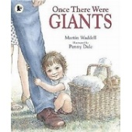  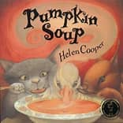 | 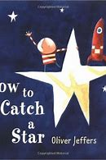  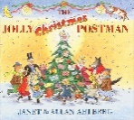  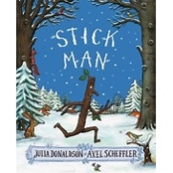 | 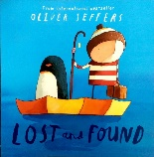  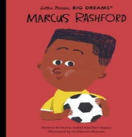  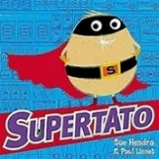 | 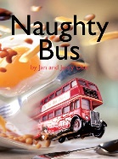  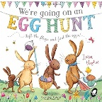   | 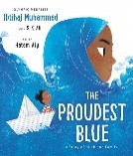  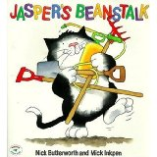  This Photo by Unknown Author is licensed under CC BY-SA-NC  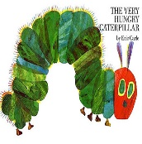 | 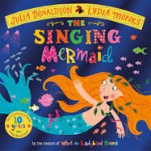  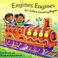  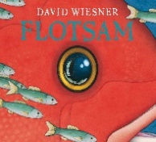
Vocabulary  Learn new vocabulary  *Use new vocabulary  in different contexts *Use new vocabulary  through the day in  discussions and  conversations.  *Learn new rhymes,  poems, and songs | myself, family, parents, siblings,  childhood baby, toddler, house, home, garden  local community,  UK, England, World  Newton le Willows  address,  gobbled, under, over, dashed, leaping, wiggled, shade/shady, animal names, rumble, squeezed, tatty, braided, grubby, grotty, sparkled, grumbly, waggled  pumpkin,pumpkin patch, soup, pipkin, slurp, quilt, clattered, trotted, stir, paced, squabble, edge, steep, plodded | Stars, wished, catch, appear, grab, tallest, life preserver, spaceship, worried, floating, space, galaxy  Seasons, forest, woods, stick, fetch, poostick, floating, weave, drifts, mast, grate, lonely, frozen, chuckle, soot, chimney, clattering  Jolly, postman, woods, fiddlers, mile, sixpence, stile, crooked, vanished, flakes, delicious, shiver, quiver, disappears, tunnel, peep-show, drifts, deep, wide,  Christmas, presents, deliver, postcode, address | key workers, jobs,  People who help us  Vegetables, escaped, frozen, search, rescue, speed, distress, strength, crept, flannel, yelled, evil, leapt, vanished, snuck, shrieked, marched  Lost, found, ignored, floated, discovered, south pole, harbour, ship, mountains, lonely, feelings and emotions  Manchester, dawn, dusk, skipped, charity, skills, torunament, country, national team, governemnt, politiatoan, role model, proud, injustice | Driver, traffic, London, buildings, sky scrapers, city, king, queen, passengers, pond, reflection, handsome, silliest, lonely, powerful, wich, cosy  Farmyard, barn, animals, hunt, excited, over, under, around, through, new life. Lifecycle | garden, planted, vegetable, seeds, scatter, summer, growth, seeds, plants, roots, leaves, stem, flower, pollen, pollenate,  ocean, hijab, twirling,  religion, Muslim, scarf, hurtful, spiritually, faith, different, pride  lifecycle, caterpillar, butterfly, chrysalis | holiday, seaside, camera, pollution, floatsam, imaginery  world, country, UK, sea, land, airport, aeroplane, language  journey, India, temple, Vishnu, sari, desert, Himalayas, Bombai, Ganges  mermaid, sea, bay, scale, shore, creatures, circus, glee, circus acts, escape
Books  Cycle 2  2024-2-25 | 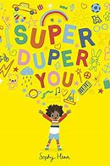  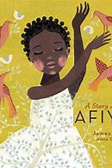   | 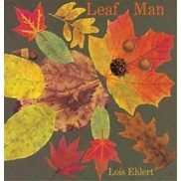     | 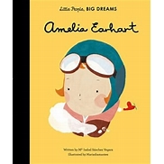  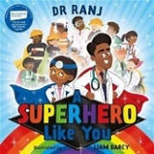  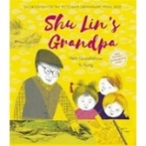  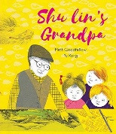 | 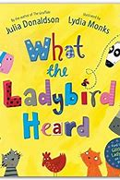  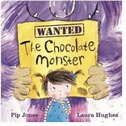 | 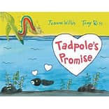  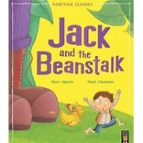  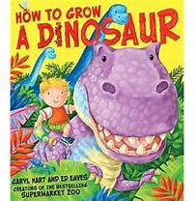 | 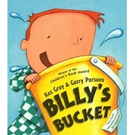  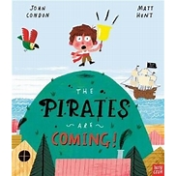  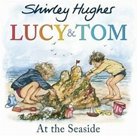
Vocabulary  Learn new vocabulary  *Use new vocabulary  in different contexts *Use new vocabulary  through the day in  discussions and  conversations.  *Learn new rhymes,  poems, and songs | myself, family, parents, siblings,  childhood baby, toddler, house, home, garden  local community,  UK, England, World  Newton le Willows  address,  unique  different  impressive  extraordinary  bold  proud  brilliant  ambitious | Pile, leaves east, marsh, pumpkins, winter squash, vegetable names, prairie meadows gliding, lake, river, south, north, flock, lonesome, rustle  Astro, astronaut, asteroid, space, spaceship, munched, gravity, space cadet, space centre, hero  Christmas spirit, workshop, glowing, neon, bloomers, frown, hover, rooftops, mission | Imagine, stretch, airshow, soared, aeroplane, mechanic, pilot, famous, fearless, Atlantic,challenge, brave, navigator, oceans, jungles, savannah, journey,  Superhero, key workers, jobs, doctor, carer, firefighter,teacher, air ambulance, recycling truck driver, scientist, vet, recyling, planet, fire engine, siren, discoveries | pen, hog, dainty  farm animal and noises, map,  cunning, dead of night, cops,panda car  market, jangle, bangle, posy, creeping, peeking, spy, chilli  caught, bulbous, twitching, fur, streaked, gleaming, disguise, prowls, booty, chomp, expensive, snaffle, swag, nicks, spiteful, gobble, shriek, stare, unfair, protest, cackle, glee, scallywag, blaxing, wild, ruined | Tadpole, promise, willow, caterpillar, beautiful, gaze, shiny, pearl, change, grown, broken, twice, forgive, rainbow, world, changes, heart, crawled, branch, moonlit, dried, fluttered, lilypad, leapt, gulp, fondly, wondering  Dinosaur, grow, packets, seeds, gardening, vegetabkle patch, weed, dig, planted, fling, soil, jungle, tumble, gigantic, footprint, creature, huge, Tyrannosaurus Rex, scary, thunders, brightly-coloured, dangling, branch, extinct, prehistoric, scatter, Pterodactly, peck, terrifying, Stegosaurus, sway, glares, jaws, terrible, dive, slamming, perfect, aliens, galaxy  Jack, Jack’s mother, giant, gold, magic beans, beanstalk, clouds, castle, harp, golden hen, axe | Billy, bucket, birthday, persuaded, rubber, plastic, metal, shingle, excitedly, special, peering, rockpool, crabs, seasweed, shrimps, shark, stingray, clown fish, shoal of barracuda, mermaid, herring, chuckled, submarines, pilchards, sealions, walrus, dolphins, scuba divers, coral reef, imagination,  pirates, climbed, hill, ship, waited, bobbing, steamboat, chugging, slowest, merchant ship, sailing, dock, flag, trudged, harbour, gangplank, ashore, crew, narrow, squawk, marched, growled,  Lucy, Tom, seaside, picnic, buckets, spade, train, armbands, sea, waves, sand, paddling, swimming, rough, splashier, tide, sandcastle, shells, stones, turret, moat, tunnel, beach, kites, bathing suits, rockpool, seaweed, crabs claw, speedboat, donkeys, ice cream
Possible Themes/Interests/Lines of Enquiry | Family  Autumn  Harvest  Black History Month  Halloween | Autumn  Bonfire Night Christmas / Nativity  Diwali  Hanukah  Black History Month  Remembrance Day  Children in Need  Anti- Bullying Week | Chinese New Year  LENT  Random Acts of Kindness Week  Valentine’s Day  Internet Safety Day | Pancake Day  Easter  Spring  Mother’s Day  Easter Egg Hunt  Easter Bonnet Parade  Start of Ramadan  Local Area -contrasting location | GROWING AND MINI BEASTS Life cycles – Frogs/butterfly/plants etc  Planting/Gardening  Eid | Planting/Gardening Summer holidays (past and present) Hot places Rockpools Mermaids  Father’s Day
Communication and Language (Listening and attention, understanding and speaking) | To understand how to listen carefully and why listening is important.  To engage in story times.  To listen attentively and respond to what they hear with relevant questions, comments and actions when being read to and during whole class discussions and small group interactions  To follow simple instructions e.g., tidy up your activity and then line up.  To use full sentences in explaining what they have been doing in their work.  To learn new vocabulary.  To learn rhymes, poems and songs. | To listen to and talk about stories to build familiarity and understanding.  To learn new vocabulary.  To use new vocabulary through the day  To ask questions to find out more and to check they understand what has been said to them.  To develop social phrases  To engage in story times.  To listen carefully to rhymes and songs, paying attention to how they sound.  To learn rhymes, poems, and songs.  To retell the story, once they have developed a deep familiarity with the text, some as exact repetition and some in their own words. | To articulate their ideas and thoughts in well-formed sentences.  To connect one idea or action to another using a range of connectives.  To engage in non-fiction books.  To listen to and talk about selected non-fiction to develop a deep familiarity with new knowledge and vocabulary.  To participate in small group, class and one-to-one discussions, offering their own ideas, using recently introduced vocabulary.  To express their ideas and feelings about their experiences using full sentences, including use of past, present and future tenses and making use of conjunctions, with modelling and support from their teacher. | To describe events in some detail  To use talk to help work out problems and organise thinking and activities explain how things work and why they might happen.  To offer explanations for why things might happen, making use of recently introduced vocabulary from stories, non-fiction, rhymes and poems when appropriate. | To listen to and talk about stories to build familiarity and understanding.  To engage in non-fiction books.  To listen to and talk about selected non-fiction to develop a deep familiarity with new knowledge and vocabulary.  To offer explanations for why things might happen, making use of recently introduced vocabulary from stories, non-fiction, rhymes and poems when appropriate.  To express their ideas and feelings about their experiences using full sentences, including use of past, present and future tenses and making use of conjunctions, with modelling and support from their teacher. | To retell the story once they have developed a deep familiarity with the text; some as exact repetition and some in their own words.  To use new vocabulary in different contexts.  To express their ideas and feelings about their experiences using full sentences, including use of past, present and future tenses and making use of conjunctions, with modelling and support from their teacher.
Personal, Social and Emotional Development | To build constructive and respectful relationships through initiating conversations and sharing resources.  To see themselves as a valuable individual.  To express their feelings and consider the feelings of others, regulate behaviour accordingly.  To tidy up their activities when they have finished.  To enjoy eating and experiencing a variety of new foods and understanding the need for healthy eating (linked to starting lunch at school) | To build constructive and respectful relationships through initiating conversations and sharing resources.  To see themselves as a valuable individual.  To express their feelings and consider the feelings of others, regulate behaviour accordingly.  To tidy up their activities when they have finished. | To show resilience and perseverance in the face of challenge.  To identify and moderate their own feelings socially and emotionally.  To be confident to try new activities  To manage own basic hygiene and personal needs. | To show understanding of their own feelings and those of others, and begin to regulate their behaviour accordingly  To set and work towards simple goals  To be confident to try new activities,  To explain the reasons for rules  To manage own basic hygiene and personal needs  To know and talk about the different factors that support their overall health and wellbeing: regular physical activity, healthy eating, toothbrushing, sensible amounts of ‘screen time’, having a good sleep routine, being a safe pedestrian. | To think about the perspectives of others.  To manage their own needs.  To show understanding of their own feelings and those of others, and begin to regulate their behaviour accordingly  To set and work towards simple goals  To be confident to try new activities,  To explain the reasons for rules  To manage own basic hygiene and personal needs | To show sensitivity to their own and to others’ needs  To be confident to try new activities and show independence, resilience and perseverance in the face of challenge  To give focused attention to what the teacher says, responding appropriately even when engaged in activity, and show an ability to follow instructions involving several ideas or actions
Physical Development | To confidently and safely use a range of large and small apparatus indoors and outside, alone and in a group.  To develop their small motor skills so that they can use a range of tools competently, safely and confidently. Suggested tools: pencils for drawing and writing, paintbrushes, scissors, knives, forks and spoons.  To further develop the skills, they need to manage the school day successfully: lining up and queuing, mealtimes, personal hygiene | To develop overall body-strength, balance, co-ordination and agility.  To revise and refine the fundamental movement skills they have already acquired: rolling, crawling, walking, jumping, running, hopping, skipping, climbing.  To develop their small motor skills so that they can use a range of tools competently, safely and confidently. Suggested tools: pencils for drawing and writing, paintbrushes, scissors, knives, forks and spoons. | To further develop and refine a range of ball skills including: throwing, catching, kicking, passing, batting, and aiming.  To develop confidence, competence, precision and accuracy when engaging in activities that involve a ball. | To develop the overall body strength, co-ordination, balance and agility needed to engage successfully with future physical education sessions and other physical disciplines including dance, gymnastics, sport and swimming. | To combine different movements with ease and fluency  To develop the foundations of a handwriting style which is fast, accurate and efficient | To confidently and safely use a range of large and small apparatus indoors and outside, alone and in a group.  To develop overall body-strength, balance, co-ordination and agility.
Literacy | To read individual letters by saying the sounds for them.  To read a few common exception words matched to the school’s phonic programme.  To blend sounds into words, so that they can read short words made up of known letter– sound correspondences  To form lower-case and capital letters correctly.  To spell words by identifying the sounds and then writing the sound with letter/s. | To blend sounds into words, so that they can read short words made up of known letter-sound correspondences.  To demonstrate understanding of what has been read to them by retelling stories and narratives using their own words and recently introduced vocabulary.  To anticipate (where appropriate) key events in stories.  To use and understand recently introduced vocabulary during discussions about stories, non-fiction, rhymes and poems and during role play.  To say a sound for each letter in the alphabet  To read words consistent with their phonic knowledge by sound-blending.  To write recognisable letters, most of which are correctly formed.  To read a few common exception words matched to the school’s phonic programme.  To spell words by identifying the sounds and then writing the sound with letter/s.  To read words consistent with their phonic knowledge by sound-blending. | To read some letter groups that each represent one sound and say sounds for them.  To read a few common exception words matched to the school’s phonic programme.  To demonstrate understanding of what has been read to them by retelling stories and narratives using their own words and recently introduced vocabulary.  To anticipate (where appropriate) key events in stories.  To use and understand recently introduced vocabulary during discussions about stories, non-fiction, rhymes and poems and during role play.  To say a sound for each letter in the alphabet and at least 10 digraphs.  To read words consistent with their phonic knowledge by sound-blending.  To read aloud simple sentences and books that are consistent with their phonic knowledge, including some common exception words.  To write recognisable letters, most of which are correctly formed.  To spell words by identifying sounds in them and representing the sounds with a letter or letters. | To read simple phrases and sentences made up of words with known letter–sound correspondences and, where necessary, a few exception words.  To re-read these books to build up their confidence in word reading, their fluency and their understanding and enjoyment.  To demonstrate understanding of what has been read to them by retelling stories and narratives using their own words and recently introduced vocabulary.  To anticipate (where appropriate) key events in stories.  To use and understand recently introduced vocabulary during discussions about stories, non-fiction, rhymes and poems and during role play.  To say a sound for each letter in the alphabet and at least 10 digraphs.  To read words consistent with their phonic knowledge by sound-blending.  To read aloud simple sentences and books that are consistent with their phonic knowledge, including some common exception words.  To write recognisable letters, most of which are correctly formed.  To spell words by identifying sounds in them and representing the sounds with a letter or letters. | To form lower-case and capital letters correctly.  To spell words by identifying the sounds and then writing the sound with letter/s.  To demonstrate understanding of what has been read to them by retelling stories and narratives using their own words and recently introduced vocabulary.  To anticipate (where appropriate) key events in stories.  To use and understand recently introduced vocabulary during discussions about stories, non-fiction, rhymes and poems and during role play.  To read words consistent with their phonic knowledge by sound-blending.  To read aloud simple sentences and books that are consistent with their phonic knowledge, including some common exception words.  To write simple phrases and sentences that can be read by others. | To write short sentences with words with known letter-sound correspondences using a capital letter and full stop.  To re-read what they have written to check that it makes sense.  To demonstrate understanding of what has been read to them by retelling stories and narratives using their own words and recently introduced vocabulary.  To anticipate (where appropriate) key events in stories.  To use and understand recently introduced vocabulary during discussions about stories, non-fiction, rhymes and poems and during role play.  To read words consistent with their phonic knowledge by sound-blending.  To read aloud simple sentences and books that are consistent with their phonic knowledge, including some common exception words.  To write simple phrases and sentences that can be read by others.
Mathematics | To compare numbers.  To make comparisons between objects relating to size, length, weight and capacity  To talk about and identify the patterns around them.  To continue, copy and create repeating patterns.  To count objects, actions and sounds. To link the number symbol (numeral) with its cardinal number value  To subitise | To count objects, actions and sounds.  To link the number symbol (numeral) with its cardinal number value.  To subitise.  To understand the ‘one more than/one less than’ relationship between consecutive numbers  To explore the composition of numbers to 10.  To talk about and explore 2D and 3D shapes (for example, circles, rectangles, triangles and cuboids) using informal and mathematical language  To describe a familiar route. Discuss routes and locations, using words like ‘in front of’ and ‘behind’  To link the number symbol (numeral) with its cardinal number value.  To compose and decompose shapes so that children recognise a shape can have other shapes within it, just as numbers can.  To begin to describe a sequence of events, real or fictional, using words such as ‘first’, ‘then... | To link the number symbol (numeral) with its cardinal number value.  To subitise.  To compare numbers.  To understand the ‘one more than/one less than’ relationship between consecutive numbers  To explore the composition of numbers to 10.  To compare length, weight and capacity.  To count objects, actions and sounds.  To compare length, weight and capacity | To compare length, weight and capacity  To begin to describe a sequence of events, real or fictional, using words such as ‘first’, ‘then...  To count objects, actions and sounds. To link the number symbol (numeral) with its cardinal number value  To compare numbers  To subitise  To understand the ‘one more than/one less than’ relationship between consecutive numbers.  To explore the composition of numbers to 10  To automatically recall number bonds for numbers 0–5 and some to 10.  To explore the composition of numbers to 10.  To select, rotate and manipulate shapes to develop spatial reasoning skills  To compose and decompose shapes so that children recognise a shape can have other shapes within it, just as numbers can.  To talk about and explore 2D and 3D shapes (for example, circles, rectangles, triangles and cuboids) using informal and mathematical language: ‘sides’, ‘corners’; ‘straight’, ‘flat’, ‘round’.  To notice and correct an error in a repeating pattern. To continue, copy and create repeating patterns | To count beyond ten  To automatically recall number bonds for numbers 0–5 and some to 10  To select, rotate and manipulate shapes to develop spatial reasoning skills.  To compose and  decompose shapes so that children recognise a shape can have other shapes within it, just as numbers can.  To compare numbers. To explore the composition of numbers to 10 | To compare numbers.  To explore the  composition of  numbers to 10  To automatically  recall number bonds  for numbers 0–5 and  some to 10  To select, rotate and manipulate shapes to develop spatial reasoning skills.  To compose and  decompose shapes so that children recognise a shape can have other shapes within it, just as numbers can.
Understanding the World | To talk about members of their immediate family and community.  To name and describe people who are familiar to them.  To share traditions and celebrations from home that they follow, with peers.  To comment on images of familiar situations in the past.  To understand that some places are special to members of their community.  To recognise that people have different beliefs and celebrate special times in different ways.  To explore their local environments, discussing plants and animals that they see and how they need to be cared for.  To understand the effect of changing seasons on the natural world around them.  To recognise some similarities and differences between life in this country and life in other countries. | To talk about members of their immediate family and community.  To comment on images of familiar situations in the past.  To compare characters from stories, including figures from the past.  To understand that some places are special to members of their community.  To recognise that people have different beliefs and celebrate special times in different ways.  To explore the natural world around them.  To describe what they see, hear and feel whilst outside.  To understand the effect of changing seasons on the natural world around them. | To talk about members of their immediate family and community.  To draw information from a simple map.  To compare and contrast characters from stories, including figures from the past.  To explore the natural world around them.  To recognise some environments that are different to the one in which they live.  To recognise that people have different beliefs and celebrate special times in different ways. | To comment on images of familiar situations in the past.  To draw information from a simple map.  To understand that some places are special to members of their community.  To recognise that people have different beliefs and celebrate special times in different ways.  To recognise some similarities and differences between life in this country and life in other countries  To recognise some environments that are different from the one in which they live.  To explore the natural world around them. | To understand that some places are special to members of their community  To recognise that people have different beliefs and celebrate special times in different ways  To recognise some similarities and differences between life in this country and life in other countries  To recognise some environments that are different to the one in which they live.  To explore the natural world around them.  To describe what they see, hear and feel whilst outside.  To understand the effect of changing seasons on the  natural world around them. | To draw information from a simple map  To comment on images of familiar situations in the past.  To compare and contrast characters from stories, including figures from the past.  To understand that some places are special to members of their community.  To recognise that people have different beliefs and celebrate special times in different ways.  To recognise some environments that are different to the one in which they live.  To describe what they see, hear and feel whilst outside.
Expressive Arts and Design | To explore using different media such as wood, crayons, paints, collage and junk modelling.  To explore, use and refine a variety of artistic effects to express their ideas and feelings.  To join in with imaginative role-play, creating their own story lines.  To develop storylines in their pretend play.  To listen attentively, move to and talk about music, expressing their feelings and responses.  Self portraits | To explore, use and refine a variety of artistic effects to express their ideas and feelings.  Listen attentively, move to and talk about music, expressing their feelings and responses.  To watch and talk about dance and performance art, expressing their feelings and responses.  To sing in a group or on their own, increasingly matching the pitch and following the melody.  To explore and engage in music making and dance, performing solo or in groups.  To join in with imaginative role-play, creating their own story lines.  Jackson Pollock-collaborative Firework pictures | To return to and build on their previous learning, refining ideas and developing their ability to represent them | To create collaboratively, sharing ideas, resources and skills. | To listen attentively, move to and talk about music, expressing their feelings and responses. | To watch and talk about dance and performance art, expressing their feelings and responses  To create collaboratively, sharing ideas, resources and skills.

Early Learning Goals – for the end of the year - Holistic / best fit Judgement!

COMMUNICATION AND LANGUAGE | PERSONAL, SOCIAL AMD EMOTIONAL DEVELOPMENT | PHYSICAL DEVELOPMENT | LITERACY | MATHS | UNDERSTANDING THE WORLD | EXPRESSIVE ARTS AND DESIGN
ELG: Listening, Attention and Understanding  Listen attentively and respond to what they hear with relevant questions, comments and actions when being read to and during whole class discussions and small group interactions  Make comments about what they have heard and ask questions to clarify their understanding  Hold conversation when engaged in back-and-forth exchanges with their teacher and peers  ELG: Speaking  Participate in small group, class and one-to-one discussions, offering their own ideas, using recently introduced vocabulary.  Offer explanations for why things might happen, making use of recently introduced vocabulary from stories, non-fiction, rhymes and poems when appropriate.  Express their ideas and feelings about their experiences using full sentences, including use of past, present and future tenses and making use of conjunctions, with modelling and support from their teacher. | ELG: Self-Regulation Show an understanding of their own feelings and those of others, and begin to regulate their behaviour accordingly.  Set and work towards simple goals, being able to wait for what they want and control their immediate impulses when appropriate.  Give focused attention to what the teacher says, responding appropriately even when engaged in activity, and show an ability to follow instructions involving several ideas or actions.  ELG: Managing Self  Be confident to try new activities and show independence, resilience and perseverance in the face of challenge.  Explain the reasons for rules, know right from wrong and try to behave accordingly.  Manage their own basic hygiene and personal needs, including dressing, going to the toilet and understanding the importance of healthy food choices.  ELG: Building Relationships  Work and play cooperatively and take turns with others.  Form positive attachments to adults and friendships with peers;  Show sensitivity to their own and to others’ needs. | ELG: Gross Motor Skills  Negotiate space and obstacles safely, with consideration for themselves and others.  Demonstrate strength, balance and coordination when playing.  Move energetically, such as running, jumping, dancing, hopping, skipping and climbing.  ELG: Fine Motor Skills  Hold a pencil effectively in preparation for fluent writing – using the tripod grip in almost all cases.  Use a range of small tools, including scissors, paint brushes and cutlery.  Begin to show accuracy and care when drawing. | ELG: Comprehension  Demonstrate understanding of what has been read to them by retelling stories and narratives using their own words and recently introduced vocabulary.  Anticipate – where appropriate – key events in stories.  Use and understand recently introduced vocabulary during discussions about stories, non-fiction, rhymes and poems and during role-play.  ELG: Word Reading  Say a sound for each letter in the alphabet and at least 10 digraphs.  Read words consistent with their phonic knowledge by sound-blending.  Read aloud simple sentences and books that are consistent with their phonic knowledge, including some common exception words.  ELG: Writing  Write recognisable letters, most of which are correctly formed.  Spell words by identifying sounds in them and representing the sounds with a letter or letters.  Write simple phrases and sentences that can be read by others. | ELG: Number  Have a deep understanding of number to 10, including the composition of each number;  Subitise (recognise quantities without counting) up to 5; - Automatically recall (without reference to rhymes, counting or other aids) number bonds up to 5 (including subtraction facts) and some number bonds to 10, including double facts.  ELG: Numerical Patterns  Verbally count beyond 20, recognising the pattern of the counting system; - Compare quantities up to 10 in different contexts, recognising when one quantity is greater than, less than or the same as the other quantity.  Explore and represent patterns within numbers up to 10, including evens and odds, double facts and how quantities can be distributed equally. | ELG: Past and Present  Talk about the lives of the people around them and their roles in society.  Know some similarities and differences between things in the past and now, drawing on their experiences and what has been read in class.  Understand the past through settings, characters and events encountered in books read in class and storytelling.  ELG: People, Culture and Communities  Describe their immediate environment using knowledge from observation, discussion, stories, non-fiction texts and maps.  Know some similarities and differences between different religious and cultural communities in this country, drawing on their experiences and what has been read in class.  Explain some similarities and differences between life in this country and life in other countries, drawing on knowledge from stories, non-fiction texts and – when appropriate – maps.  ELG: The Natural World  Explore the natural world around them, making observations and drawing pictures of animals and plants.  Know some similarities and differences between the natural world around them and contrasting environments, drawing on their experiences and what has been read in class.  Understand some important processes and changes in the natural world around them, including the seasons and changing states of matter. | ELG: Creating with Materials  Safely use and explore a variety of materials, tools and techniques, experimenting with colour, design, texture, form and function.  Share their creations, explaining the process they have used; - Make use of props and materials when role playing characters in narratives and stories.  ELG: Being Imaginative and Expressive  Invent, adapt and recount narratives and stories with peers and their teacher.  Sing a range of well-known nursery rhymes and songs; Perform songs, rhymes, poems and stories with others, and – when appropriate – try to move in time with music.

