Apps we use in school:
Icon | App | Subject area | Cost |  | No. of licences | info
Icon | App | Subject area | Item | total | No. of licences | info
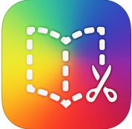 | Book Creator | Literacy | ½ price for 20+  £1.99 each | £39.80 | 20 | Creation of an animated book similar to Animoto, Photostory – sound, images, video
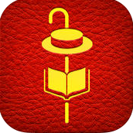 | The fantastic flying books or Mr Morris Lessmore | Literacy | ½ price for 20+  £1.99 each | £39.80 | 20 | Adaptable story, making choices throughout the animated story
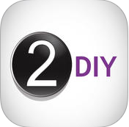 | 2 DIY | Coding | free | free | 100 | Create your own interactive resources, activities, games, puzzles, quizzes. You can create cross-curricular, personalised resources and use them on whiteboards.
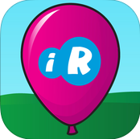 | Multiple Wipeout | Mathematics | ½ price for 20+  £0.39 each | £7.80 | 20 | Similar to primary resources version, popping balloons related to multiples and factors.
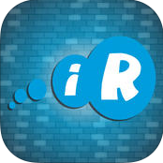 | Super Tiles | Mathematics | ½ price for 20+  £0.39 each | £7.80 | 20 | Cover three numbers in a line either horizontally or vertically. Using the three numbers rolled on the dice, players must make a numerical sentence which equals a number on the board.
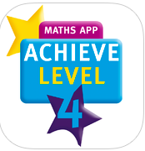 | Achieve level 4 maths | Mathematics | ½ price for 20+  £2.24 each | £44.80 | 20 | Tried and tested formula for raising attainment in the year 6 National Tests. Schools have been using Achieve books for over 10 years to improve children’s test results.
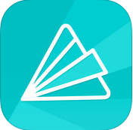 | Animoto | Animation/ Literacy | free | free | 100 | Make fun videos wherever you are, with photos and video clips from your Camera Roll. Choose from one of our sleek video styles, add a song, and you’re done!
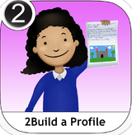 | 2 build a profile (Ipad minis x4) | EYFS | free | free | 4 | Reception and Nursery based profile for taking photos and sharing information.
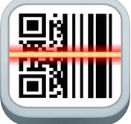 | QR Reader | all | free | free | 100 | To read QR codes
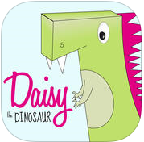 | Daisy Dinosaur | Coding KS1 | free | free | 100 | Easy drag and drop interface that kids of all ages can use to animate Daisy to dance across the screen.
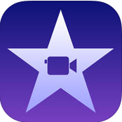 | I Movie | animation | Free with ipad | Free with ipad | Each ipad exclusive | iMovie lets you enjoy your videos and tell stories like never before. Browse your video library, share favourite moments, create beautiful movies and watch them on all your devices in iMovie Theater.
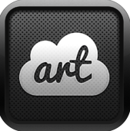 | Cloud Art | Literacy | ½ price for 20+  £0.39 each | £7.80 | 20 | Simply give Cloudart some text from a web page or paste some into the app and it will automatically create a gorgeous word cloud for you in seconds.
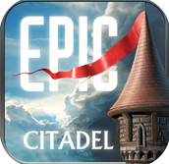 | Epic Citadel | Special Effects | free | free | 100 | From the circus bazaar to the sweeping cathedral in the center of town, Epic Citadel dazzles with a visual parade of special effects,
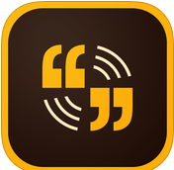 | Adobe Voice | Recording | free | free | 100 | Create stunning animated videos in minutes. No filming – just talk to tell your story. Pick from over 25,000 beautiful iconic images to show your ideas and Voice automatically adds cinematic motion and a soundtrack. Persuade, inform and inspire anyone online.
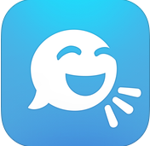 | Tellagami  (on Ipads 3, 4, 5 , 6, 7) | animation | £3.99 each | £19.95 | 5 | Tellagami is a mobile app that lets you create and share a quick animated video called a Gami.
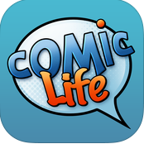 | Comiclife 3 | Story animation | ½ price for 20+  £1.99 each | £39.80 | 20 | Packed with fonts, templates, balloons, captions, and lettering art, Comic Life is a fun, powerful and easy-to-use app that makes creating comics easier than ever. And now you can build your comics anywhere you like!
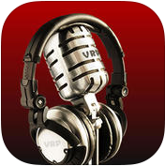 | Voice Recorder | Speaking and listening | free | free | 100 | Voice Record Pro is a professional voice recorder. It allows you to record voice memos and on-site sounds at unlimited length with configurable quality.
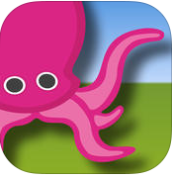 | Green Screen | recording | ½ price for 20+  £0.39 each | £7.80 | 20 | Green Screen by Do Ink makes it easy to create incredible green screen videos and images right on your iPad.
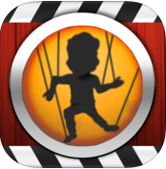 | Puppet Pals | animation | free | free | 100 | Children unlock creativity with this easy to use (but hard to put down) interactive puppet show! Even young children can create high quality cartoons from their imaginations. Kids can even star in the show along side the built-in characters!
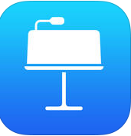 | Keynote | Presentation | Free with ipad | Free with ipad | Each ipad exclusive | It makes creating a world-class presentation — complete with animated charts and transitions — as simple as touching and tapping.
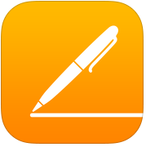 | Pages | Word processing | Free with ipad | Free with ipad | Each ipad exclusive | Pages is the most beautiful word processor you’ve ever seen on a mobile device. This powerful word processor helps you create gorgeous reports, CVs and documents in minutes
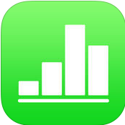 | Numbers | Spreadsheets | Free with ipad | Free with ipad | Each ipad exclusive | Numbers includes support for Multi-Touch gestures and Smart Zoom so you can create powerful spreadsheets using just your fingers.
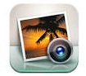 | iphotos | presentation | Free with ipad | Free with ipad | Each ipad exclusive | Collaborating photos together in a booklet
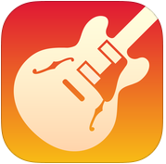 | Garage Band | Music | Free with ipad | Free with ipad | Each ipad exclusive | Touch Instruments and a full-featured recording studio — so you can make music anywhere you go. Use Multi-Touch gestures to play a piano, organ, guitar, and drums.
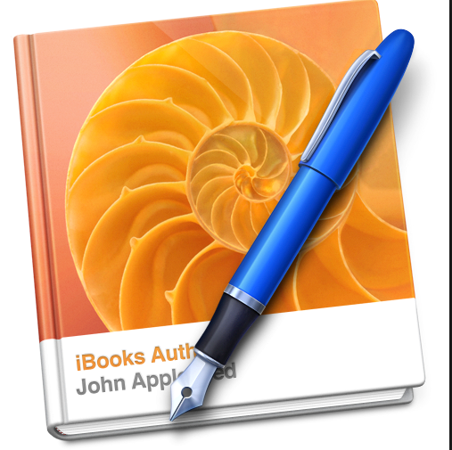 | Ibook author | Literacy | free | free | 100 | Collection of stories for reading in class
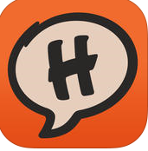 | Halftone 2 | Comic life | ½ price for 20+  £0.74 each | £14.80 | 20 | Halftone 2 makes it easy to create comic and scrap books with your images. Choose a page layout, apply photo filters, position captions, add speech and thought balloons, place some WHAMs, BAMs, and POWs
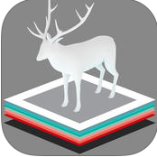 | Zookazam | Augmented relaity | free | free | 100 | To experience the possibilities of Augmented Reality download Zookazam 3.0.1, an educational AR App that not only allows you to learn about the animals but also you will be able to witness a giraffe popping out of a flat piece of paper in a photo realistic 3d
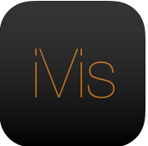 | Ivisualisier | Film recording | £2.29 each | £22.90 | 10 | iVisualiser is the perfect presentation tool for both education and industry alike.
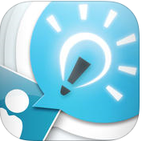 | Explain everything | Science | ½ price for 20+  £1.14 each | £22.90 | 20 | Explain Everything is an easy-to-use design, screencasting, and interactive whiteboard tool that lets you annotate, animate, narrate, import, and export almost anything to and from almost anywhere.
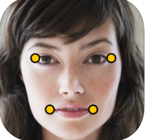 | Morfo | animation | ½ price for 20+  £0.39 each | £7.80 | 20 | Use Morfo to quickly turn a photo of your friend's face into a talking, dancing, crazy 3D character!
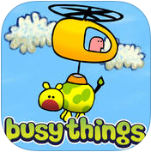 | Busy bundle | Coding KS1 | ½ price for 20+  £0.39 each | £7.80 | 20 | Navigate the helicopter to rescue cows from the trees and place them in the matching baths. At later levels you will need to cage the monster first! Another great problem-solver from Busythings Ltd for very young children aged between 3 to 6
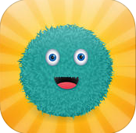 | Kodable | Coding | free | free | 100 | This award winning game and accompanying curriculum, is designed to teach the basics of computer coding to kids 5 and up.
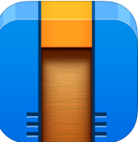 | Cargobot | Coding | free | free | 100 | Over one million people have enjoyed Cargo-Bot! The puzzle game that challenges your brain and helps you learn programming concepts.
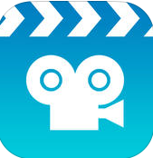 | Stop motion | Coding | free | free | 100 | Get Stop Motion Studio, the world’s easiest app to get you into stop motion moviemaking today!
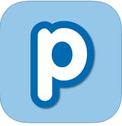 | Popplet | Jotter | free | free | 100 | Popplet is the simplest tool to capture and organize your ideas. With Popplet you can quick jot down your ideas and sort them visually.
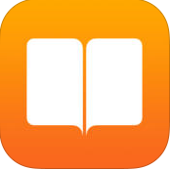 | iBooks | Literacy | Free with ipad | Free with ipad | Each ipad exclusive | Download books to use in class
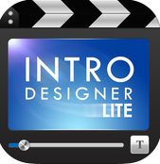 | Introlite | Movie making | free | free | 100 | This is a great little app that can help you create professional-looking intro videos for your creations.
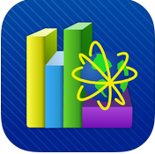 | MLD | languages | free | free | 100 | Multi language dictionary
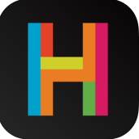 | Hopscotch | Program design | free | free | 100 | Hopscotch is programming designed for everyone! In a few minutes, you'll be making characters move, dance, draw, and interact.
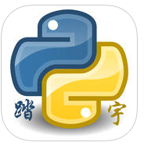 | Pythoni 3.3 | Coding KS2 | free | free | 100 | You can enter python code by keyboard, and then you can execut the python code,support the input function.  *You can use the file system to supports txt, pdf, chm, mp3,m4v,zip, gif, png, html, py ,doc...
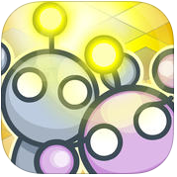 | Lightbot | Coding | free | free | 100 | Lightbot is a programming puzzle game- a game whose game mechanics require using programming logic to solve levels.
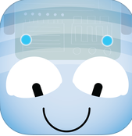 | Bluebot | Coding | free | free | 100 | The app enables you to write an algorithm, send it and then Blue-Bot will follow your instructions. There are numerous features, which make writing algorithms both fun and educational.
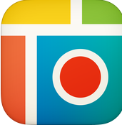 | Pic Collage | Photography | free | free | 100 | Create a collage of photos
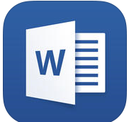 | Microsoft Word, Excel, PowerP | Word processing, spreadsheet, presentation | free | free | 100 | Word processing, spreadsheet, presentation
 | Veescope 5 | Green screen | ½ price for 20+  £1.14 each | £22.80 | 20 | Real-time Green Screen/Chroma Keying to your iPad, iPhone or iPod Touch.
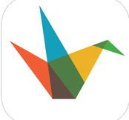 | Haiku deck | Presentation | free | free | 100 | Haiku Deck makes it a snap to create beautiful presentations that will wow your audience – whether you’re pitching an idea, teaching a lesson, telling a story, or igniting a movement.
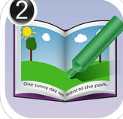 | 2 Create a story | KS1 Literacy | free | free | 100 | The perfect recipe for a perfect story
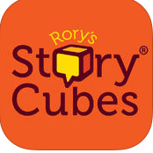 | Rorystory cubes | Literacy (story) | ½ price for 20+  £0.74 each | £14.80 | 20 | 9 cubes, 54 images, Over 10 million combinations, Unlimited stories! Shake to roll the cubes. Can you create a story using all 9 face-up images?
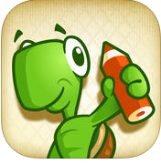 | Move the Turtle | Coding | ½ price for 20+  £1.49 each | £29.80 | 20 | Move the Turtle teaches children (ages 5+) the basics of programming (yes, we do mean coding!
 | Robologic | Coding | ½ price for 20+  £0.49 each | £9.80 | 20 | RoboLogic is a neat logic game. You have to "program" a robot's movements by dragging commands to the memory of the bot. Your goal is to activate all the marked boxes.
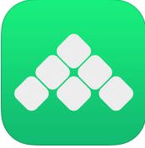 | Hyperpad | Presentations | ½ price for 20+  £1.99 each | £39.80 | 20 | Bring your imagination to life by creating apps like games, books, presentations, brochures, kiosks, and more!
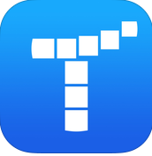 | Tynker for Schools  (on Ipads 3, 4, 5 , 6, 7) | Coding | £2.24 each | £11.20 | 5 | Learn to program with puzzles and easily build your own games. No internet connectivity required. Start by solving coding puzzles. Over 200 puzzles included in 4 adventures.
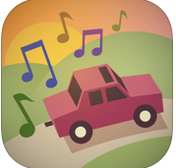 | Isle of Tune  (on Ipads 3, 4, 5 , 6, 7) | Music | £2.29 each | £11.45 | 5 | The addictive multi-award winning music making game arrives on the iPad, iPhone and iPod Touch with NEW features, NEW sounds and enhanced controls!
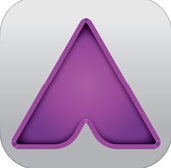 | Aurasma | Augmented reality | free | free | 100 | Aurasma is the industry-leading augmented reality app that’s changing the way millions of people see and interact with the world. In fact, it’s the only mobile app that lets you create and share your own augmented reality experiences!
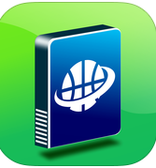 | WebDav | Saving system | free | free | 100 | A system of saving documents onto a icloud space to be accessed and edited at a later date. My WebDav can turn your iPhone, ipad, ipod into WebDav client, download files from WebDav server and upload files into WebDav server.
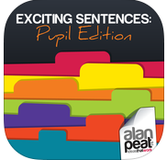 | Exciting Sentences | Alan Peat Literacy | free | free | 100 | A reminded of the Alan Peat sentences used in class. The Alan Peat Pocket App of Exciting Sentences provides teachers and parents with 25 ‘consistent-language’ sentence types, clearly explained and right there on either iPad or iPhone instantly at hand.
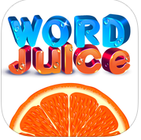 | Word Juice | Alan Peat Literacy | free | free | 100 | You have to create words! Each orange is divided into 8 segments (three vowels and five consonants) AND a central vowel. Tap the letters to make a word, then tap ‘GO’ to squeeze the orange and start juicing! Each word must be three or more letters long and MUST include the central vowel.

