

Nursery Newsletter
26th September 2025
Welcome to the Nursery newsletter-informing you weekly about events happening or coming up in our Foundation Stage unit.
Over the last few weeks, the children have all settled extremely well. We have been very proud of them all.
They have been exploring the setting and have already found their favourite places to play. The staff have been introducing important routines and ensuring that each child knows how to find and use the resources in the classroom, so that they can begin to work independently and take responsibility for their own learning. We have also been carrying out a first day observation and observing the children during their play to inform our baseline assessments.
So far, we have looked at the story ‘Brown Bear, Brown Bear’ and ‘So Much’ and talked about people in our house. We have drawn black and white representations of our family members, and also painted our own self-portraits too.
To support our discussions ‘Who lives in your house?’ could you please send in a family photo or email a photograph of your family to add to our display in the home corner. (tina.lawrenson@sthelens.org.uk)
Thank you for all your support so far.
Reminders


Foundation Stage Fund
Please remember to pay £1 a week, per family towards the FS fund. This helps us to buy some of the extras that enhances your child’s learning, for example play dough ingredients, pasta, shaving foam, cooking ingredients, bubbles… to name but a few.

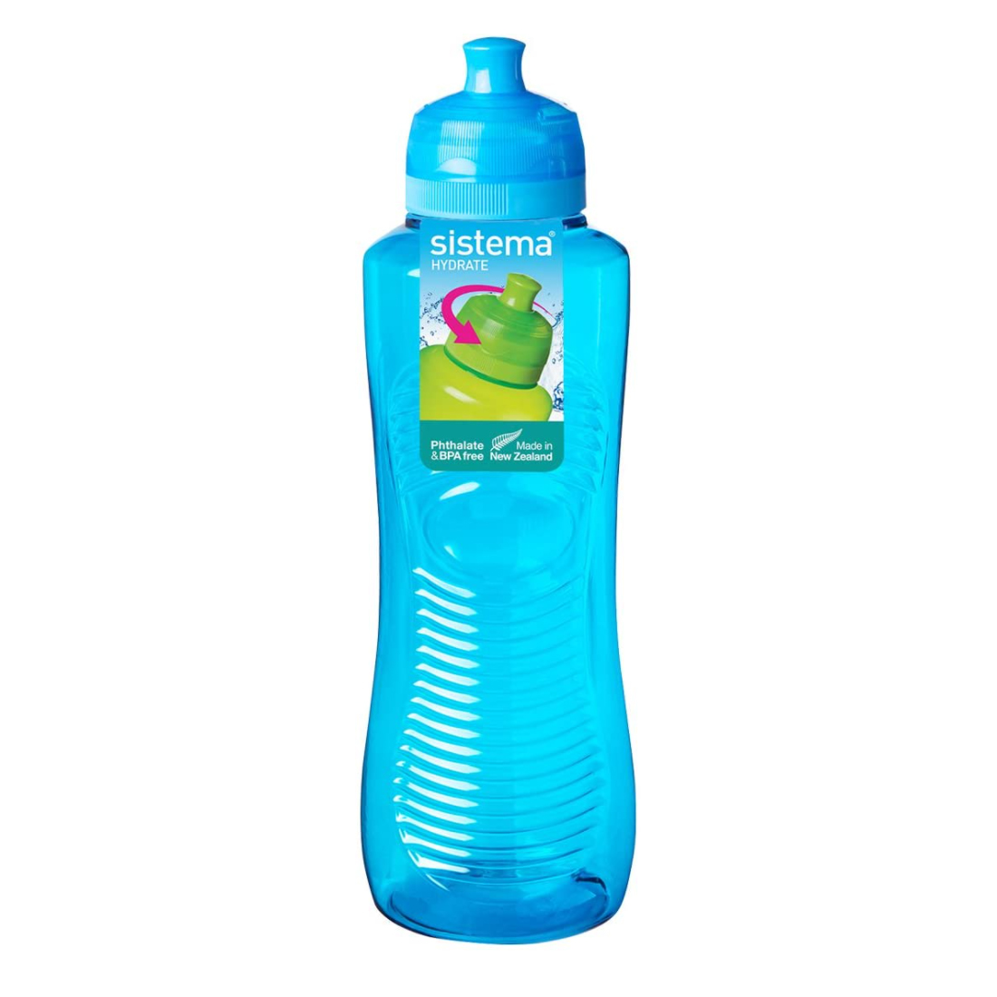
Water Bottles
Please provide a separate water bottle (no juice or flavoured water) for your child to access during the day. Don't forget to put their names on it.


Spare clothes/ Labels
Please provide a full change of clothes every day (these can be left on your child’s peg, if it is more convenient) Can you also ensure that all your child's belongings are labelled-even shoes! Makes returning lost items easier for us and you!
Please could you encourage your child to practise putting their coat and shoes on by themselves.

Packed Lunches
Please find attached a list of Early Years food choking hazards. Please note the foods the children shouldn’t have or that need to be cut up especially when you are making a packed lunch for school.
*WE DO HAVE CHILDREN WITH SEVERE PEANUT ALERGIES! *
Also, please could you provide a healthy packed lunch as we do have Healthy School Status and promote healthy eating. Juice can be part of their packed lunch (separate to the water bottle.)

