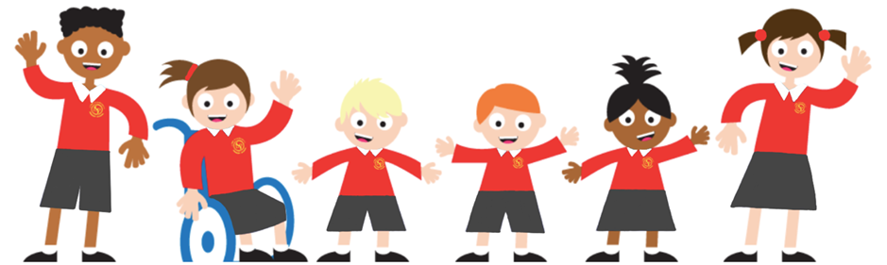
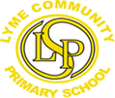
Nursery Newsletter
^{11th July 2025}
Welcome to this week’s news.
This week, we have continued our story, Sand between my Toes. The children enjoyed our own ‘beach day’ in the nursery gardens, complete with paddling pools, sandcastles and even ice-creams…yummy!

We had a wonderful time celebrating Arts Week. Throughout the week we added more pages to create our own sketch books. We explored line and pattern, and used a range of media to explore mark-making with…even twigs dipped in ink!

Linked to Arts Week, we watched a short ‘Jo-Jo and Gran-Gran’ video about Street Art. This provide us with the opportunity for lots of discussions about art, and introduced new language such as ‘design, skulpture’ and ‘murals’. It also inspired us to go outside and further investigate pattern on the playground using the chunky chalks.

The Twig-a-loo was trimmed down this week, and the loose branches provided the children with new den making materials. They had such fun and spent extended periods of time working together and enjoying the dens in role-play.

Finally, some children noticed a bee on one of our sunflowers. We had a lovely conversation about nectar, honey and the good job bees do in our gardens. Despite being wary at first, the children eventually watched the bee with great interest for a long time. I don’t think the bee even noticed us though!
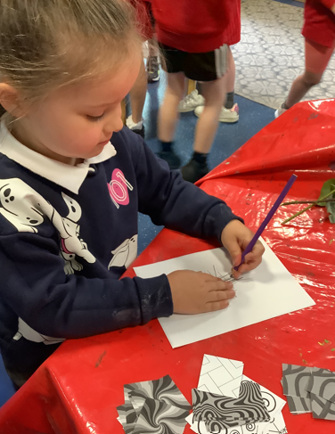
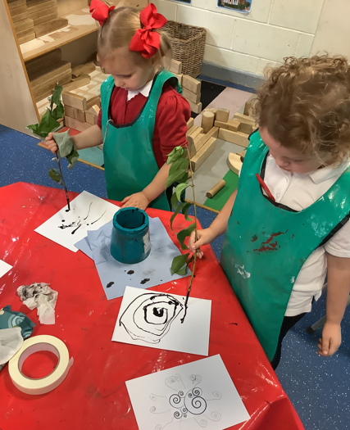
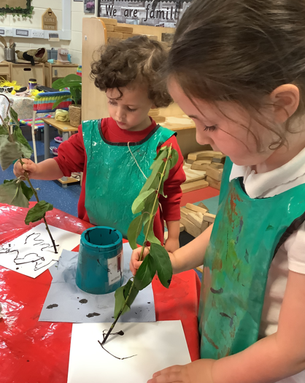
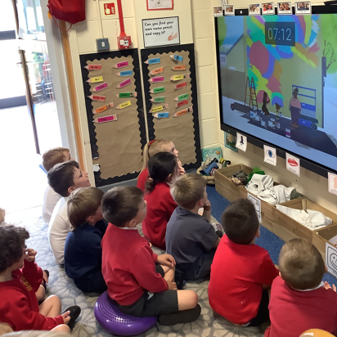
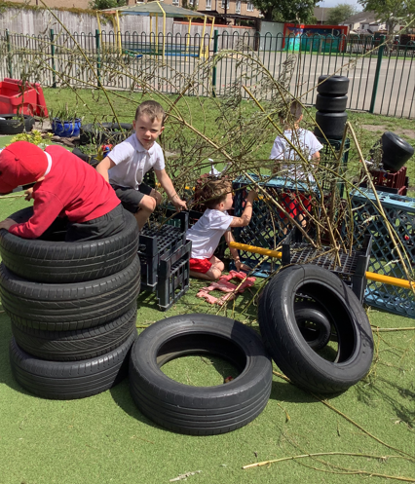
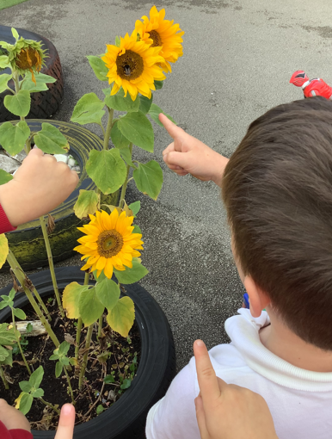

Reminders
Please make sure names are in jumpers/cardigans. The children are taking them off due to the hot weather and they are struggling to find them.  Thank you |   Piggy Money-  This is £1 per  week please.
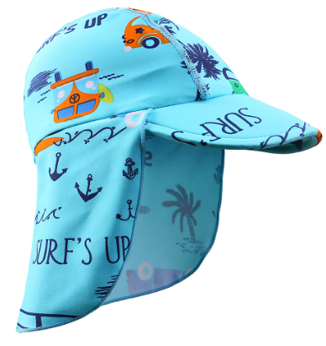
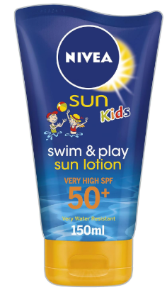
Don’t forget to put suncream on your child before nursery and bring a water bottle and
sun hat with
their name in please!
Please don’t hesitate to come and speak to us if you have any concerns or questions about your child. Our door is always open.

