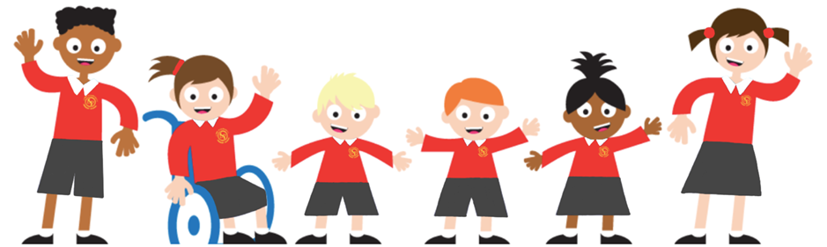

Nursery Newsletter
^{4th July 2025}
Welcome to this week’s news.
This week, we have introduced our new story, Sand between my Toes. The children enjoyed exploring the story props, especially listening to the sea in the different shells. We talked about the events in the story and related these to our own experiences.

Outside, the children loved playing with the bubble mix and large bubble wands. Some of the bubble they made were huge and caused lots of excitement!

The children have been showing off their skills in phonics and seeing how many phonemes they have remembered…they were very impressive and should feel proud of the progress they have made.

At lunchtime, the children created their own storyline in their play, and together they all made a wall to protect themselves from ‘the monsters’. They used words like, gigantic, enormous and tall when talking about the wall as it got bigger and bigger.

In the tough tray we have been exploring pattern with the coloured stacking disks and developing our pincer grasp.

Some children even made fishing rods using found materials linked to our interest in the sea.

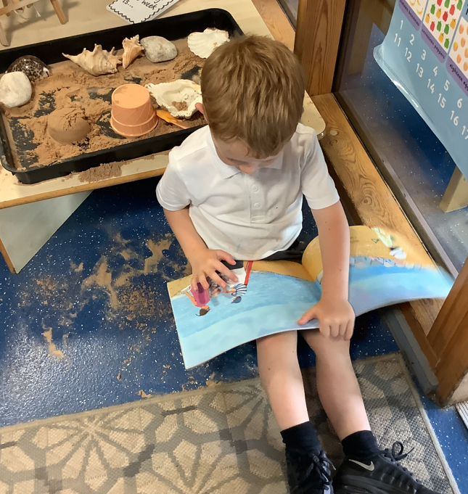
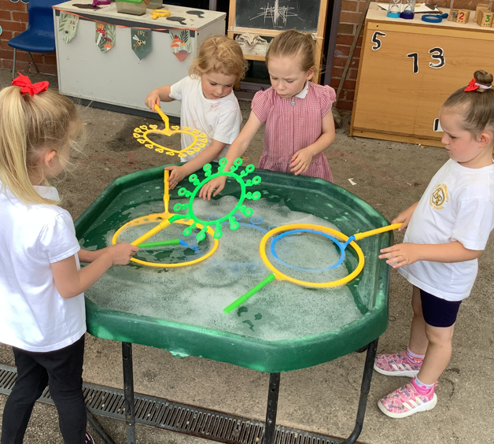
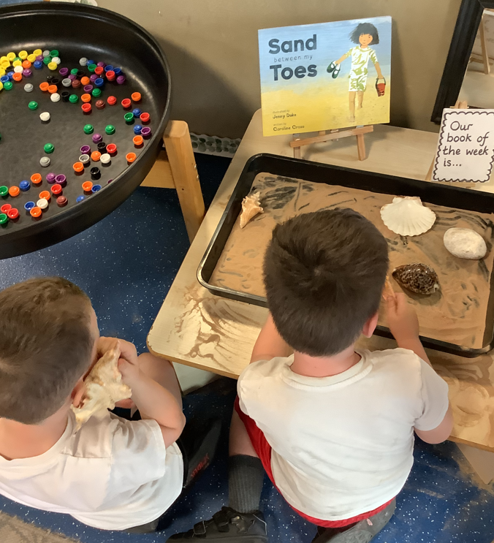
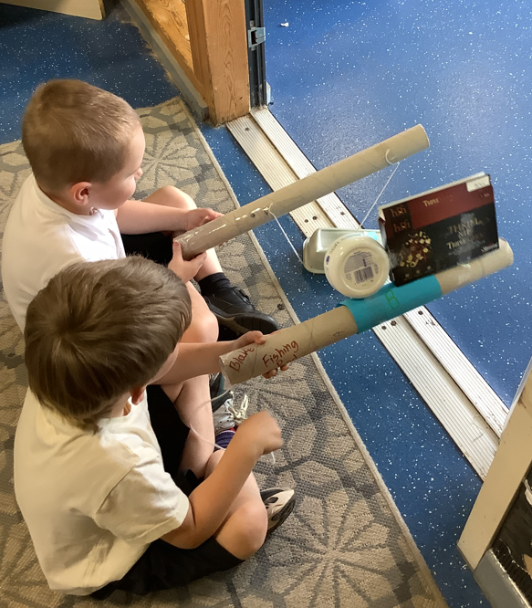
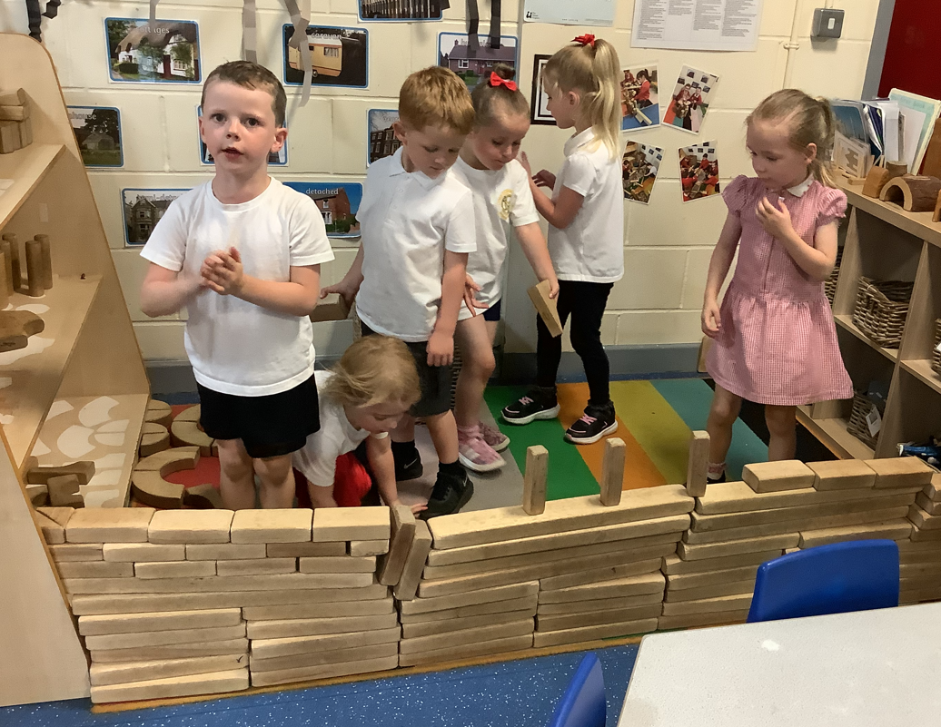

Reminders
Please make sure names are in jumpers/cardigans. The children are taking them off due to the hot weather and they are struggling to find them.  Thank you |   Piggy Money-  This is £1 per  week please.
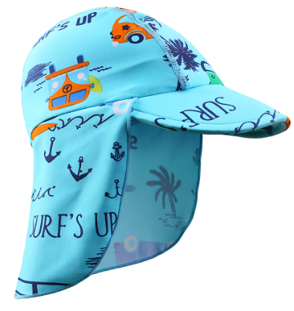
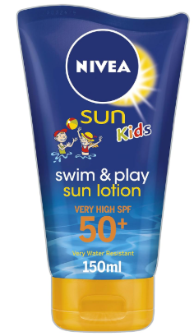
Don’t forget to put suncream on your child before nursery and bring a water bottle and
sun hat with
their name in please!
Please don’t hesitate to come and speak to us if you have any concerns or questions about your child. Our door is always open.

