YEARS 1 / 2 DOJO HOMEWORK – AUTUMN HALF TERM 2 2026
Homework activities for this term are outlined below.
You will receive ‘Dojo Points’ for each task completed and at the end of the half term, your homework will be celebrated in our ‘Dojo Gallery’ for everyone to see.
If you complete all of the tasks, you will receive a homework celebration certificate and a bonus 10 dojo points!
All tasks need to be completed and returned by Tuesday 14th December.
HOMEWORK TASKS WORTH 1 DOJO POINT | HOMEWORK TASKS WORTH 3 DOJO POINTS | HOMEWORK TASKS WORTH 5 DOJO POINTS
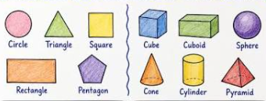  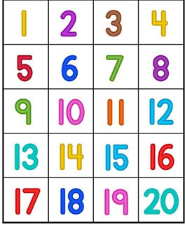  Maths: This half term we will begin to learn about 2D & 3D shapes. What shapes can you find around your house? Make a list of the objects you find and the shape that they are. | Computing/Art: Complete the set ‘2Do’ on Purple Mash, creating your own Rangoli pattern painting.    To find the ‘2Do’ project set by Mrs Cain, click on the orange ‘2Do’ clipboard at the top of the page. Once the work is complete, don’t forget to save your work and click on ‘Hand in’ so that Mrs Cain can see your creations! |   Geography: Find out five facts about India which you find the most interesting. Write them in your homework book. You could research on the internet or even find a book at the library.
    RE: Draw a picture of your favourite gift that you have ever received. Think about why it was your favourite and what it means to you. | 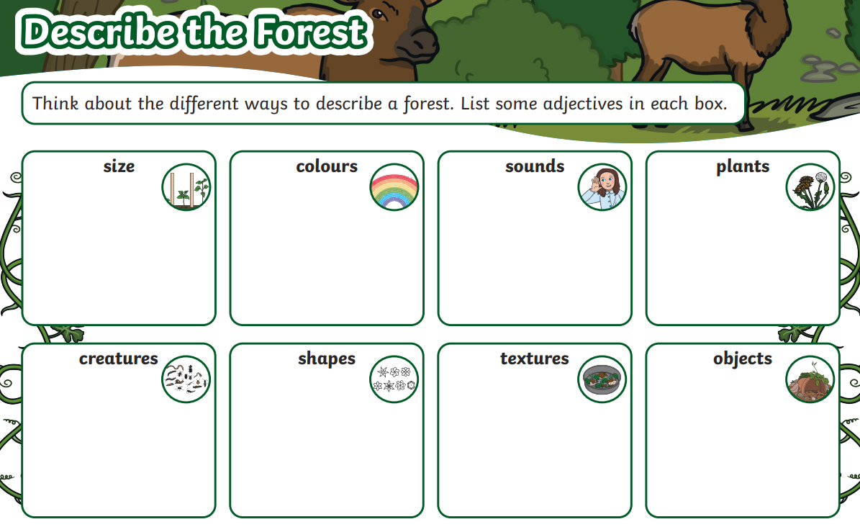  English: Describe the forest using adjectives. Use the given template to help you describe what you might see, hear and feel in the forest. | 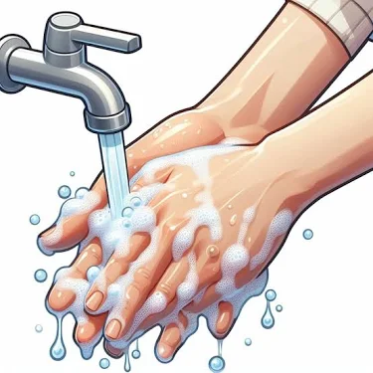  Science: Create a poster which shows the steps of good handwashing. Ask someone in your family to follow the steps you include on your poster to test how accurate your poster is.

