YEARS 1 / 2 DOJO HOMEWORK – AUTUMN HALF TERM 1 2026
Homework activities for this term are outlined below.
You will receive ‘Dojo Points’ for each task completed and at the end of the half term, your homework will be celebrated in our ‘Dojo Gallery’ for everyone to see.
If you complete all of the tasks, you will receive a homework celebration certificate and a bonus 10 dojo points!
All tasks need to be completed and returned by Tuesday 20th October.
HOMEWORK TASKS WORTH 1 DOJO POINT | HOMEWORK TASKS WORTH 3 DOJO POINTS | HOMEWORK TASKS WORTH 5 DOJO POINTS
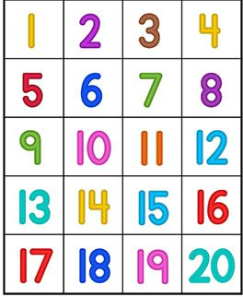  Maths: Practice writing your numbers to 20. Make sure your numerals are written the correct way round!  As an extra challenge, can you spell the number words to match the numbers? |   Computing: Use ‘2Beat’ on PurpleMash to explore rhythm, tempo and pulse. | 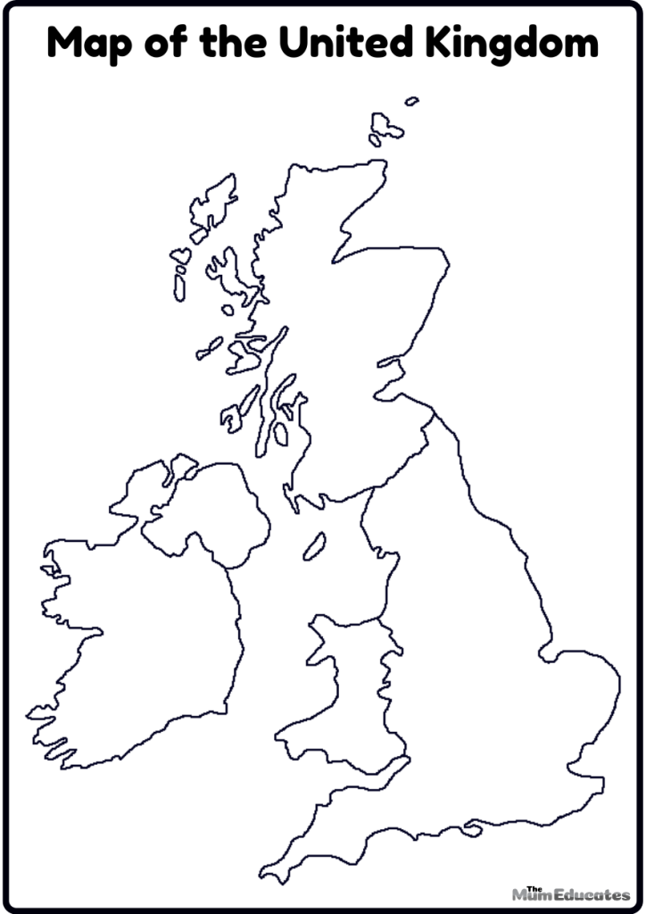  Geography: Name the four countries of the United Kingdom. Can you label them on a map? Perhaps you could find the capital cities or show the flags for each country.
  English: Write about your favourite object at home. You could also draw a picture. Don’t forget to use your capital letters, finger spaces and punctuation. Use your phonics for spelling!  Y1 - Write a simple label or single sentence.  Y2 - Write a few sentences to describe your object. | 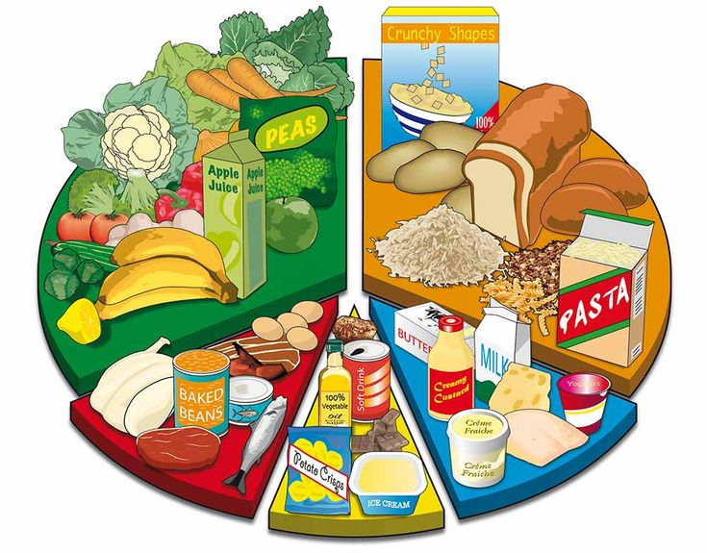  DT: Design a healthy, balanced meal. You could draw the meal or find pictures of foods for your meal to cut and stick. | Science: Choose a natural habitat and research which living things can be found in that habitat.  

