Bunbury Aldersey CE Primary School

Coming Back to School
A guide for Bunbury Children
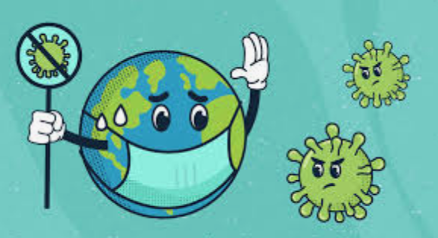
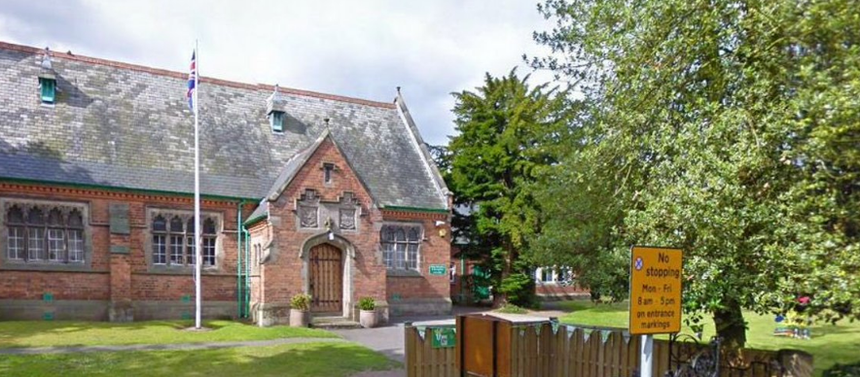
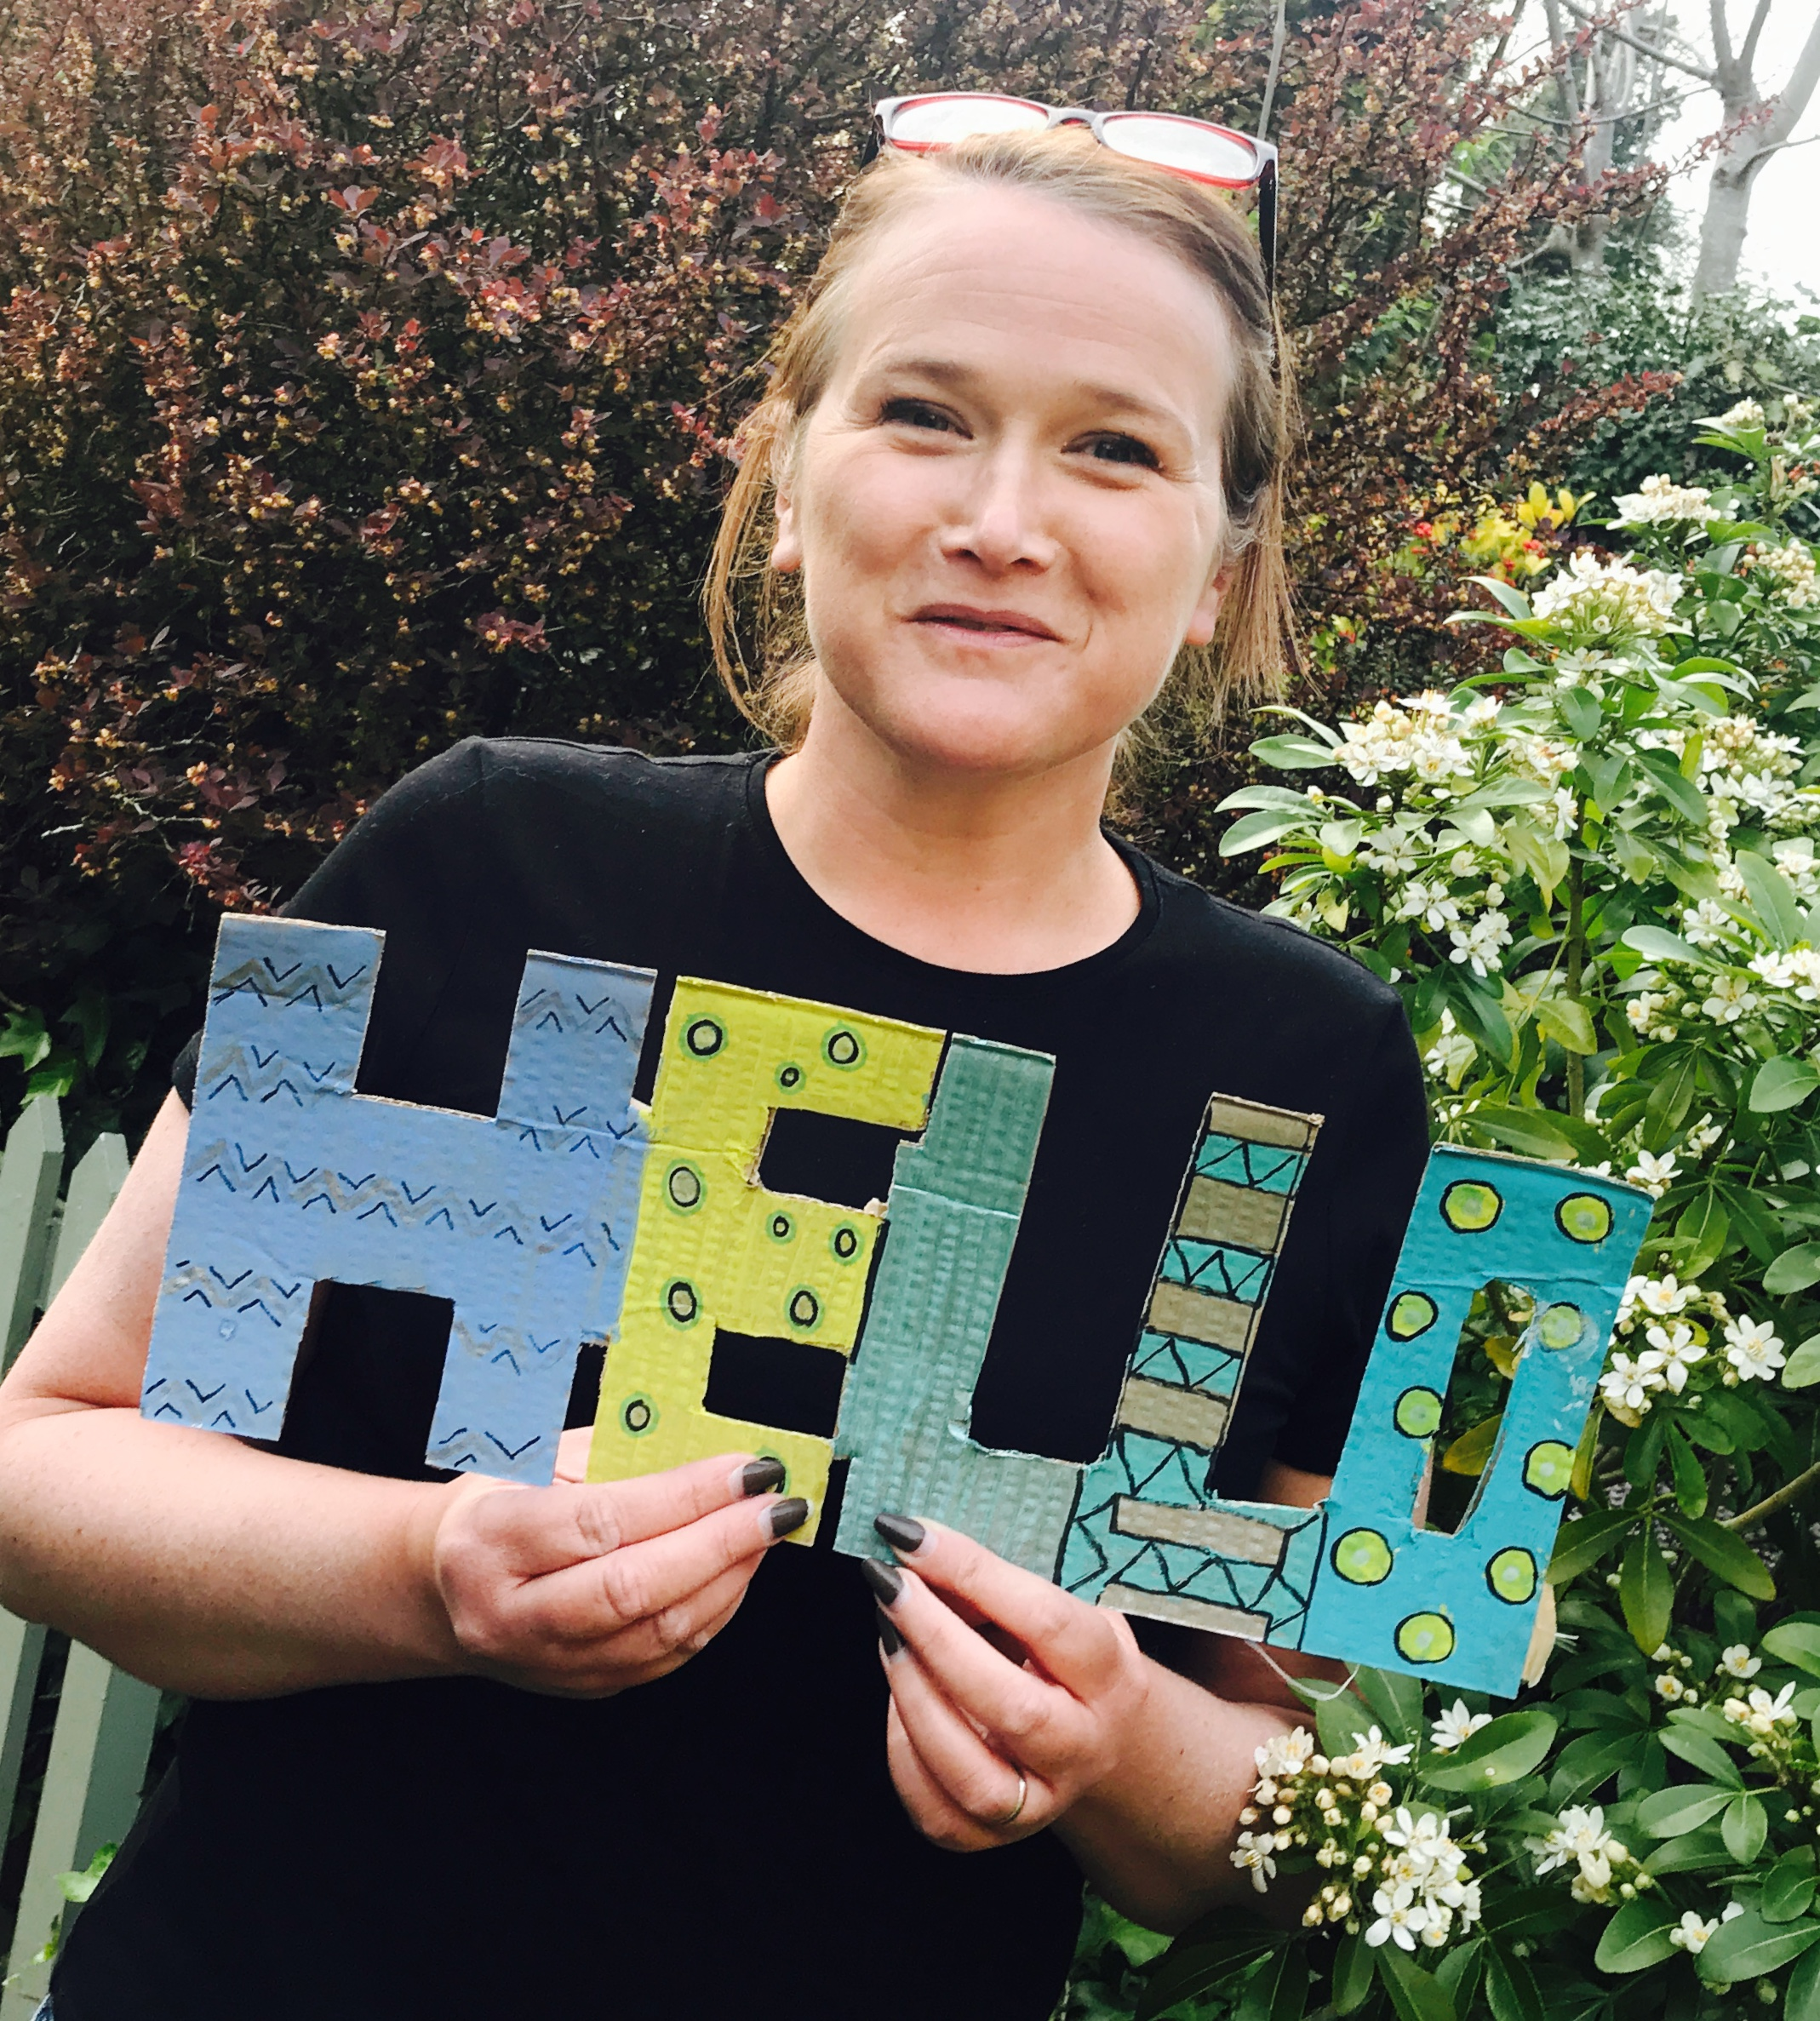

Hello children,
Its Mrs Badger here.

Back in March when we closed our doors I told you in our worship that staying away from each other and from our wonderful school would not last forever.

You have all done a fantastic job over the past few months staying apart from each other and helping our doctors and nurses to stop the virus spreading further. There are still lots of very clever grown-ups working together to make sure we all stay as safe as possible and we need to listen to what they have to say for a while longer.

However, we are now at a point where we can welcome you all back into our classrooms, back with our teachers and most importantly back with your friends.
Bunbury school will be together once more.

School will be very different for a little while when you return and I don’t want anyone to worry about what it will be like. Mrs Badger has lots of tricks up her sleeve ready to help prepare you for the return – one of these is this little booklet.

Inside you will find information and pictures showing and explaining to you what it will be like. Everyone at school has been working very hard to keep you all very safe when you return and we will all be helping you to get used to some of the things we will have to do.

I don’t want you to worry and as I have asked you all along please talk to one of the grown -ups around you if anything is worrying you. I have asked your grown-ups to read this book to you as much as they can, showing you the pictures and sharing with you all the information about returning to school. You may hear some things that you are worried about, but these are not worries for you. Tell someone you trust about your worry and let them look after it for you. You can log onto our school Padlet and send me any questions you might have about coming back to school.

One thing I do know which will be no different to before is how much we care for you, how much we will look after you and most importantly your teachers smiles.

Welcome back children.

Mrs Badger x

What is Coronavirus

Coronavirus is an illness that affects people’s breathing and lungs. It can be spread from person to person by coughing or touching surfaces.

Children who get corona virus will usually only get a little ill, like a cold. Lots of children don’t get it at all.

The same goes for your mummy and daddy, if they get it. Grown-ups with healthy bodies are not likely to become very ill.

But coronavirus can make people very poorly especially if they are old or have illnesses already.

We must do everything we can to protect everyone around us.

There have been big changes in our lives because of coronavirus.
Schools have closed and we have needed to stay at home.
So, coronavirus has probably made your life feel very different for a number of months.
All these changes might have made you feel worried or scared.
That’s ok.
It’s totally normal to feel like this.
When you are back in school we will be doing lots of things to help you with all these feelings.



How will we keep you safe in school.
Keeping everything clean..

There will be lots of cleaning going on around school during the day to keep everything clean.
You will be asked to wash your hands properly lots of times during the day

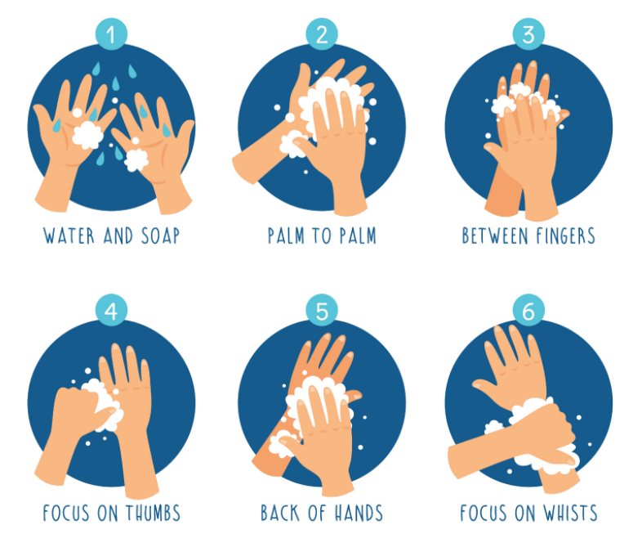

Can you practice washing your hands at home?

If you cough – remember you need to cough into your elbow.
Remember how Mrs Badger showed you how to ‘dab’ when coughing.
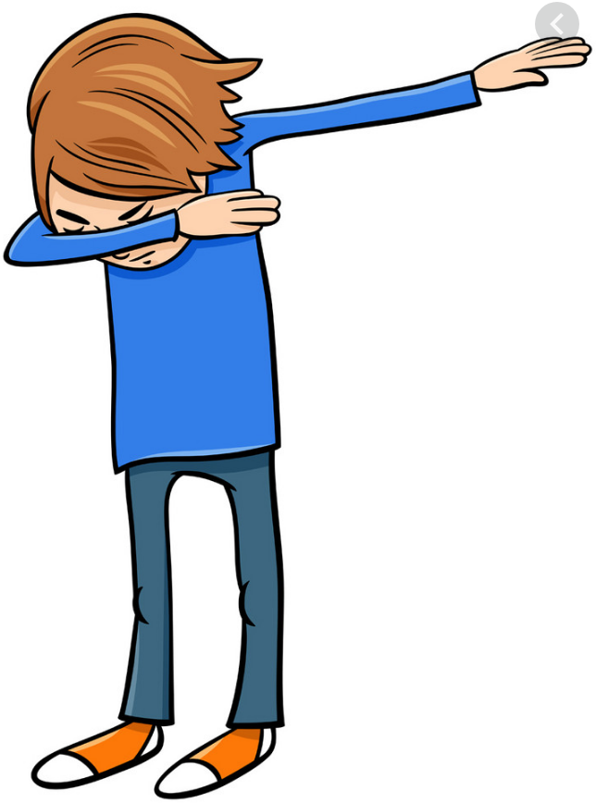

If you sneeze or blow your nose you need to use a tissue. You will need to put your tissue straight into a bin.
We need to remember to – “catch it, bin it, kill it.”

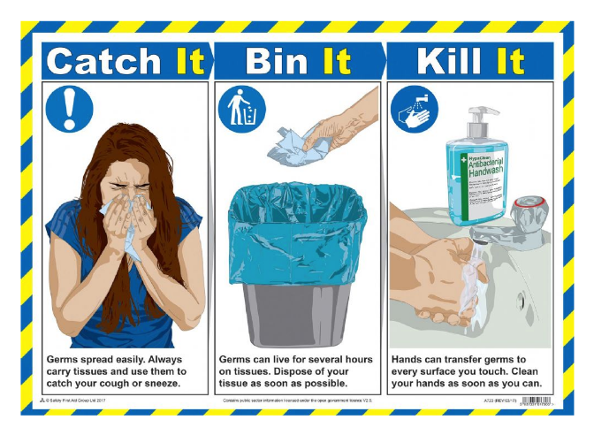

Class bubbles

We have to keep your classes separate for a while so that you don’t mix with too many people. You will be able to work, play and eat with the children in your year group, they will be your bubble. At the moment though you won’t be able to play with anyone in a different class at school.

These groups are called bubbles and within them you will have friends from your class, a teacher and a teaching assistant to help you.



You will do everything with your bubble. We need to make sure your bubble doesn’t pop so you will have your lessons, eat your lunch and play at playtime as a bubble.
For a little while they will be your new school family.
Your bubble teacher will care for you just as much as your Mum and Dad.
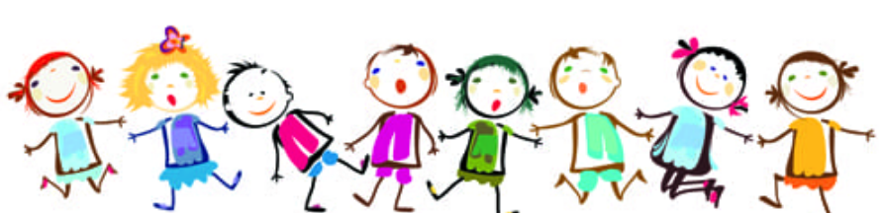

In your bubble we have to keep sharing of resources and equipment to a minimum.
You will all have your own pencil case which you will need to look after.
Inside it there will be lots of things just for you.
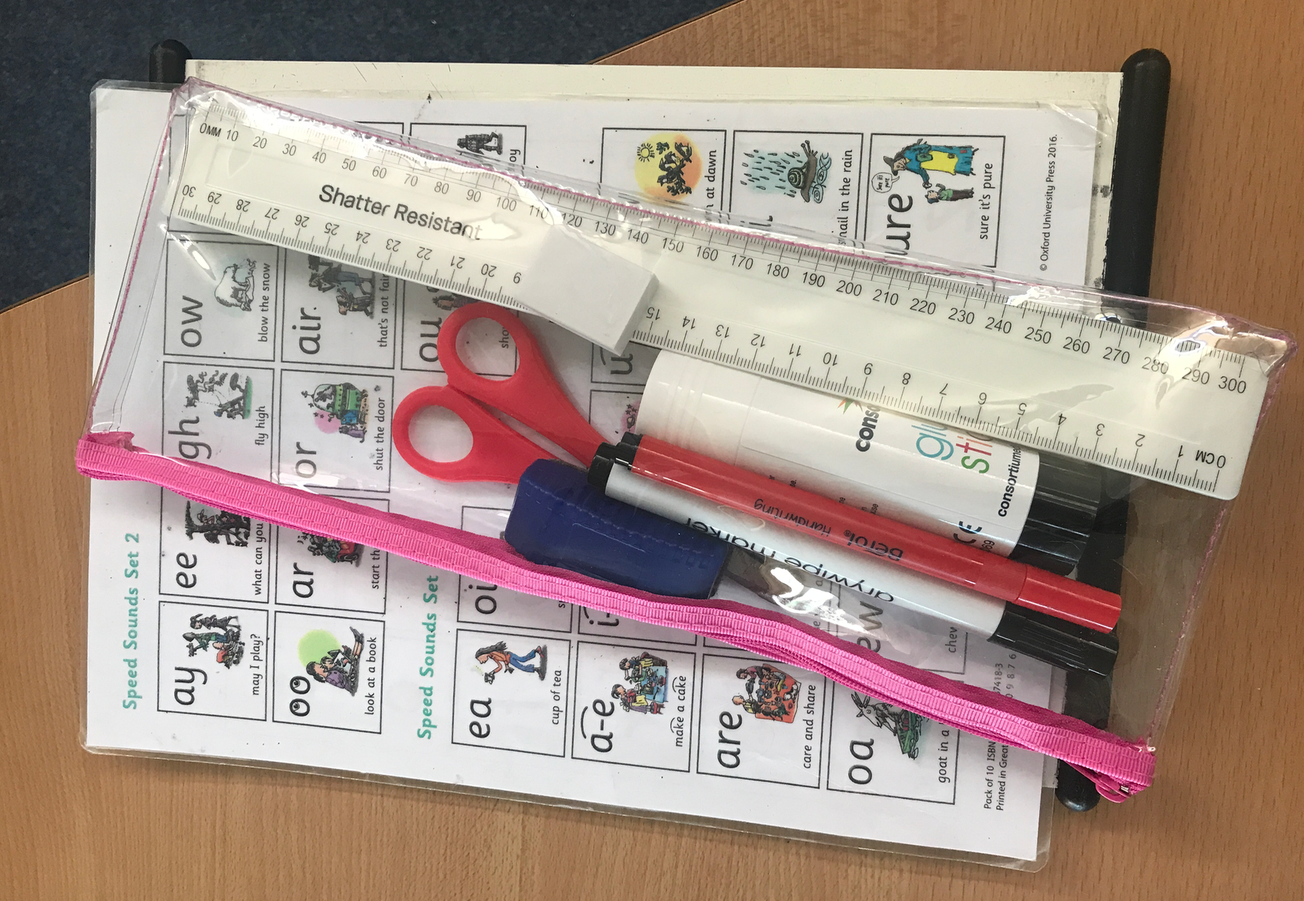

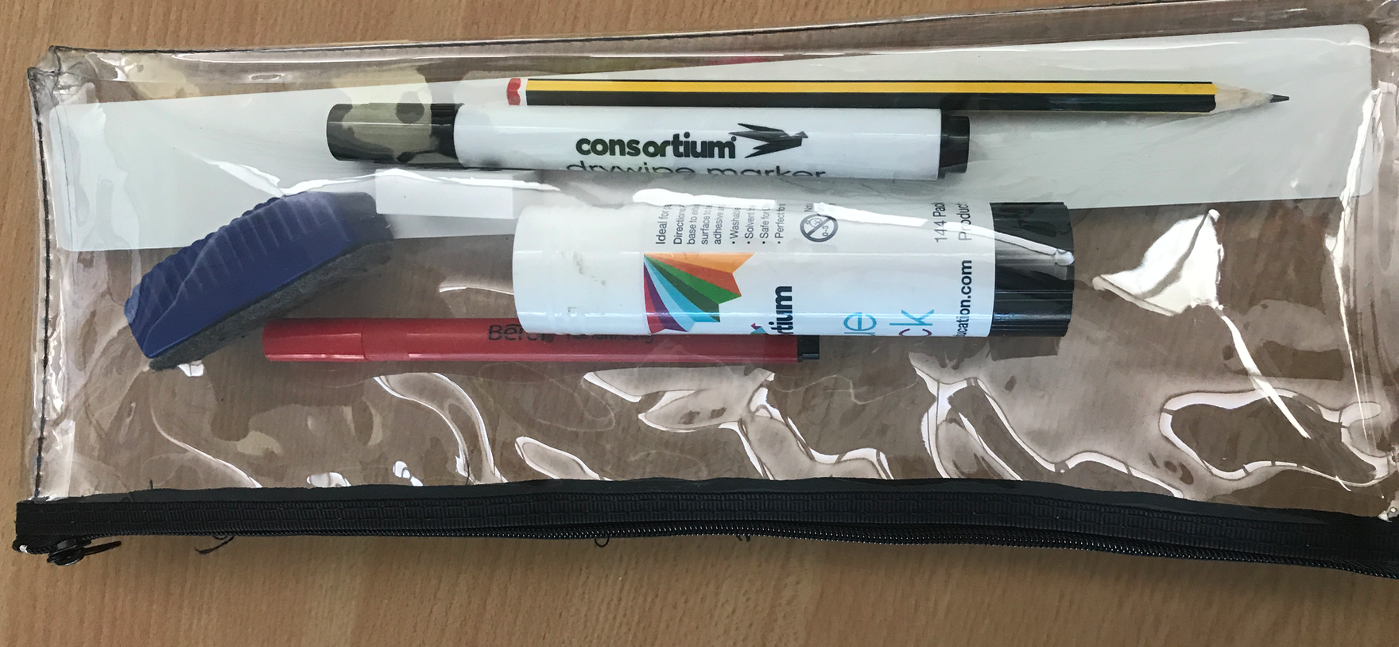

Classrooms

Your classrooms will look a little bit different for a while.
We have needed to space all the tables out so that they all face forward.
You can sit next to people but not opposite them.

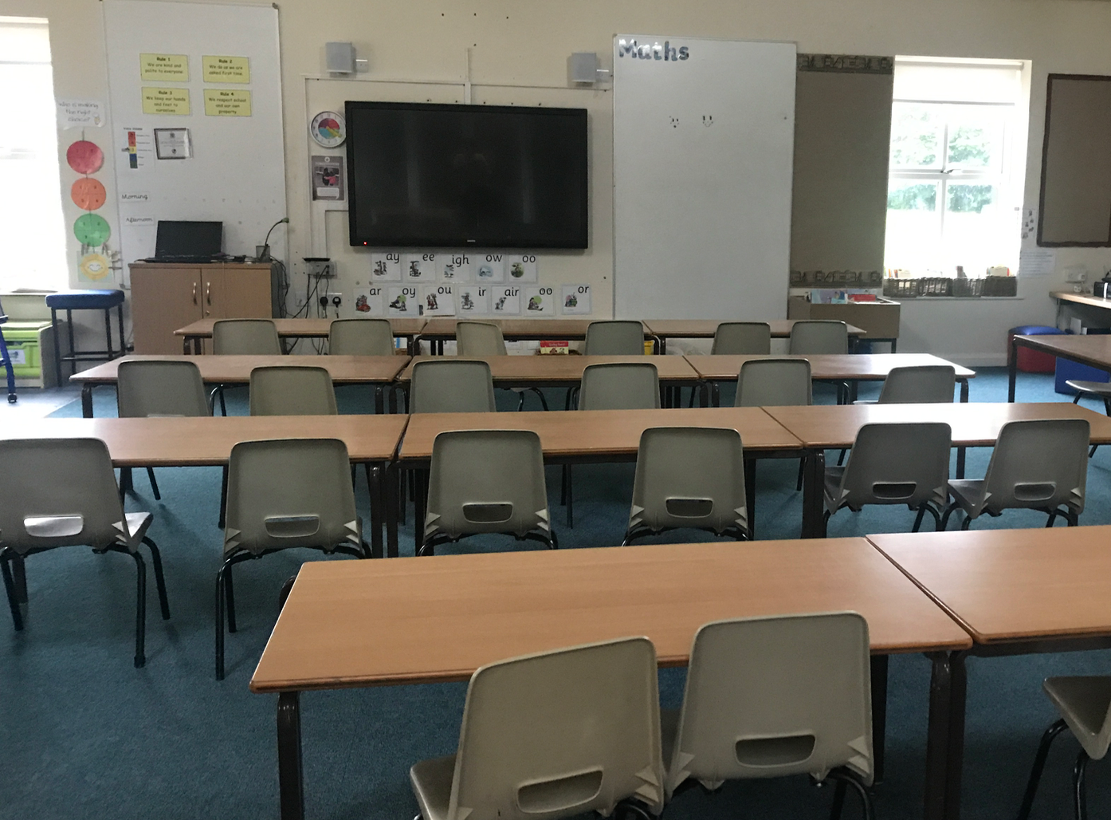
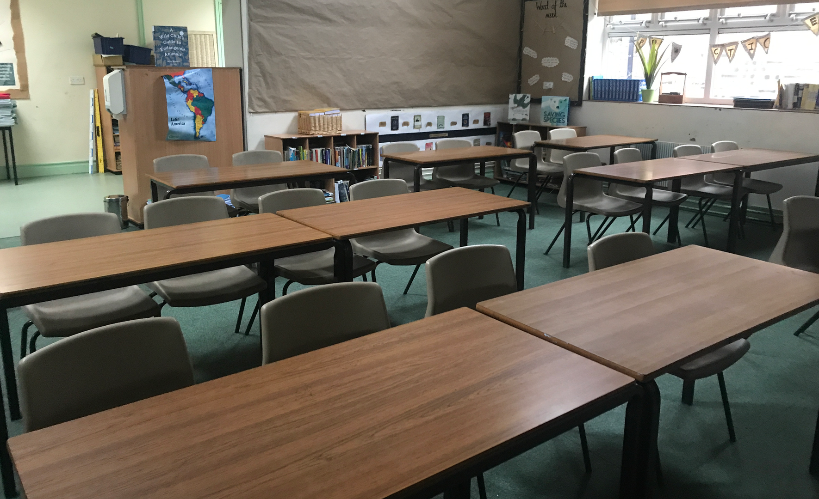
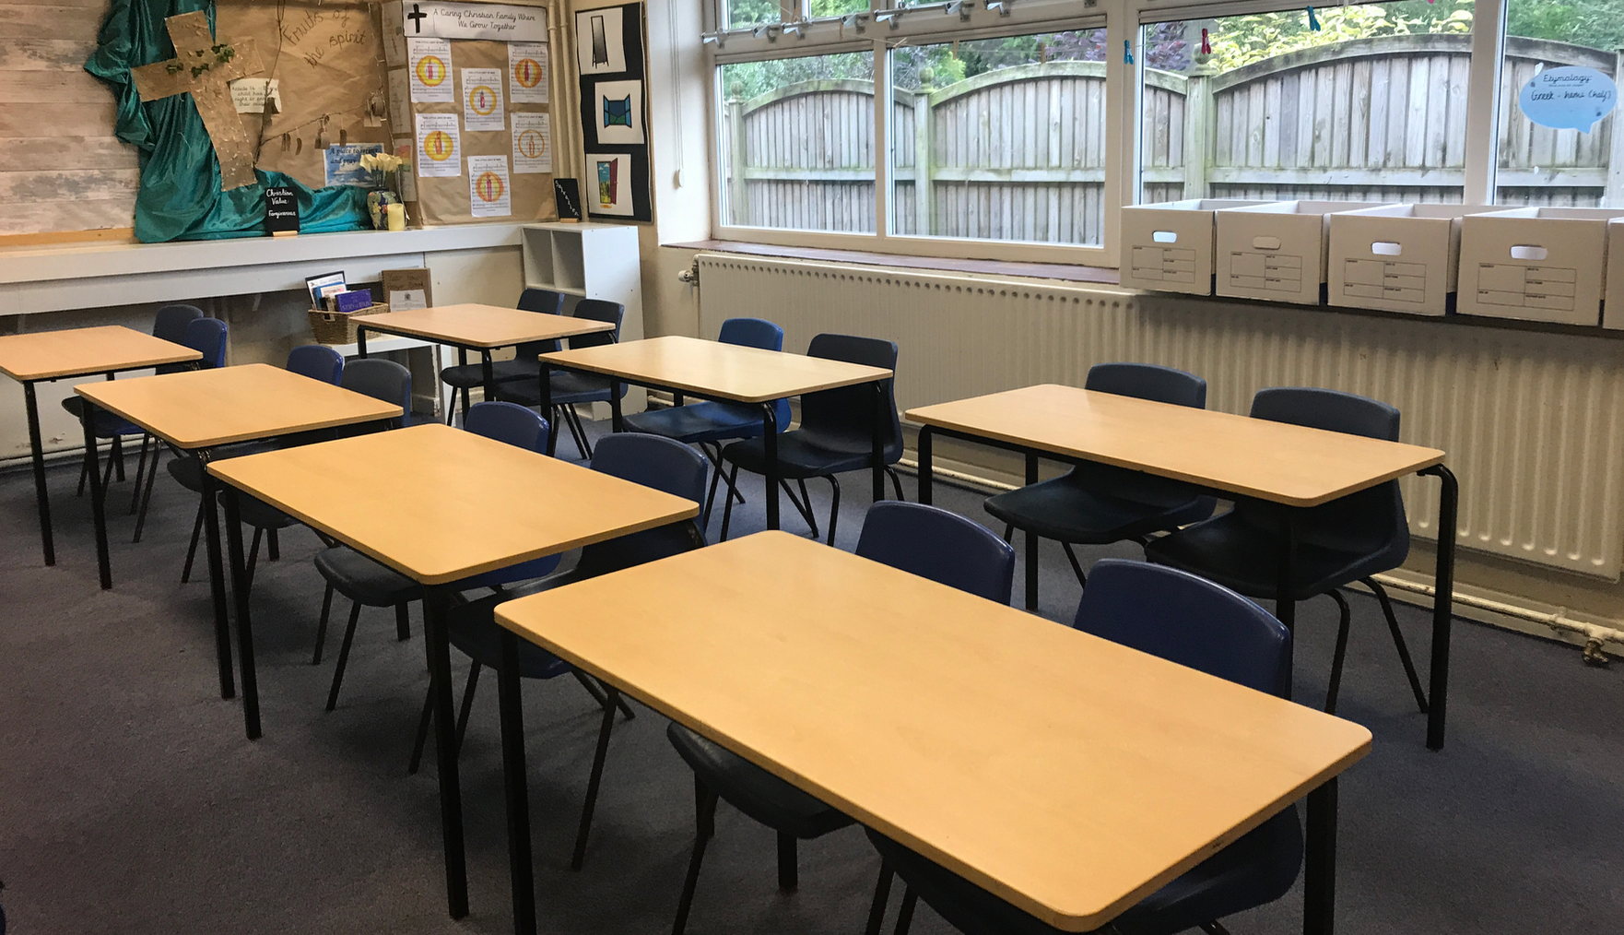
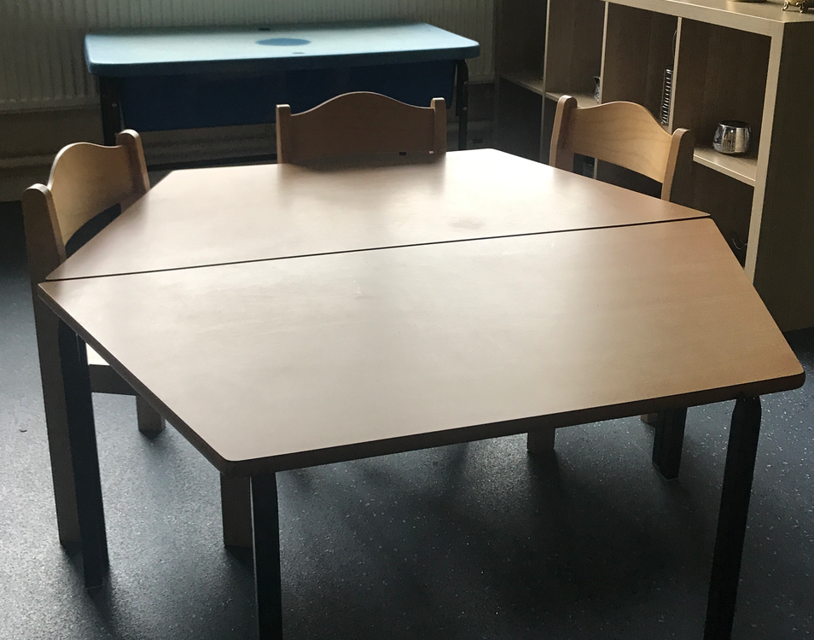
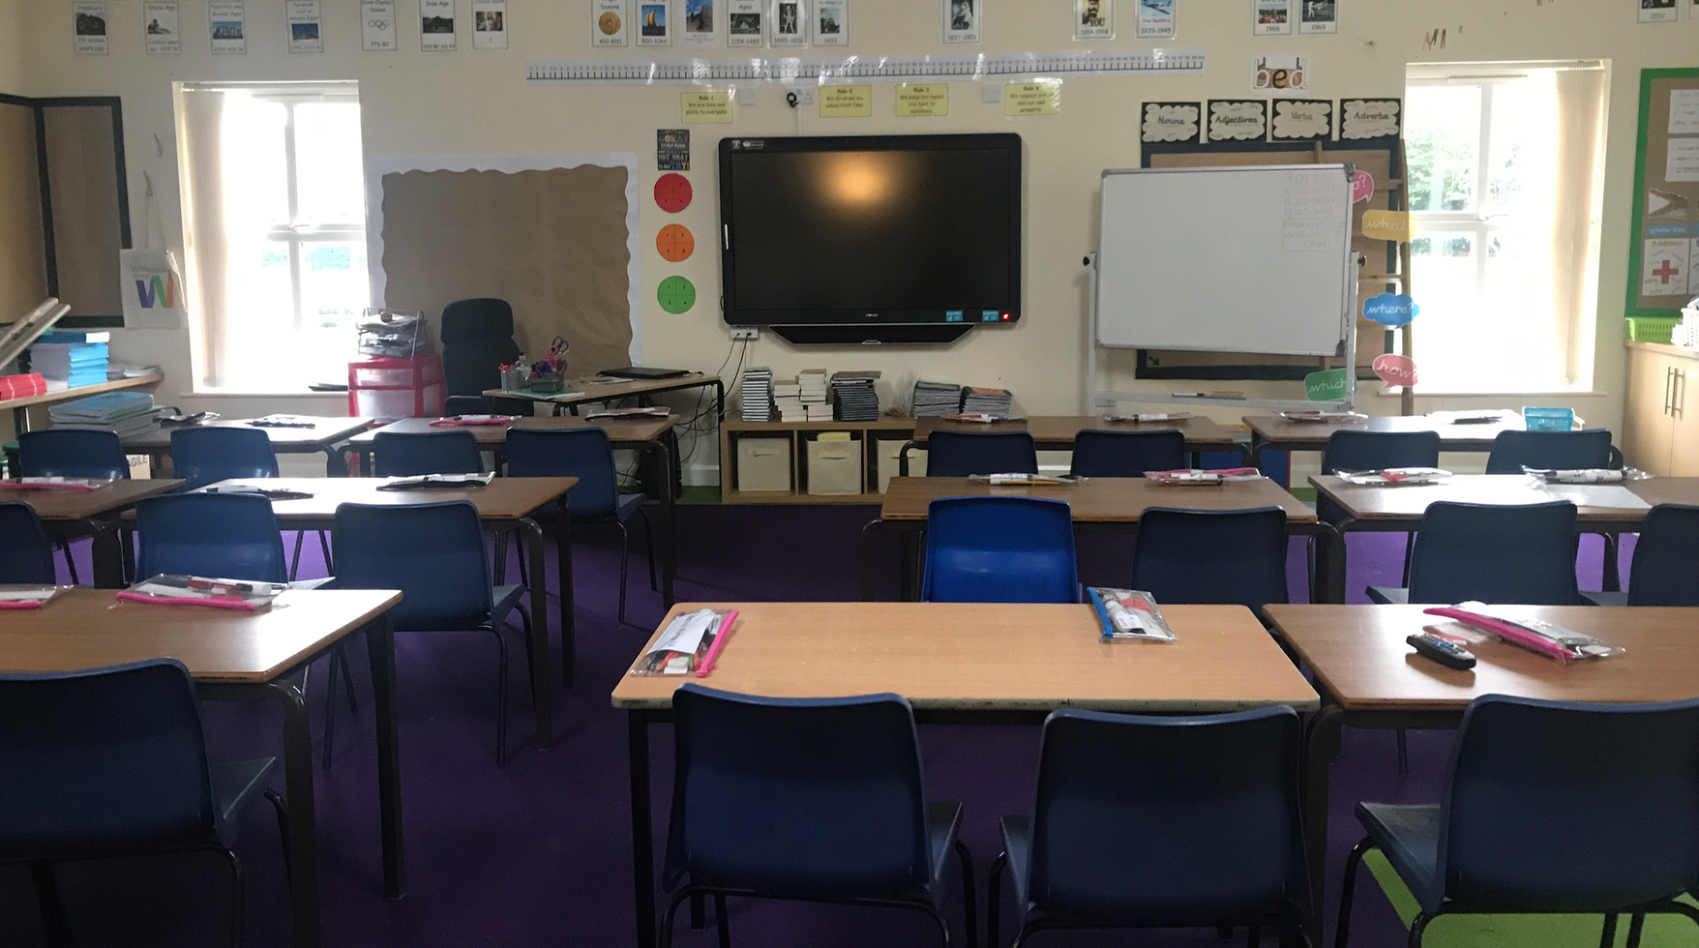

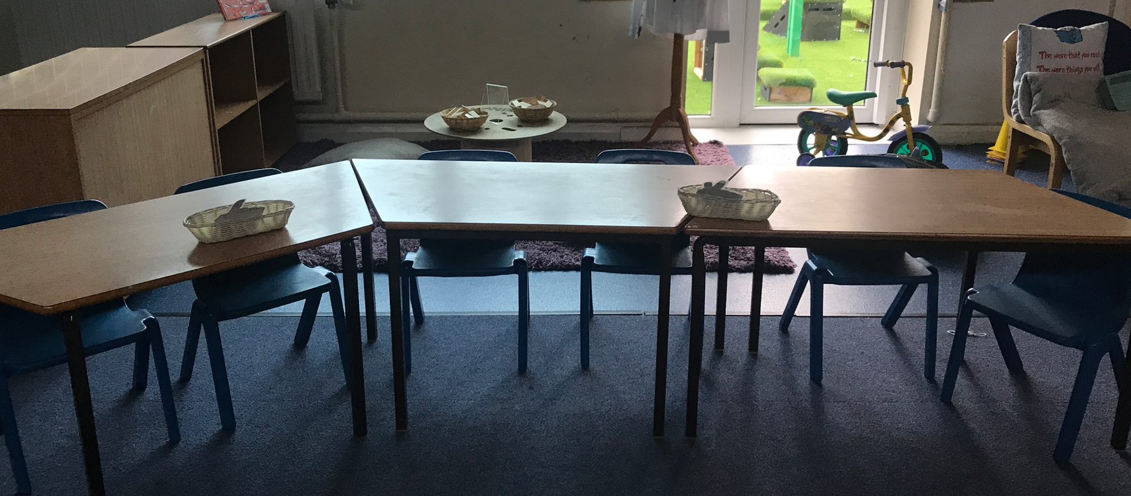

Moving around school

You will only be allowed to go around the school with an adult and the rest of your bubble.

There will be arrows to follow on the floor of the corridor and we will be only allowed to go in one direction.

You will see signs asking you to stop and posters reminding you not to get too close to anyone else.
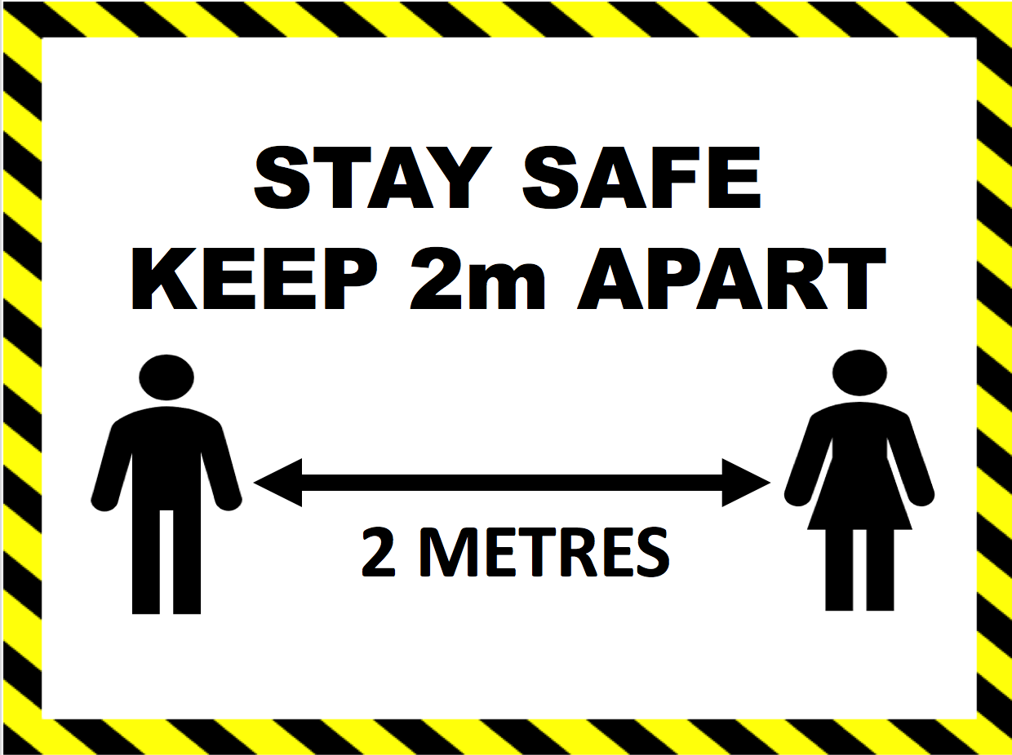

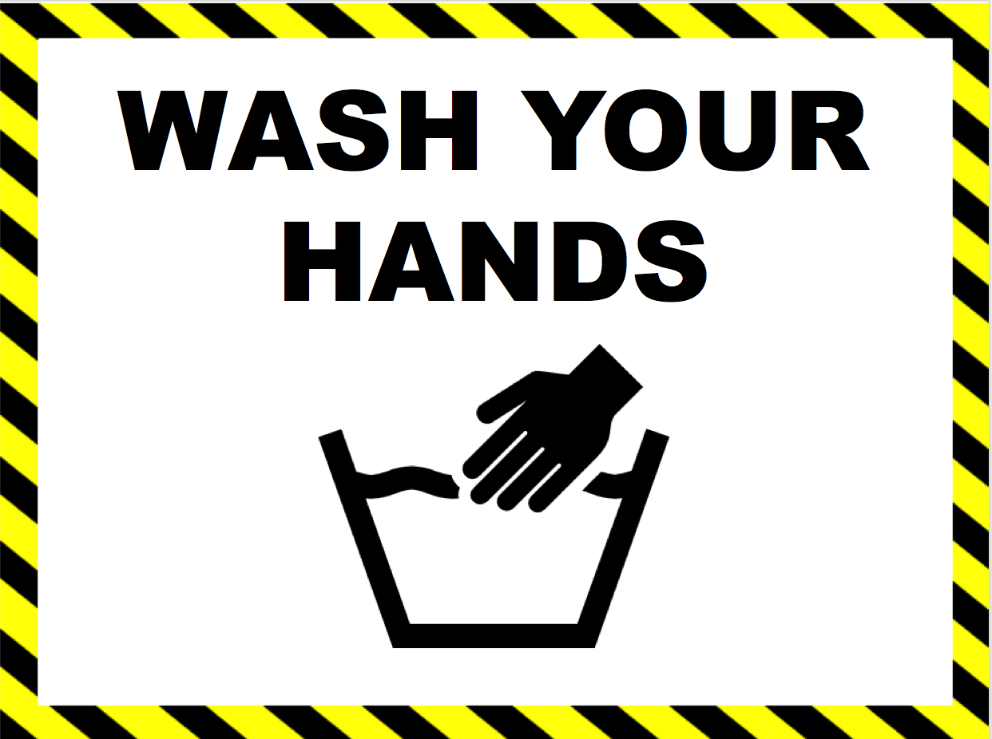

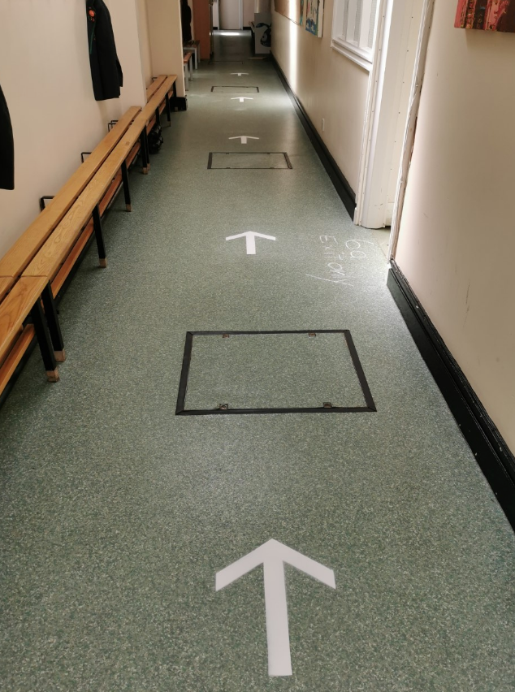
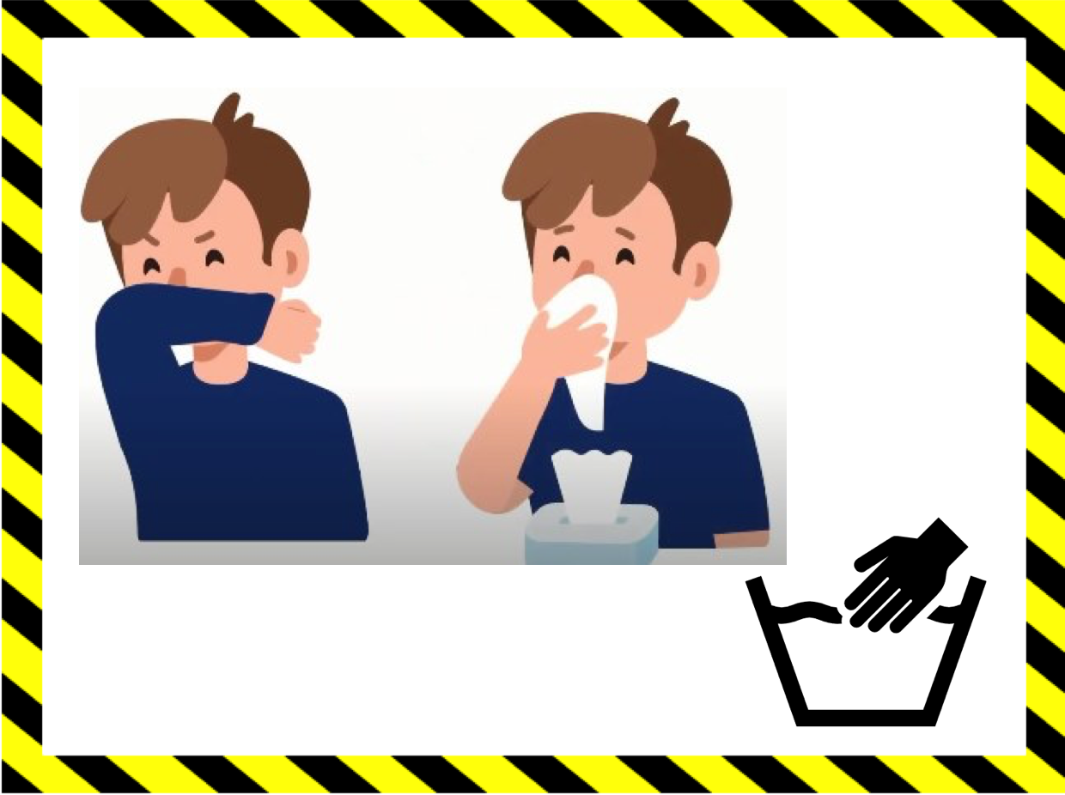
Lunches

For a little while we won’t be able to use the hall for our dinners.
This is because we want to keep you in your bubble and to not let the bubbles mix.
We won’t be able to have our normal lovely home cooked meals as it might be a bit difficult and messy to bring spaghetti bolognaise to your classroom!
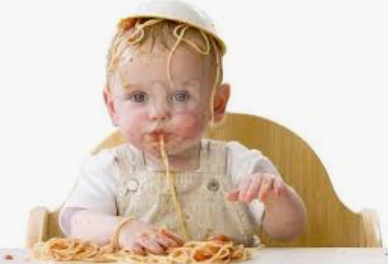

Sophie has made a great menu for us to choose from and she will be working really hard to make sure your dinners are as tasty as ever. It will look something like this.

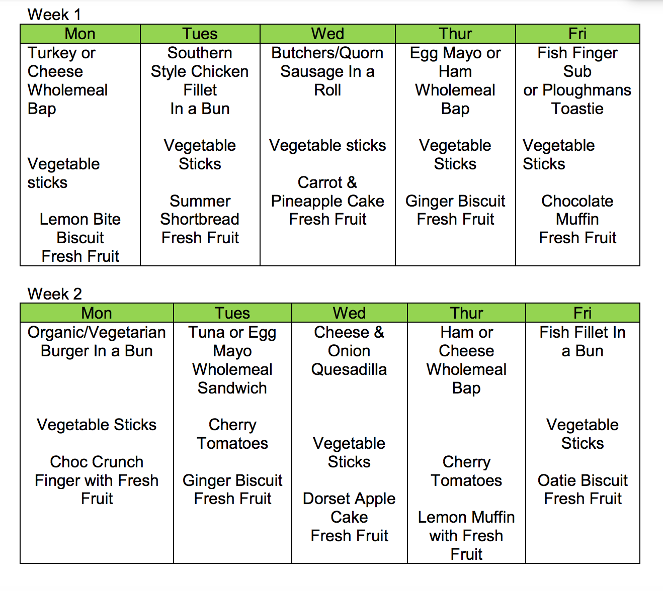

If you want to bring your own packed lunch you are able to do this.
Your lunchbox must be emptied and cleaned with hot soapy water each night.
During the day it will be kept under your desk in your classroom.

You will also be asked to bring a water bottle.
Your water bottle must be emptied and cleaned with hot soapy water each night.
During the day it will be kept on your desk in your classroom.

Masks

Sometimes in school you might see some of the grown- ups wearing a mask on their face.
They might need to do this if you are poorly or have fallen over.
Some of the older children may want to wear one at times as well.

Please don’t be frightened they are just to keep us all safe.

Underneath the mask your teacher will still be smiling away at you.
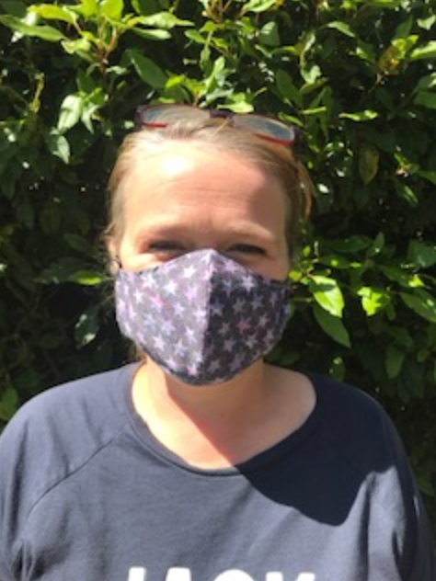



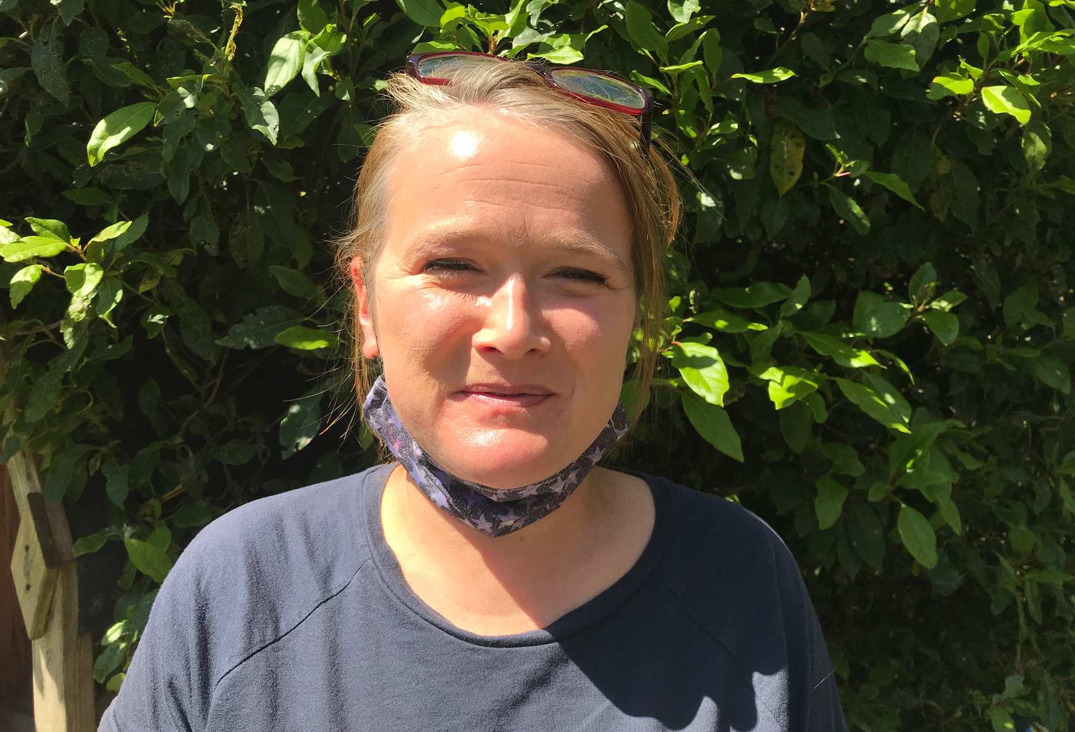

Resources for talking to your child about Coronavirus

http://www.bunburyaldersey.cheshire.sch.uk/serve_file/441584

http://www.bunburyaldersey.cheshire.sch.uk/serve_file/441590

http://www.bunburyaldersey.cheshire.sch.uk/serve_file/441596

http://www.bunburyaldersey.cheshire.sch.uk/serve_file/441603

http://www.bunburyaldersey.cheshire.sch.uk/serve_file/441609

http://www.bunburyaldersey.cheshire.sch.uk/serve_file/441612

https://www.nspcc.org.uk/keeping-children-safe/childrens-mental-health/depression-anxiety-mental-health

