Reading information from pictograms
Pictograms are as they sound- made of pictures.

Pictogram to show animals in a the zoo

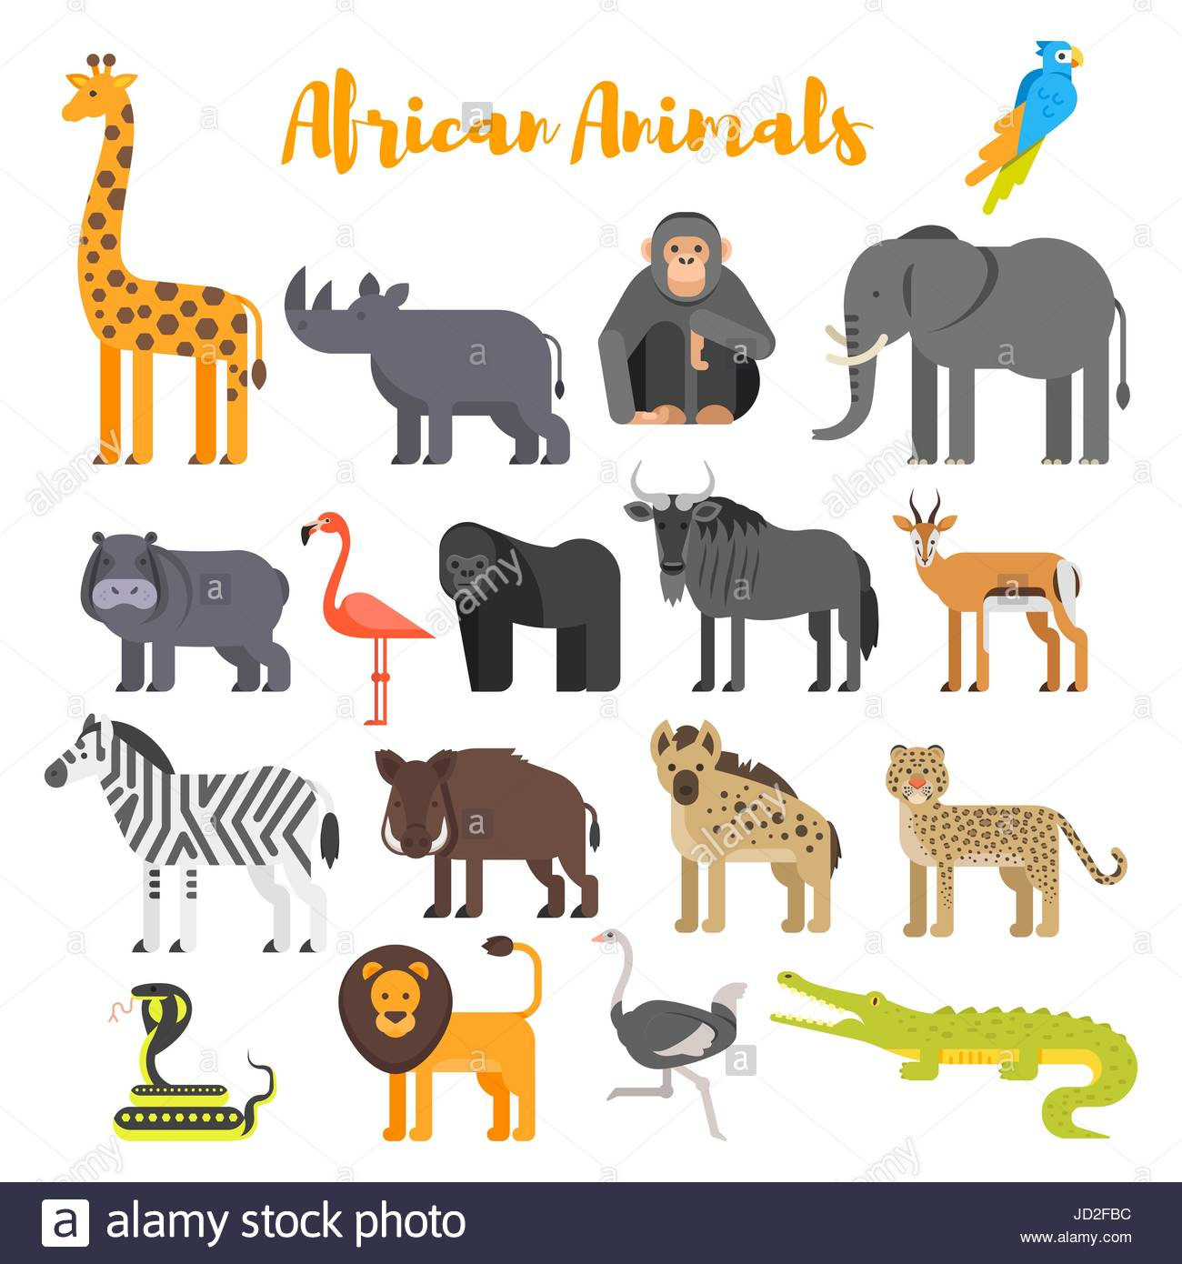
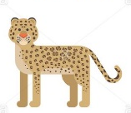
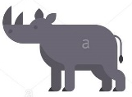
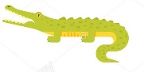

rhino gazelle crocodile lion leopard

- How many leopards are at the zoo? __________

- Which animal does the zoo have most of? _______________

- How many herbivores are there altogether at the zoo? ________

- How many carnivores are there altogether at the zoo? ________

- What is the difference between the number of crocodiles and the number of gazelles? _________

(Remember to ‘find the difference’ you can count up from the smallest number to the biggest number.)
Block graphs
Class 5 have made this block graph to show their favourite African animal
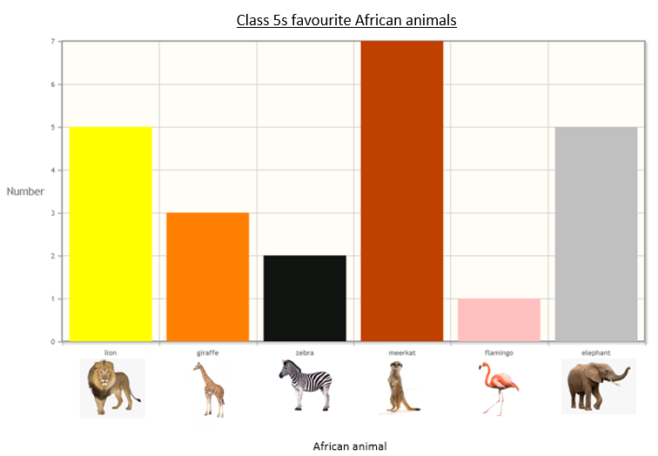

Can you answer these questions about their graph?

- How many children liked zebras best? ________________________

- Which was the most popular African animal? ___________________

- Which was the least popular African animal? ___________________

- Which 2 animals got the same number of votes?

_______________________ and _______________________

- How many more children liked lions than giraffes? _________

- How many more children liked elephants than flamingos? _________

- How many children chose either the giraffe or zebra? _________

- How many children are there altogether in class 5? ________
This is a block graph to show how long some African animals live in the wild. This one has horizontal blocks instead of vertical ones.
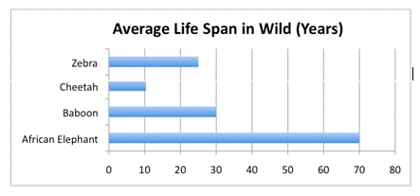

Can you answer these questions from reading the graph?

- Which animal lives the longest? ________________

2) Which animal has the shortest life span? _________________

- How many years do baboons live for? ___________

- How many years do zebras normally live for? _____________

- How many years longer do baboons live than cheetahs? _________

- How many years longer do elephants live than baboons? __________

- Lions usually live 5 years longer than cheetahs in the wild. Can you add this information onto the top of the block graph? How many years do lions live for? ____________

