Year 1/2
Week beginning: Monday 29th June 2020 Summer term 2- Week 5 out of 7

Hello Deer Class superstars!
I hope you have all had a lovely weekend!
Did any of you see any lightning or hear thunder?
I had to shelter from a huge storm on Friday night and it was an exciting, noisy one!

Click on the picture below to hear my introduction to our week's learning.

So, this week I have set you maths work (multiplication/counting in 2s, 5s and 10s), writing (jackal WANTED poster), Music and art (make and decorate a shaker instrument), Science (carnivore, herbivores and omnivores) Geography (co-ordinates).
Mr Dooley has also given me some orienteering PE activities for you!

We now have some of our year 1 children back in school who are working from this webpage, just as you are at home.
We will be following this timetable should you want to do something similar. Please continue to do whatever works for you though as there is no right or wrong answer!
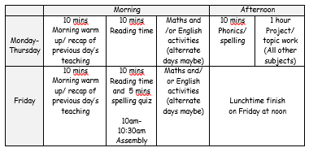
Have fun completing some or all of these activities and I look forward to seeing your work and receiving your emails if you would like to share anything!
Have a lovely week.
Still missing you all lots!

Love from Miss Dutton x

Click here to enter online Purple Mash resources
Click here to enter Mathletics
Click here to enter TT Rockstars

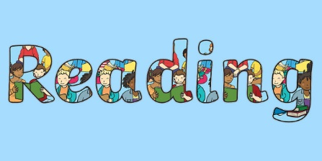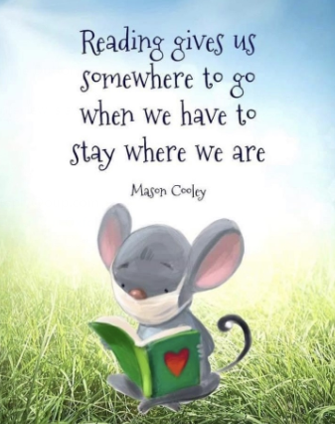
Use the link below to register on the Oxford Owls website. It is easy to set up the registration and it will give you access to a range of ebooks for ages 3-11.
Oxford Owl E Book Registration- link


Reading and Spelling - It is really important that you can all read and write words with the sounds below. Keep practising them! Can you choose a sound and write 6 words for it. Try to learn to spell 5 common exception words each week too
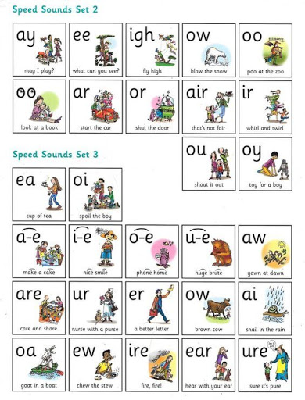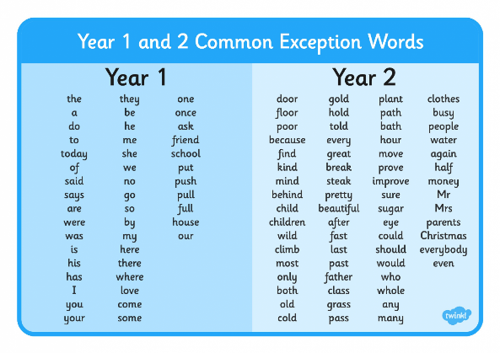
Year 1 children- Check you can spell these words from the list above?

there/ where love some/ come

Year 2 children-
Learn to spell these 6 words that end in 'al'.

jackal animal pedal metal hospital capital


Maths
* * * Please keep practising temperature, mass, capacity, time telling, adding, subtracting and counting in 2s, 3s, 5s and 10s to learn your times tables. There are also maths challenges for year 1 and year 2 in the files at the bottom of this page. * * *
As mathematicians- Can you count in 2s, 5s and 10s and solve problems multiplication calculations involving these?

Warm up- Quickfire addition and subtraction questions
8 + 2 = 9 - 2 = 10 + 4 = 6 - 4 = 6 + 3 =
12 - 2 = 15 + 3 = 7 + 4 = 10 - 7 = 15 + 3 =

Multiplication
This week your activities are all linked to multiplication.
Mr add can sometimes get tired!
For example when trying to solve problems like this and having to us his add sign more than once
2 + 2 + 2 + 2 + 2 + 2
Mr multiply comes along to help by making the calculation more simple using his sign just once.
There are 6 lots of 2 so he writes 6 x 2
Multiplication is repeated addition.

We become much better at multiplication in year1 and 2 when we can confidently count in 2s, 5s and 10s.
Click on the links below to find your activities for this week. You don't have to print these you can just write the answers down if you like.
There is a number line to 20 and a hundred square too should you need them.

Counting in 2s, 5s and 10s - Activities

Using the multiplication sign - Activities

Number line 0-20
100 square


Science
As scientists- Can you name some animals that are carnivores, herbivores and omnivores?

Over the past few weeks we have been learning about these different groups of animals-
mammals, fish, birds, insects, arachnids and reptiles.
This week I would like you to sort some of our African animals into 3 groups.
Some animals are carnivores and eat meat.
Some animals are herbivores and eat plants.
Two of our African animals are omnivores and eat both plants and meat.
Our two omnivores are the baboon and the meerkat.
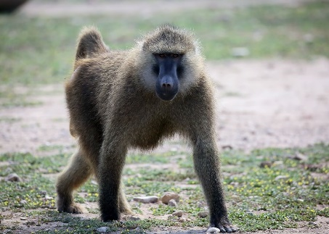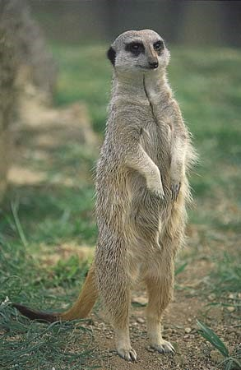
They like to eat plants and berriesbut also insects and sometimes small reptiles too!
Challenge- Can you sort these African animals into the other two groups- carnivores and herbivores?
You might want to write these words as headings and then either draw some of your favourite animals underneath or copy their names. You could use one of these sorting hoops ideas. Why do you think one of them has 3 sections?
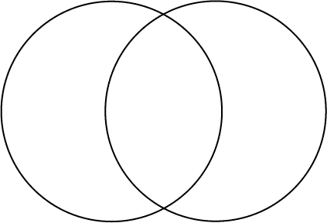
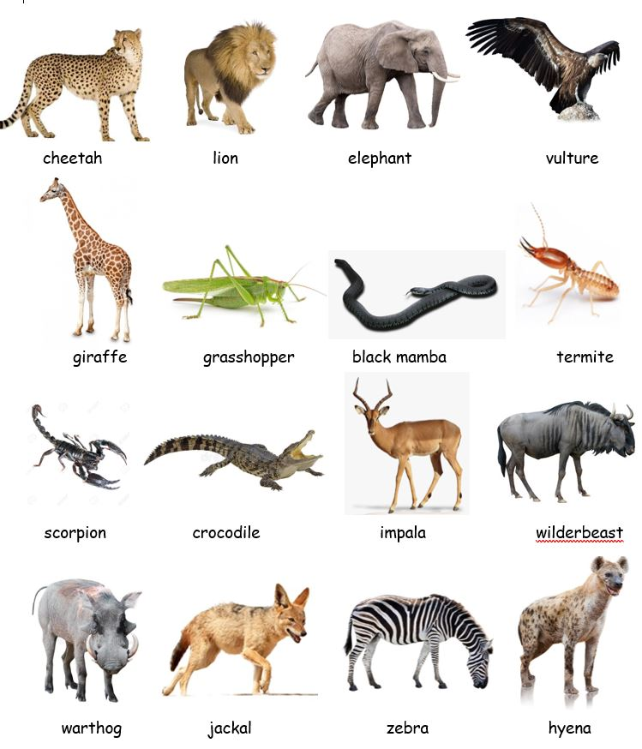


Writing
As writers- Can you create a WANTED poster using intereting adjectives- describing words?
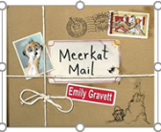 Meerkat Mail by Emily Gravett- story video
Have you spotted the cheeky jackal hiding on every page of our Meerkat Mail book?
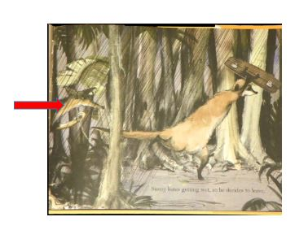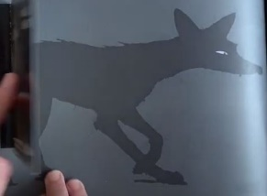
He has been following Sunny on his journey, hoping to have him for dinner!
This week I would like you to create a WANTED poster for the jackal, describing him well so that other animals in the desert can keep a look out for him.
Challenge 1- Here is an example of a WANTED poster for the Big Bad Wolf.
Can you fill in (orally) the missing adjectives -describing words?
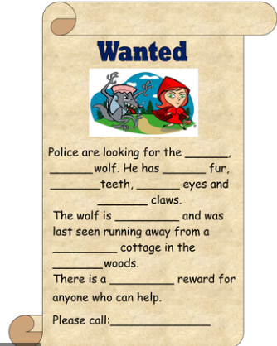
Challenge 2- Create your own WANTED poster for the jackal in meerkat mail. Draw a picture and use some interesting adjectives in your writing to describe what he looks like, his character, how he moves and where he hides.
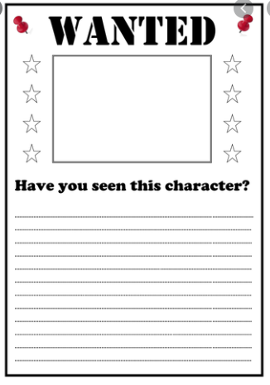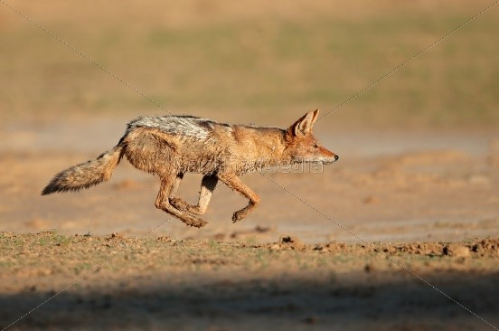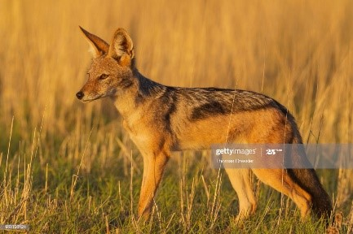
Don't forget to use punctuation in sentences such as capital letters, full stops, commas, maybe even exclamation marks and question marks. Try to use interesting adjectives (describing words) and conjunctions (joining words) such as 'and, but, so, because, when, that, if, or'.

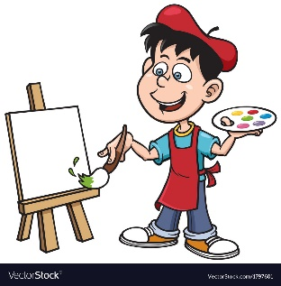
Music and Art
As a musician- can you create your own shaker instrument that you can play quickly, slowly, loudly and quietly?

Challenge 1- Create your own instrument that you can shake to make a sound. Have a go at some junk modelling then put something inside your shaker that will move to make a sound. Some options are rice, pasta, lentils, scrunched up paper, paper clips, pebbles etc. Here are some examples below.
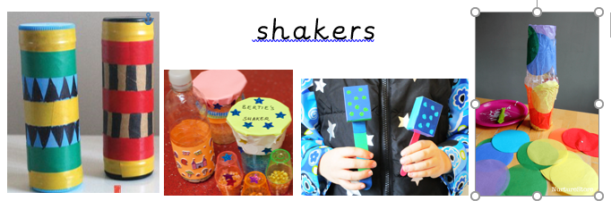

Challenge 2- Decorate your instrument using African patterns of your choice.
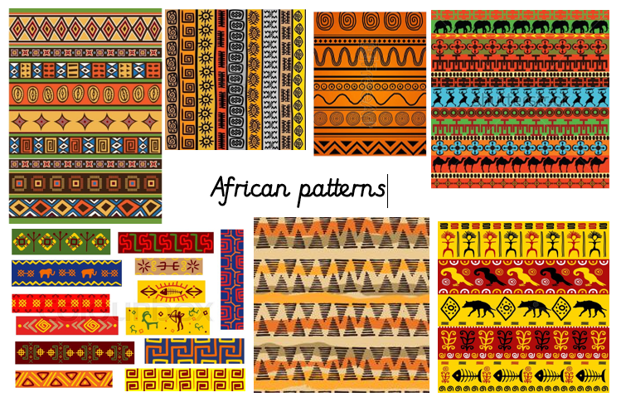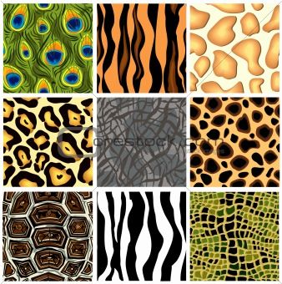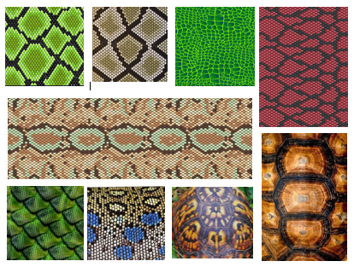

Challenge 3- Can you play your instrument
-quietly/ softly?
-loudly?
- slowly?
-quickly?
- Can you make a short sound? (Tip your shakewr quickly)
- Can you make a long sound? (Tip your shaker slowly.)

Challenge 4- Can you play your instrument along with one of these African tunes, keeping to the beat?
Which song has the fastest and which has the slowest beat?
Which is your favourite piece of music out of the three?
African music 1 https://www.youtube.com/watch?v=L7m61Em4A5k
African music 2 https://www.youtube.com/watch?v=Kr1Z9jVPBz4
African music 3 https://www.youtube.com/watch?v=kZHfmgIb4mc


Geography
As geographers- can you create a simple map and use co-ordinates?

Challenge 1- Use a ruler to make your own grid something similar to this with letters across the bottom and numbers up the side. You can choose how many squares, letters and numbers you want to use.

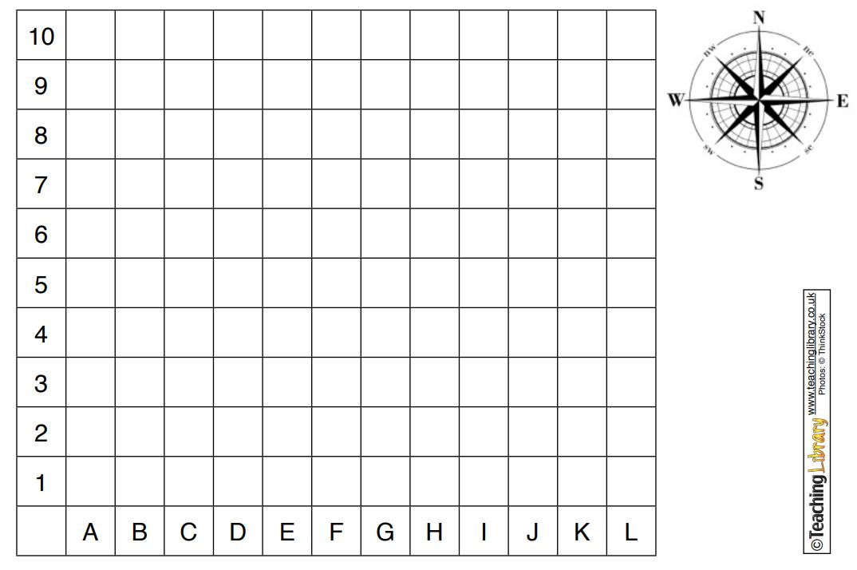
Challenge 2- Next draw on some of the places that Sunny visits in the story. Try to keep each one to one or two boxes on the grid.
- Sunny's home in the sand dunes
- Uncle Bob's burrow
- the termite mound
- the farm
- the rainforest
-Madagascar (Remember this across the sea so you'll need some water on your map!)
-marsh restaurant
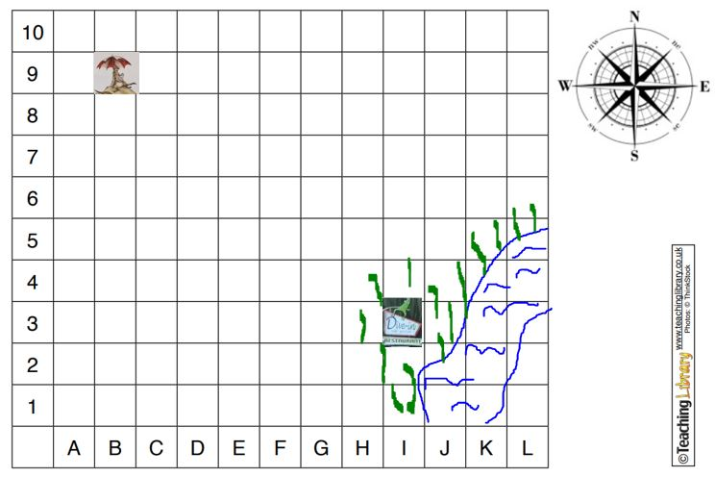

Challenge 3- Now write the co-ordinates for the places his visits.
Co-ordinates are often used to help locate things on a map.
You record co-ordinates of places by writing the letter and then the number where the place can be found on the map with a comma to seperate them.

For example on the grid above
Sunny's sand dune is at at the co- ordinates B, 9
The marsh restaurant is located at at I, 3

If your place is drawn over more than one box then just choose one main grid reference to write for it.

You could also give directions using North, South, East, West using your map.
For example the marsh restaurant is East of Sunny's sand dune.



Computing
In computing can I multiplication games giving instructions for movement?
On Purple Mash I have set you some 'to do' counting in 2s, 5s and 10s games.
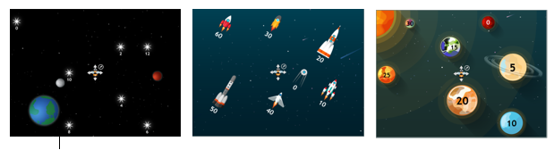


PE
As sports people- Can you try out some orienteering activities?
Mr Dooley has sent you the following message...

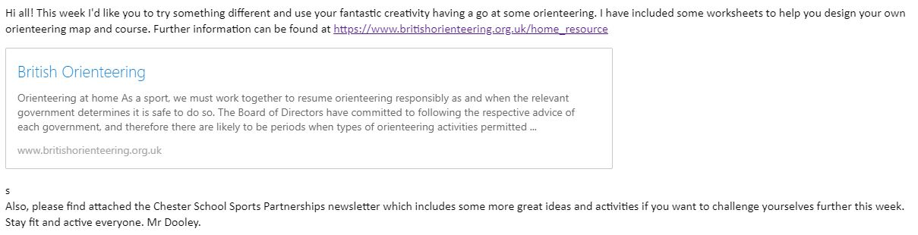
Create your own map
Garden orienteering
Numbered markers
Other activities

Have fun!

