Multiplication

Introduction
When we multiply we are adding together equal groups.

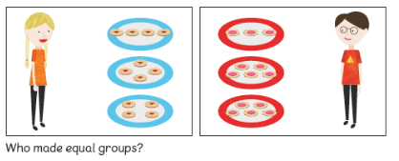

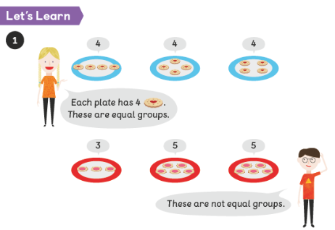

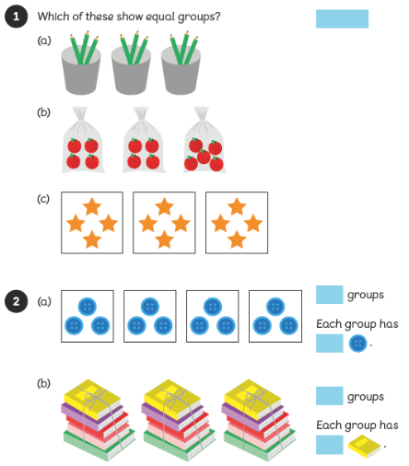


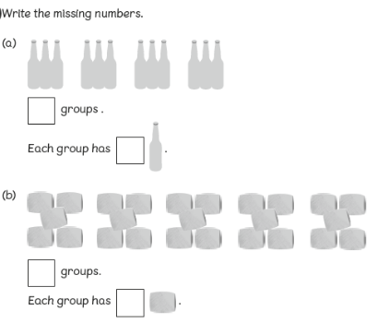

Adding equal groups
5 + 5 + 5 + 5
Count 4 fives
5, 10, 15, 20

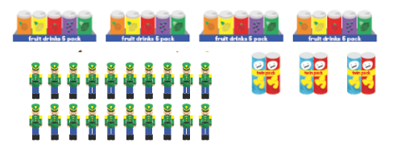

10 + 10
Count 2 tens
10, 20
2 + 2 + 2
Count 3 twos
2, 4, 6

Can you count how many objects there are all together by counting in 2s?
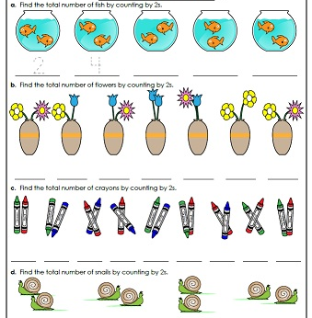

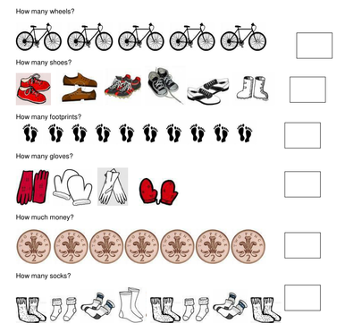

2 + 2 + 2 + 2 =

2 + 2 + 2 + 2 + 2 + 2 =

Can you count how many there are altogether by counting in 10s?

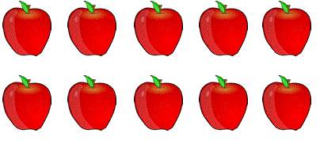


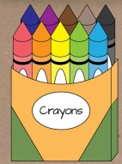

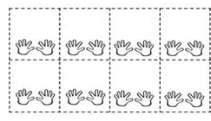

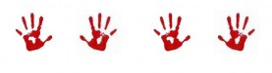
Can you count how many there altogether by counting in 5s?
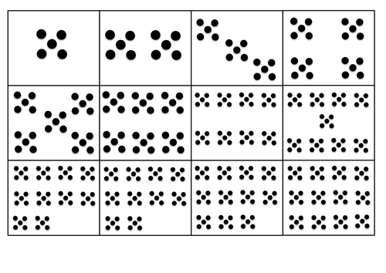
5 10 15 20 25 30 35 40

